

**PRATHMESH PATIL**

**A71004819033**

**BCA SEM4**

**Introduction to Open Source Technologies (PHP , MySQL) LAB**

AMITY UNIVERSITY MAHARASHTRA

Amity Institute of Information Technology

This is to certify that Mr. Prathmesh Patil is a Bonfire student of Amity Institute of Information Technology, at Amity University Maharashtra and he has done the project work titled “ Introduction to Open Source Technologies (PHP , MySQL) LAB ” at Amity University Mumbai as prescribed by AIIT, AUM in partial fulfilment of the requirement of BCA Program for the academic year 2021-22.

Teacher’s signature :-

|  |  |  |  |  |  |
| --- | --- | --- | --- | --- | --- |
| Experiment No. | Serial No. | Questions | Page Number | Date | Remarks |
| **Experiment 1** | 1 | Write a Hello program in php. | 12 | 04-01-21 |  |
|  | 2 | Write a PHP program to show case-sensitive | 13 |  |  |
|  | 3 | Write a PHP program to show use multiline strings. | 14 |  |  |
|  | 4 | Write a PHP program to add two numbers and print the output. | 15 |  |  |
|  | 5 | Write a PHP program to show use of echo with two variables. | 16 |  |  |
|  | 6 | Write a PHP program to find greatest number. | 17 |  |  |
|  | 7 | Write a PHP program to show use of switch-case. | 18 |  |  |
|  | 8 | Write a PHP program to show switch-case for addition/subtraction of a given number. | 20 |  |  |
|  | 9 | Write a PHP program to show use of function. | 22 |  |  |
| **Experiment 2** | 10 | Write a php program to find the sum of digits | 23 | **11-01-2021** |  |
|  | 11 | Write a php program to execute all string function | 24 |  |  |
|  | 12 | Write a php program to implement all scope global ,local and static. | 25 |  |  |
|  | 13 | Write a PHP to find a number is odd or even. | 29 |  |  |
|  | 14 | Write a php program to find odd or even of a number enter by user using form tag. | 30 |  |  |
|  | 15 | Write a php program to find the sum of digit enter by user using form tag | 33 |  |  |
|  | 16 | Write a php program to print welcome and the name enter by the user using form tag | 34 |  |  |
|  | 17 | Write a simple php program to show GET and POST. | 35 |  |  |
| **Experiment 3** | 18 | Write a PHP program to check the given year is a leap year or not. | 38 | **25-01-2021** |  |
|  | 19 | Write a PHP program to find addition of two number using form and isset | 39 |  |  |
|  | 20 | Write a PHP program on Print_r() the information about some variables in a more human-readable way. | 41 |  |  |
|  | 21 | Write a program in PHP check age < 18 print not eligible for voting using form tag and using if statement. | 42 |  |  |
|  | 22 | Write a program to find student grade using if else if statement with form tag | 43 |  |  |
|  | 23 | Write a program to implement Calculator using form and switch case | 45 |  |  |
|  | 24 | Write a PHP program to Print multiplication table of entered numbers | 47 |  |  |
|  | 25 | Write a program in PHP on foreach loop iterate on arrays | 49 |  |  |
|  | 26 | Write a PHP Program to print the numbers in reverse order-reverse.php | 52 |  |  |
| **Experiemnt 4** | 27 | Write a php program to showcase time and date | 53 | 01-02-21 |  |
|  | 28 | Write a php program to swap 2 number enter by user | 54 |  |  |
|  | 29 | Write a php program to print the element of array using print_r | 56 |  |  |
|  | 30 | Write a php program to showcase for loop | 57 |  |  |
|  | 31 | Write a php program to use unset function on array element. | 58 |  |  |
|  | 32 | Write a php program to showcase use of var_dump on array | 59 |  |  |
|  | 33 | Write a php program to call a function on a button click. | 60 |  |  |
|  | 34 | Write a php program to take 2 variable from user than print the sum. | 63 |  |  |
|  | 35 | Write a php program to connect user to sql server. | 64 |  |  |
| **Experiment 5** | 36 | Write a PHP Program for Cross site scripting | 67 | **8-02-2021** |  |
|  | 37 | Write a PHP program for Strip tags | 69 |  |  |
|  | 38 | Write a PHP code for stripcslaches function. | 71 |  |  |
|  | 39 | Write a php code for trim function | 72 |  |  |
|  | 40 | Write a PHP program script to secure your inputs trim, stripcslashes and html special chars functions.  In order to prevent this attack, we need to use special functions . | 73 |  |  |
|  | 41 | Write a PHP program looping through indexed array | 74 |  |  |
|  | 42 | write a PHP program for associative array. | 76 |  |  |
|  | 43 | Write a PHP program for multidimensional array | 77 |  |  |
|  | 44 | Write a PHP program for sort associative array in descending order using arsort function and Write a PHP program for sort associative array in ascending order using asort | 79 |  |  |
| **Experiment 6** | 45 | Write a php program to check if a pattern is present or not using preg_match | 85 | **15-02-2021** |  |
|  | 46 | Write a php program to check if a pattern is present or not using preg_match_all. | 86 |  |  |
|  | 47 | Write a php program to check if a pattern is present Replace it using preg_replace. | 89 |  |  |
|  | 48 | Write a php program to check if a name is correct or not using regular expression. | 90 |  |  |
|  | 49 | use preg_match() function search string pattern if yes print hello otherwise print bye. | 91 |  |  |
|  | 50 | Write a php program to check if email is correct or not using filter. | 93 |  |  |
|  | 51 | Write a php program to check if a name is correct or not using regular expression. | 94 |  |  |
|  | 52 | Write a php program to check if name , email id and mobile number is valid or not using regular expression. | 95 |  |  |
| **Experiment 7** | 53 | Write a php program to on constructor function using class | 99 | **22-02-2021** |  |
|  | 54 | Write a php program to access public variable outside class scope | 100 |  |  |
|  | 55 | Write a php program to intialise class value in constructor than print it using different functions. | 101 |  |  |
|  | 56 | Write a php program to check access specifiers | 103 |  |  |
|  | 57 | Write a PHP code to access variables which are has a access specifier as private protected . | 104 |  |  |
|  | 58 | Write a PHP program to print name using get() method. | 106 |  |  |
|  | 59 | Using inheritance create base class car and derived class that is sports car and display the value of variables | 107 |  |  |
| **Experiment 8** | 60 | write a php code add 2 variable and the variable are inherited by other class | 109 | **1-03-2021** |  |
|  | 61 | Write a php code to showcase include | 111 |  |  |
|  | 62 | Create the file include1.php and require.php copy all the content of files in index3.php . | 112 |  |  |
|  | 63 | Write a program for Effect of require and include statement if the files does not exist. | 114 |  |  |
|  | 64 | Write a php code to show the effect of include and require statement if the file does not exist | 115 |  |  |
|  | 65 | Write a PHP program using basename() function. | 115 |  |  |
|  | 66 | Write a php program Copy() function | 117 |  |  |
|  | 67 | Write a PHP program for Disk_free_space() function | 118 |  |  |
|  | 68 | Write a php code to showcase fread | 119 |  |  |
|  | 69 | Write a php code using file system function to read entire content | 120 |  |  |
|  | 70 | Write a php code to showcase file_exists | 121 |  |  |
| **Experiment 9** | 71 | Write a php program for creating cookie. | 122 | **15-3-2021** |  |
|  | 72 | Write a php program for deleting cookie. | 124 |  |  |
|  | 73 | Write a php program to print cookie. | 125 |  |  |
|  | 74 | Write a php program for create,delete,retrive cookie in one single program using form method. | 126 |  |  |
| **Experiment 10** | 75 | Write a php program to start a session. | 133 | **22-3-2021** |  |
|  | 76 | Write a php program to storing and accessing session data.($_SESSION is a super global array and 2 session variables is created firstname and lastname) | 135 |  |  |
|  | 77 | Write a php program to access the session data of previous session. | 136 |  |  |
|  | 78 | Write a PHP program to print the value of session id using PHP session | 137 |  |  |
|  | 79 | **Write a PHP program to destroy the session.** | 138 |  |  |
|  | 80 | **Write a php program to destroy session completely.** | 140 |  |  |
|  | 81 | **Write a PHP program to increase counter value every time user visits page using session** | 142 |  |  |
|  | 82 | **Write a php code for destroying the counter session.** | 143 |  |  |
|  | 83 | **Write a PHP code using session such that session will expire if user does not refresh page within 20 seconds. After 20 seconds if the page is not refreshed session will expire.** | 144 |  |  |
|  | 84 | **Write a php to create a file which does not exist in drive using fopen()** | 145 |  |  |
|  | 85 | **Write a php program to create a file and write to the file.** | 146 |  |  |
|  | 86 | **Write a php program to create a file and overwrite it.** | 148 |  |  |
|  | 87 | **Write a PHP program to append the file** | 150 |  |  |
|  | 88 | **Write a php program to read the content of the file** | 152 |  |  |
| **Experiment 11** | 89 | **Write a php program for read the content of text file using fread() and filesize()** | 153 | 5-4-2021 |  |
|  | 90 | **Write a php program to read 12 bytes of the file** | 154 |  |  |
|  | 91 | **Write a php program for fgets() function.** | 155 |  |  |
|  | 92 | **Write a Php program for read a file character by character using fgetc()** | 156 |  |  |
|  | 93 | **Write a php program for deleting file.** | 158 |  |  |
|  | 94 | **Write a php program for creating hyperlinks and insert data to text file on clicking the hyperlink.Use include statement also.** | 159 |  |  |
|  | 95 | **Write a php program by using die() function handle the error if file does not exist** | 162 |  |  |
|  | 96 | **Write a php programs for custom error handler** | 164 |  |  |
| **Experiment 12** | 97 | **Using php and mysql create database** | 166 | **12-4-2021** |  |
|  | 98 | **Using php and mysql create table** | 168 |  |  |
|  | 99 | **Using php and mysql insert values to table** | 170 |  |  |
|  | 100 | **Using php and mysql update values in the table.** | 171 |  |  |
|  | 101 | **Using php and mysql delete values.** | 172 |  |  |
|  | 102 | **Using php and mysql create student form and insert data into mysql.** | 174 |  |  |

**Experiment no :- 1**

Q1. Write a php program to showcase hello world.

Code :-

<html>

<body>

<?php

$txt="PHP WORLD";

echo "Hello $txt";

?>

</body>

</html>

Output:-

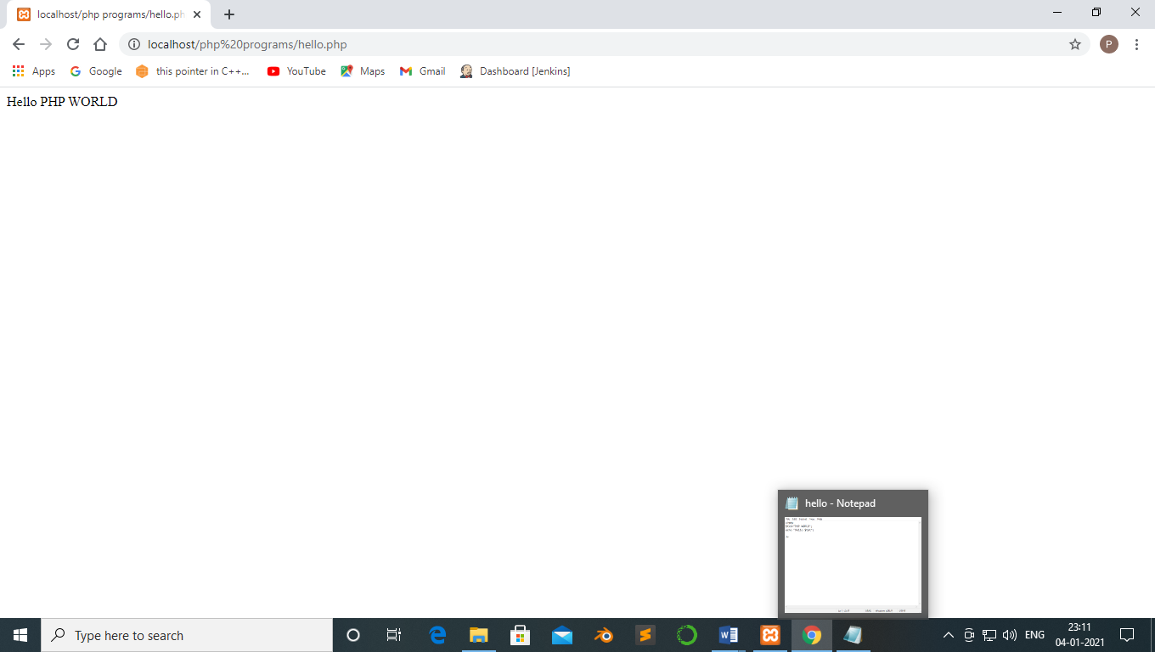

Q2. Write a php program to show the case sensitivity of variables.

Code :-

<html>

<body>

<?php

$color = "black";

echo "My car is".$Color."</br>";

echo "My dog is".$color."</br>";

echo "My phone is".$COLOR."</br>";

?>

</body>

</html>

Output:-

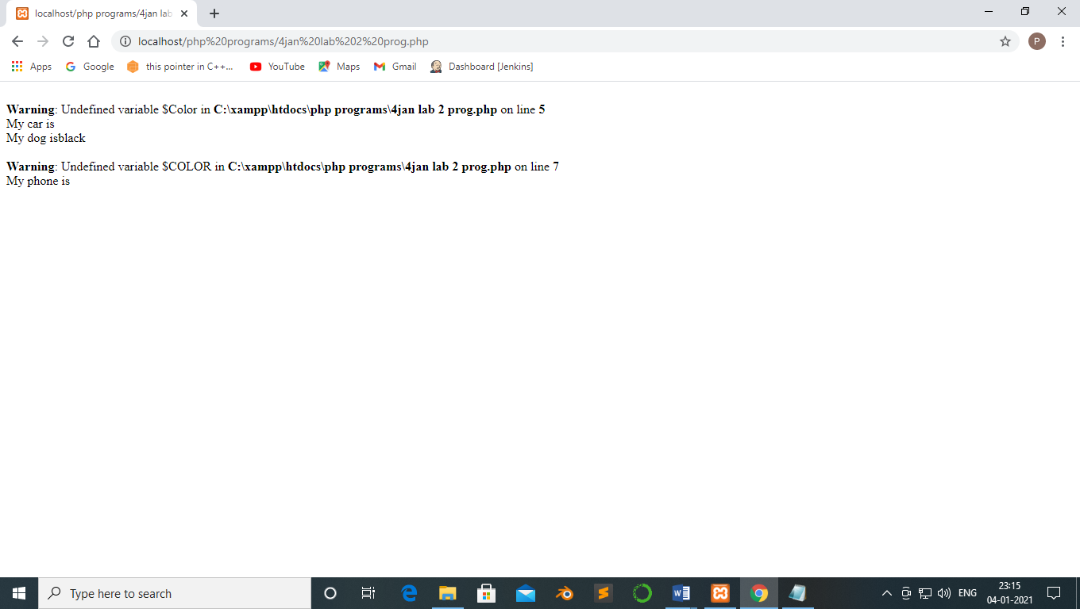

Q3. Write a php program to print multi line statement using echo.

Code :-

<html>

<body>

<?php

echo "hello by php echo

this is mutli line

text printed by

PHP echo statement

";

?>

</html>

</body>

Output:- 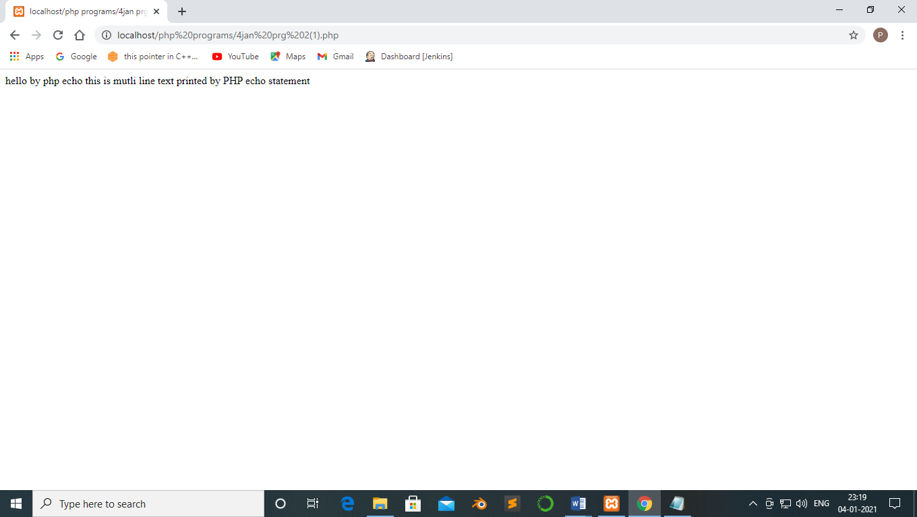

Q4. Write a php program to print multiple argument using echo.

Code :-

//php Multiple arguments using echo

<html>

<body>

<?php

$fname="Prathmesh";

$lname="Patil";

echo "My name is:".$fname,$lname;

?>

</html>

</body>

Output:-

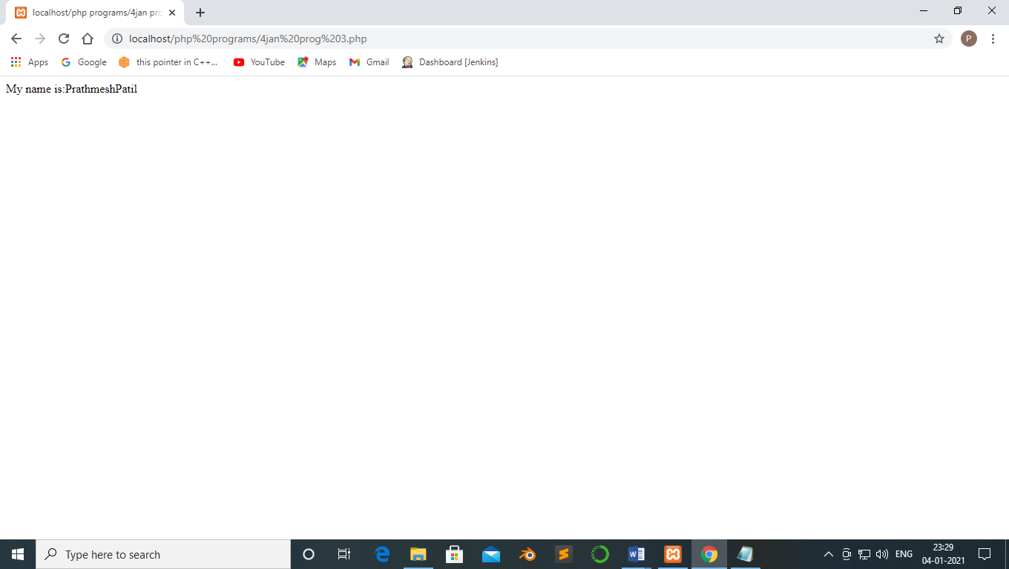

Q5. Write a php program to find the greater of 2 number using if else.

Code :-

<html>

<body>

<?php

//finding greater number

$first_number = 7;

$second_number=21;

if($first_number > $second_number){

echo "$first_number is greater than $second_number";

}else{

echo "$second_number is greater than $first_number";

}

?>

</html>

</body>

Output:-

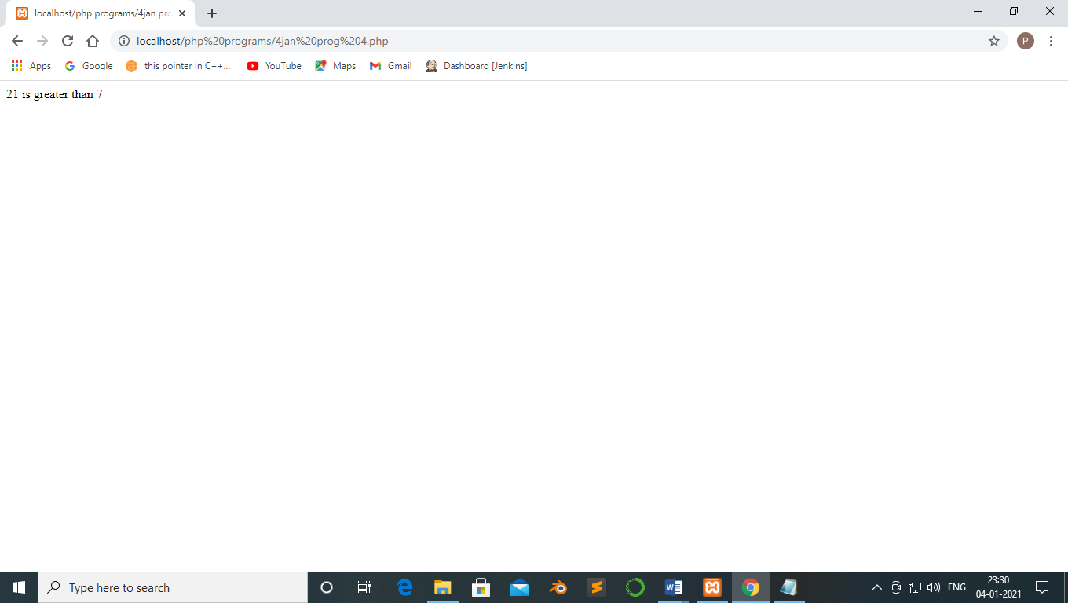

Q6. Write a php program to perform addition of 2 number.

Code:-

<html>

<body>

<?php

$a="25";

$b="35";

$c=$a+$b;

echo"<br>$c";

?>

</html>

</body>

Output:-

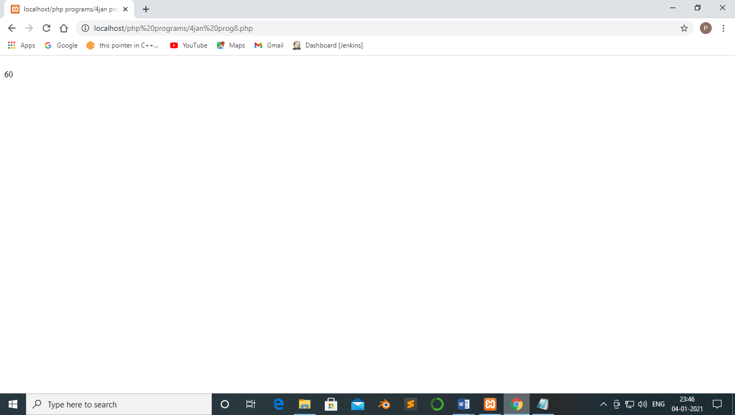

Q7. Write a php program to showcase switchcase.

<html>

<body>

<?php

$today ="Monday";

switch($today){

case "tuesday":

echo "pray for us sinners.";

break;

case "Monday":

echo "ladies night, take her out for dinner";

break;

case"Wednesday":

echo "take care as you go out tonight.";

break;

default:

echo "have a nice day at work";

break;

}

?>

</html>

</body>

Output:-

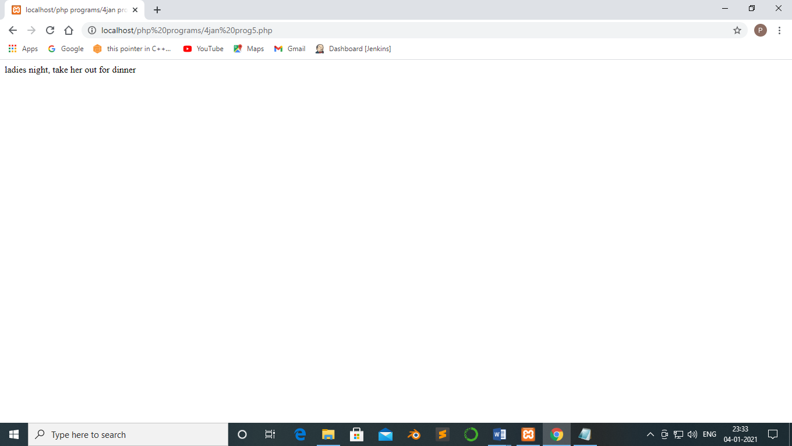

Q8. Write a php program to declare two variable and perform addition using switch case

Code :-

<html>

<body>

<?php

$a="5";

$b="10";

$c=$a+$b;

$operation="addition";

switch($operation){

case "addition":

echo "$a + $b=".$c;

break;

default:

echo "Invalid";

break;

}

?>

</html>

</body>

Output:-

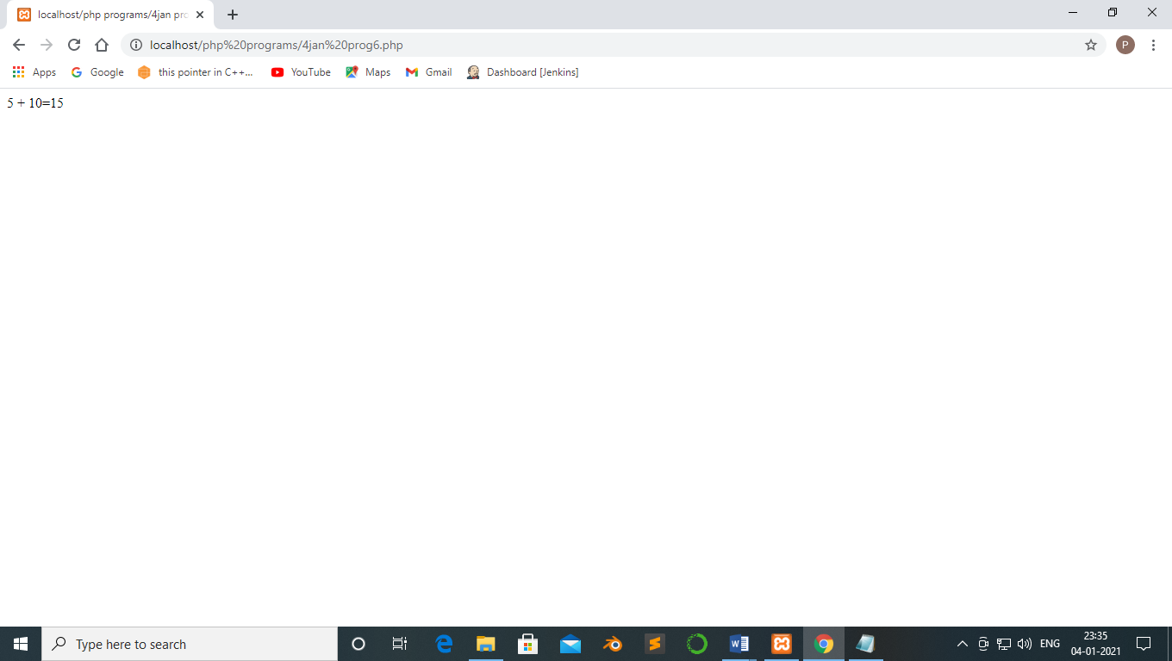

Q9. Write a php program to print hello using function.

Code :-

<html>

<body>

<?php

function hello(){

echo "hello";

}

hello()

?>

</html>

</body>

Output:-

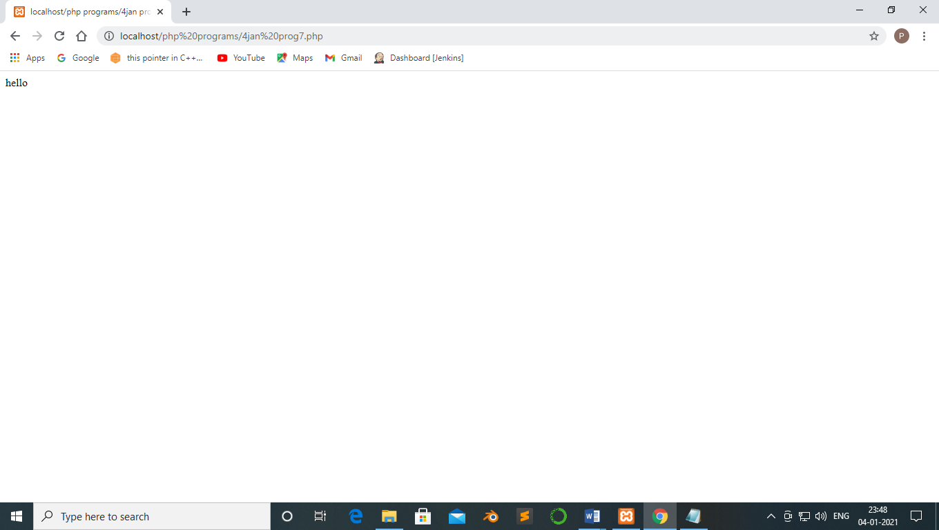

**11-01-2021**

**Experiment no :-2**

Q10. Write a php program to find the sum of digits

Code:-

<?php

$num=14579;

$sum=0;

$rem=0;

for($i=0;$i<=strlen($num);$i++)

{

$rem=$num%10;

$sum=$sum+$rem;

$num=$num/10;

}

echo "sum of digits 14579 is $sum";

?>

Output:-

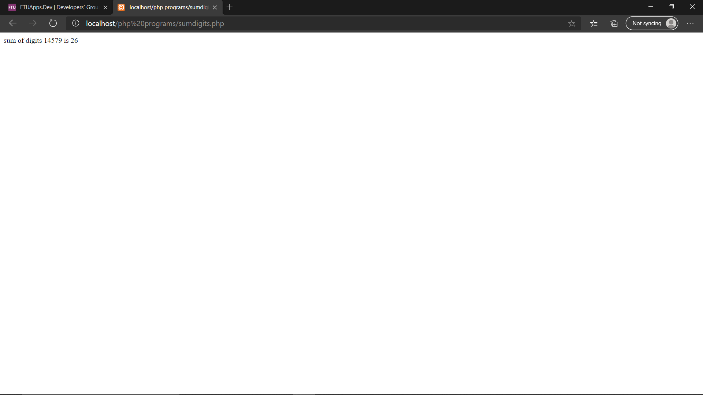

Q11 write a php program to execute all string function

Code :-

<?php

$str1="welcome to PHP";

$str2="welcome to pHP";

echo "By using 'strncmp()' function:".strncmp($str1,$str2,strlen($str1));

echo "<br>";

echo strlen("Hello world");

echo "<br>";

echo str_word_count("Hello world!");

echo "<br>";

echo strrev("Hello world!");

echo "<br>";

echo strpos("Hello world!", "world");

echo "<br>";

echo str_replace("world" ,"Anny","Hello world!");

echo "<br>";

?>

Output:-

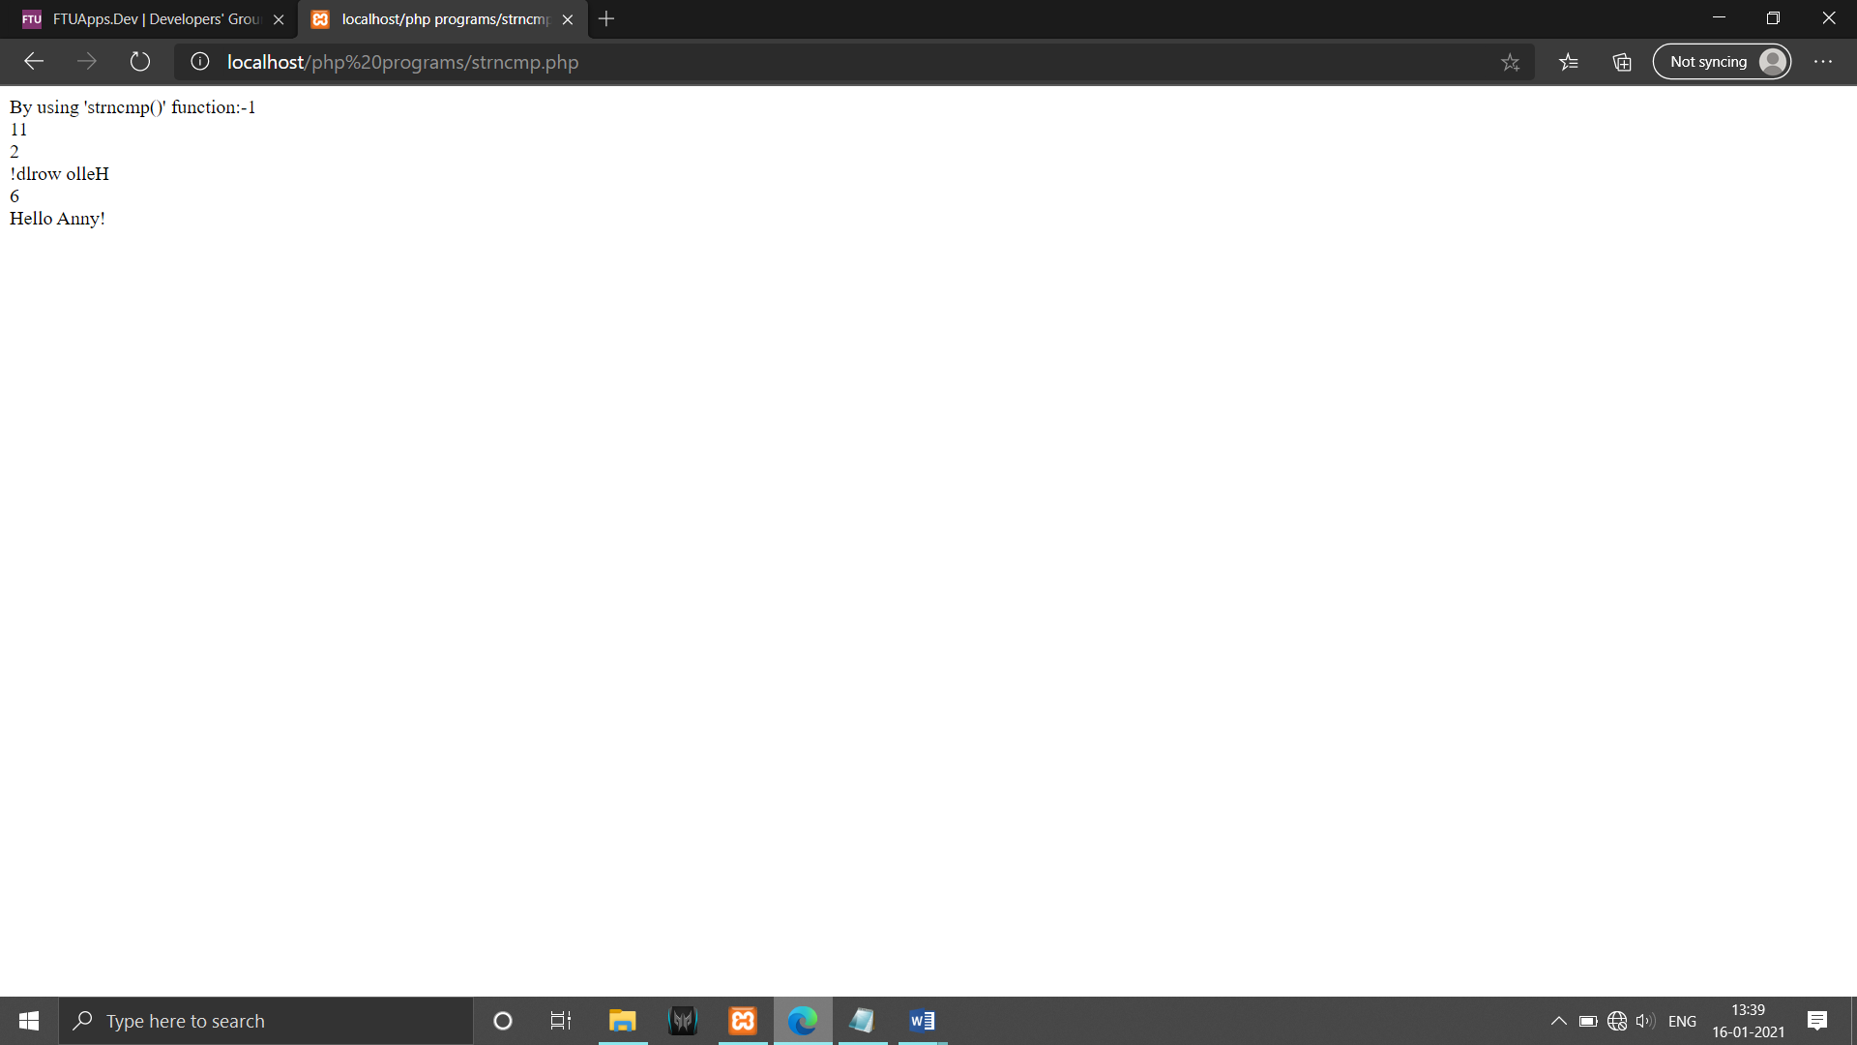

Q12 Write a php program to implement all scope global ,local and static.

Global :

Code :-

<?php

$name="php";

function global_var()

{

global $name;

echo "variable inside the function: ".$name;

echo "<br>";

}

global_var();

echo "variable outside the function:".$name;

?>

Output:-

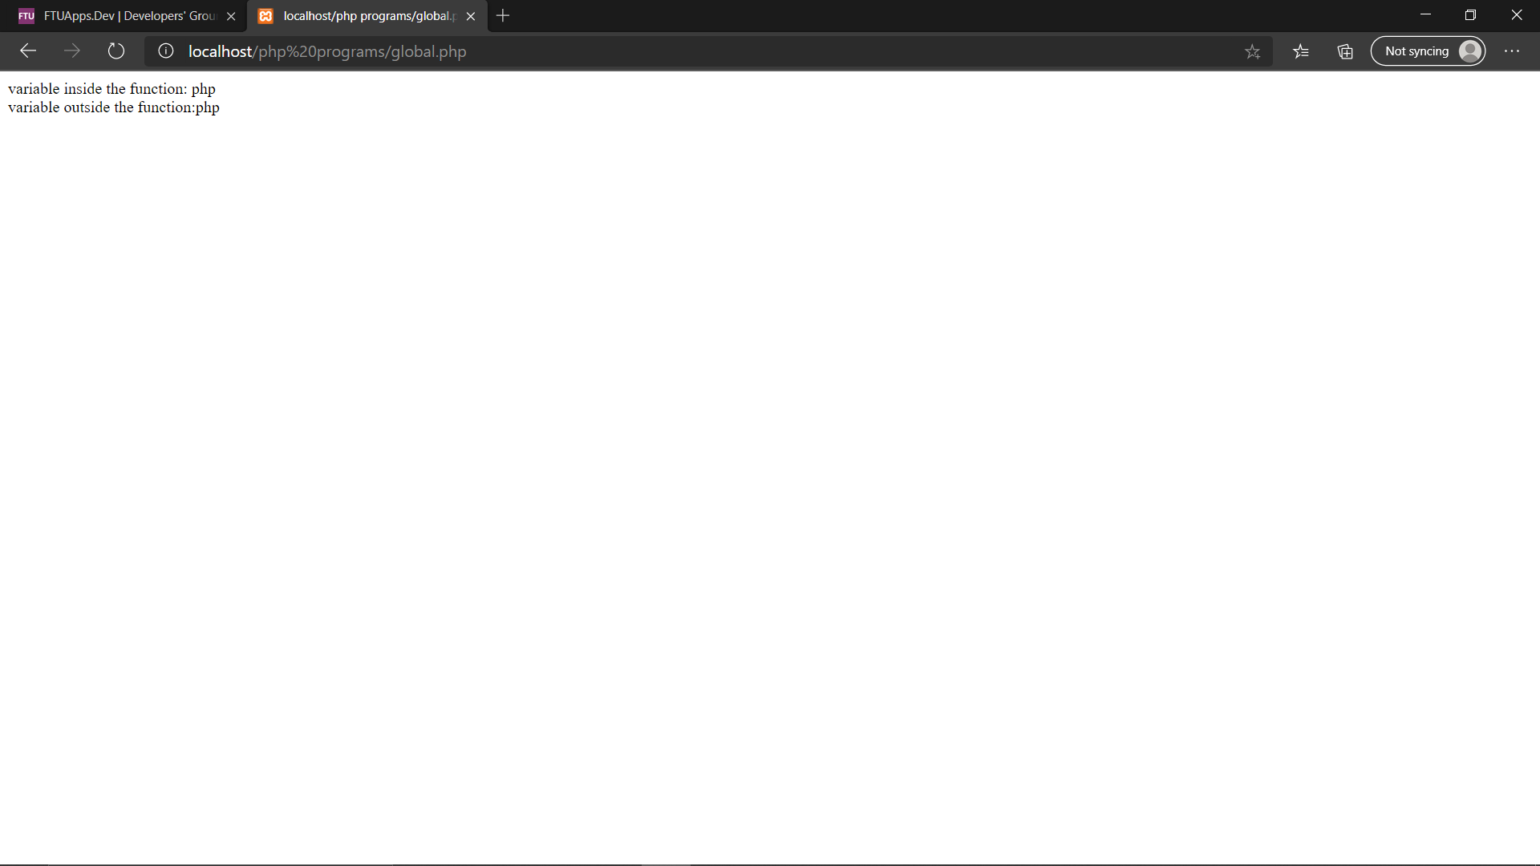

Code:-

<?php

$x=15;

function global_var()

{

$x;

echo "variable x inside the function: ".$x;

echo "<br>";

}

global_var();

echo "variable x outside the function:".$x;

?>

Output:-

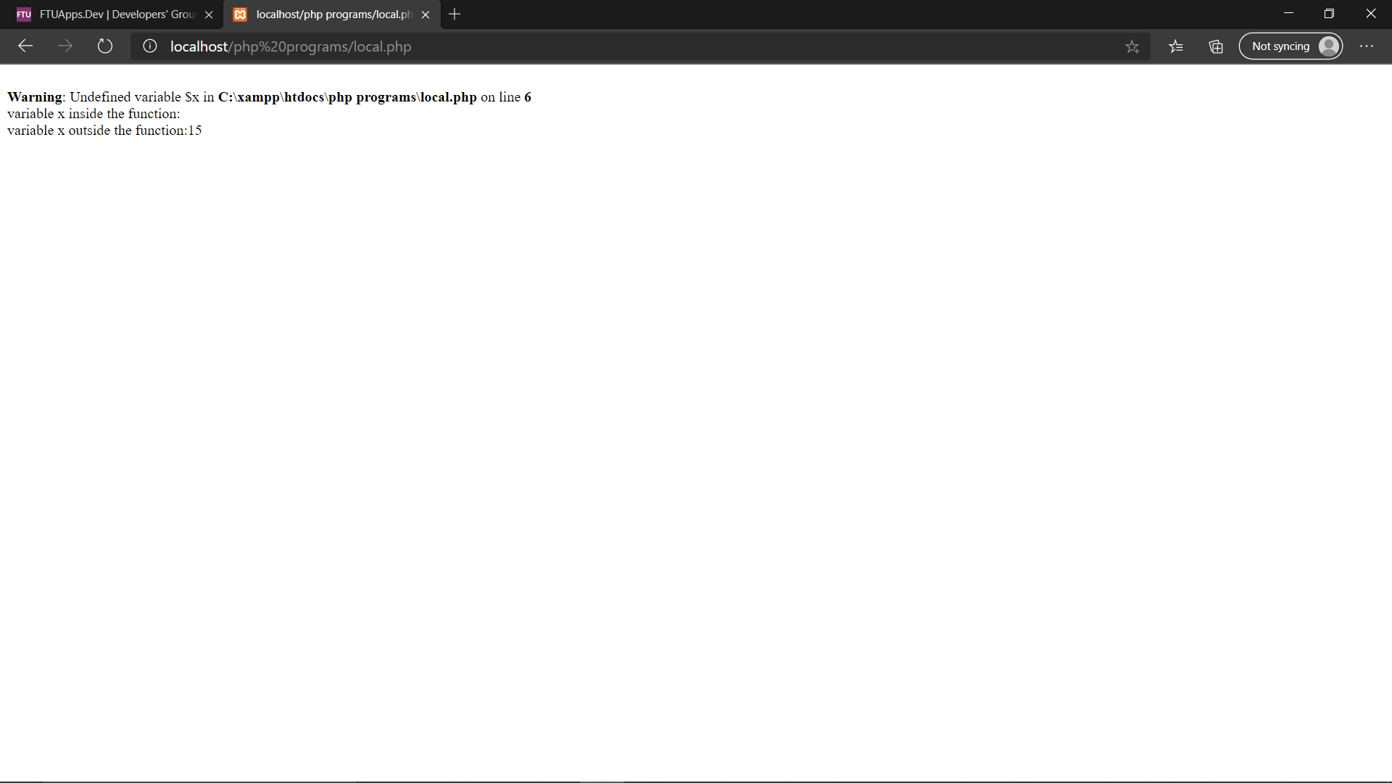

Local :-

Code :-

<?php

function global_var()

{

$x=17;

echo "variable x inside the function: ".$x;

echo "<br>";

}

global_var();

echo "variable x outside the function:".$x;

?>

Output:-

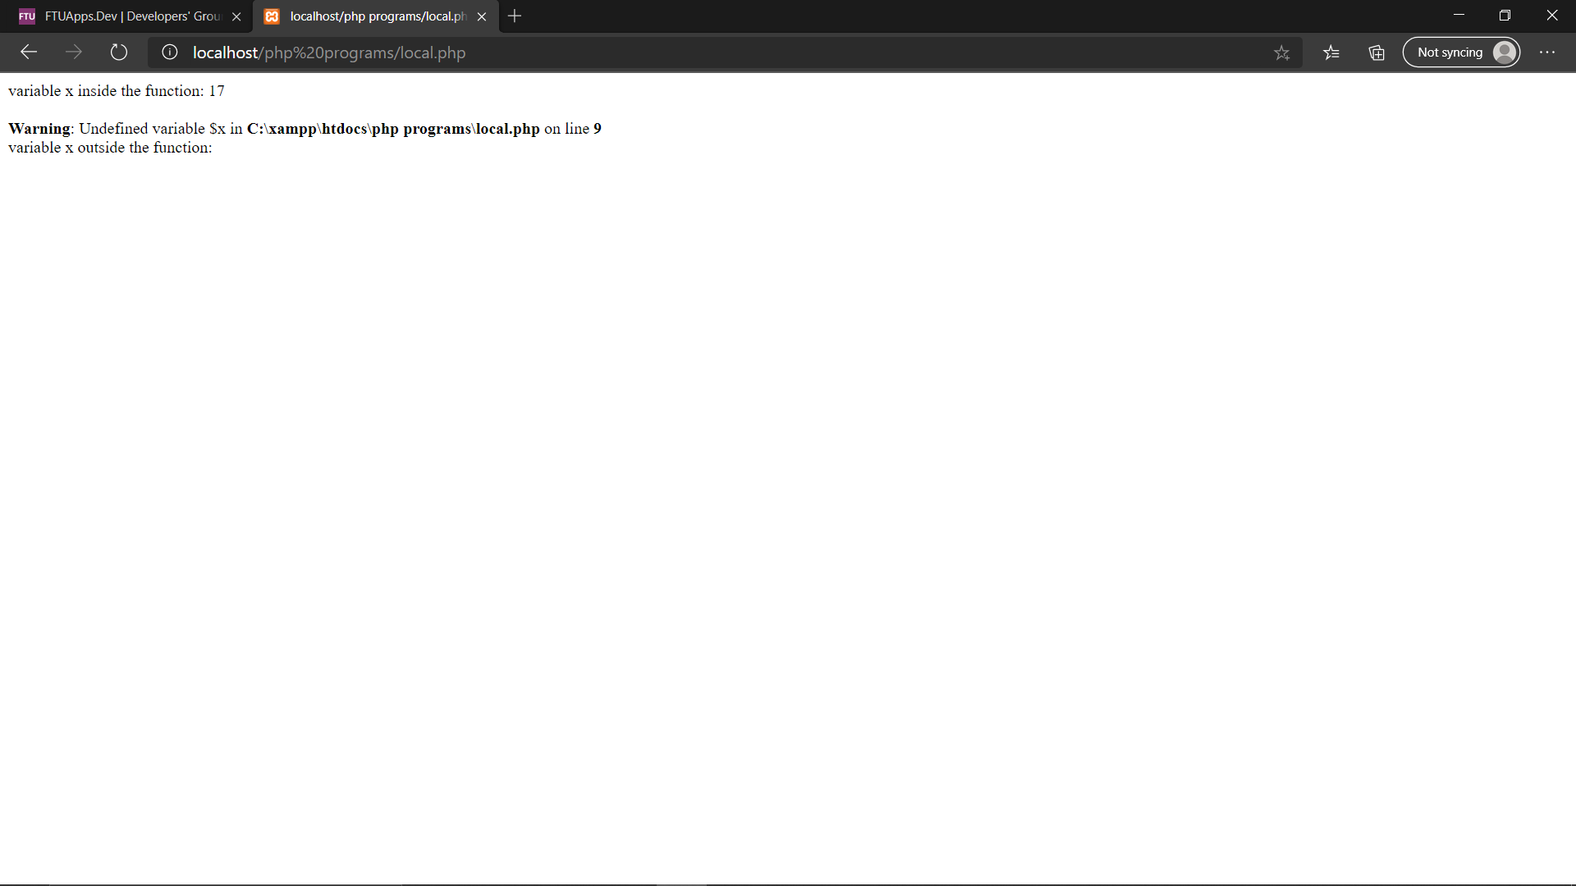

Static :-

Code :

<?php

function global_var()

{

static $x=1;

echo $x;

$x++;

}

global_var();

echo"<br>";

global_var();

echo"<br>";

?>

Output:-

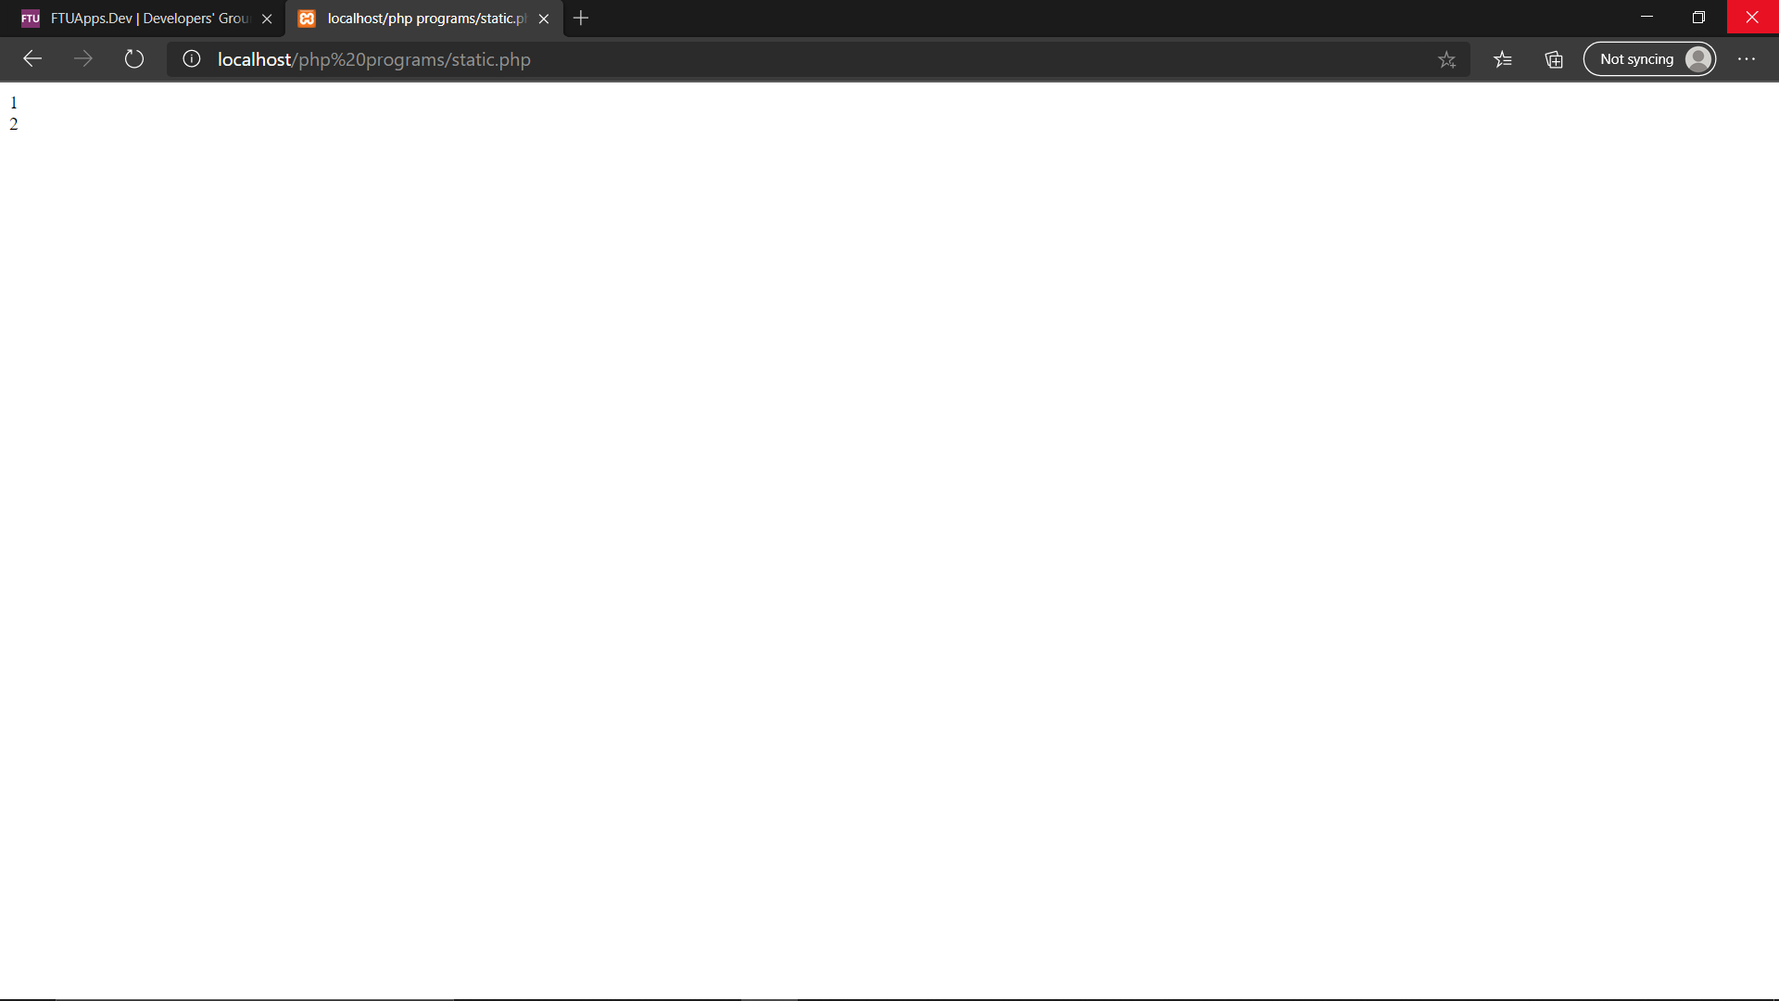

Q13 write a PHP to find a number is odd or even.

Code :-

<?php

$number=192;

if($number%2==0)

echo "$number is Even Number";

else

echo "$number is Odd Number";

?>

Output:-

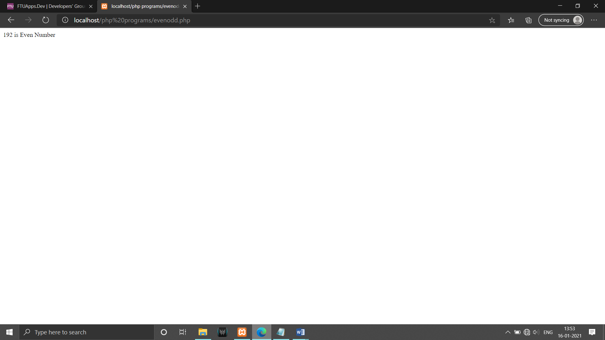

Q14 Write a php program to find odd or even of a number enter by user using form tag.

POST:-

Code :-

<!DOCTYPE html>

<html>

<head>

<tilte></tilte>

</head>

<body>

<form method='POST'>

<h2>Please input number:</h2>

<input type="text" name="number">

<input type="submit" value="submit">

</form>

</body>

</html>

<?php

if($_POST)

{

$number=$_POST['number'];

if($number%2==0)

{

echo "$number is Even Number";

}

else

{

echo "$number is Odd Number";

}

}

?>

Output:-

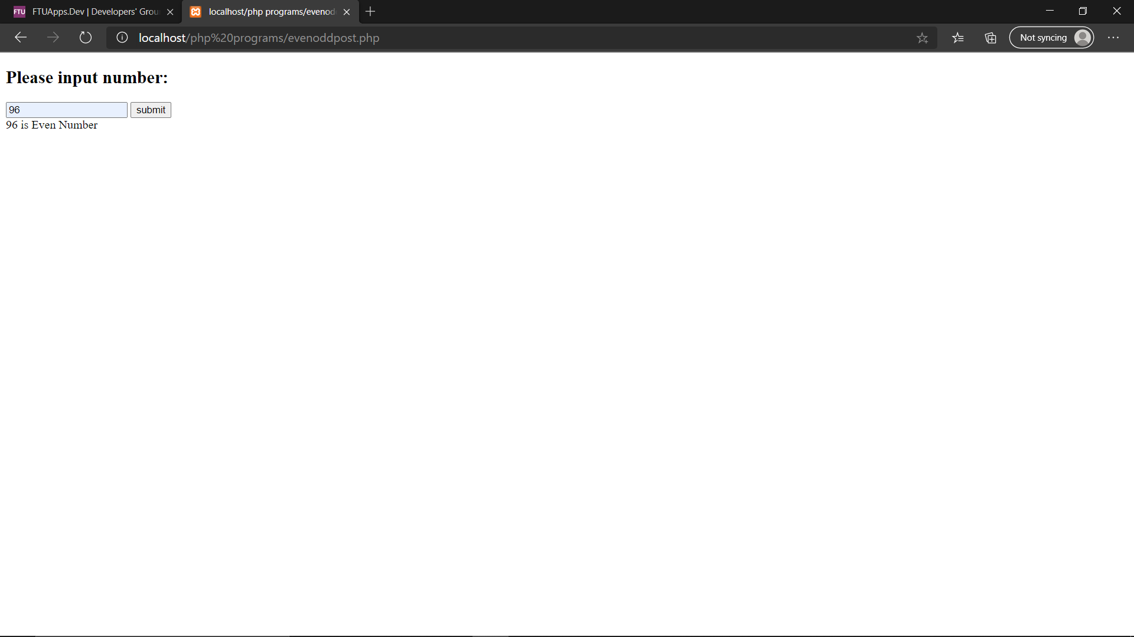

GET :

Code:-

<!DOCTYPE html>

<html>

<head>

<tilte></tilte>

</head>

<body>

<form method='GET'>

<h2>Please input number:</h2>

<input type="text" name="number">

<input type="submit" value="submit">

</form>

</body>

</html>

<?php

if($_GET)

{

$number=$_GET['number'];

if($number%2==0)

{

echo "$number is Even Number";

}

else

{

echo "$number is Odd Number";

}

}

?>

Output:-

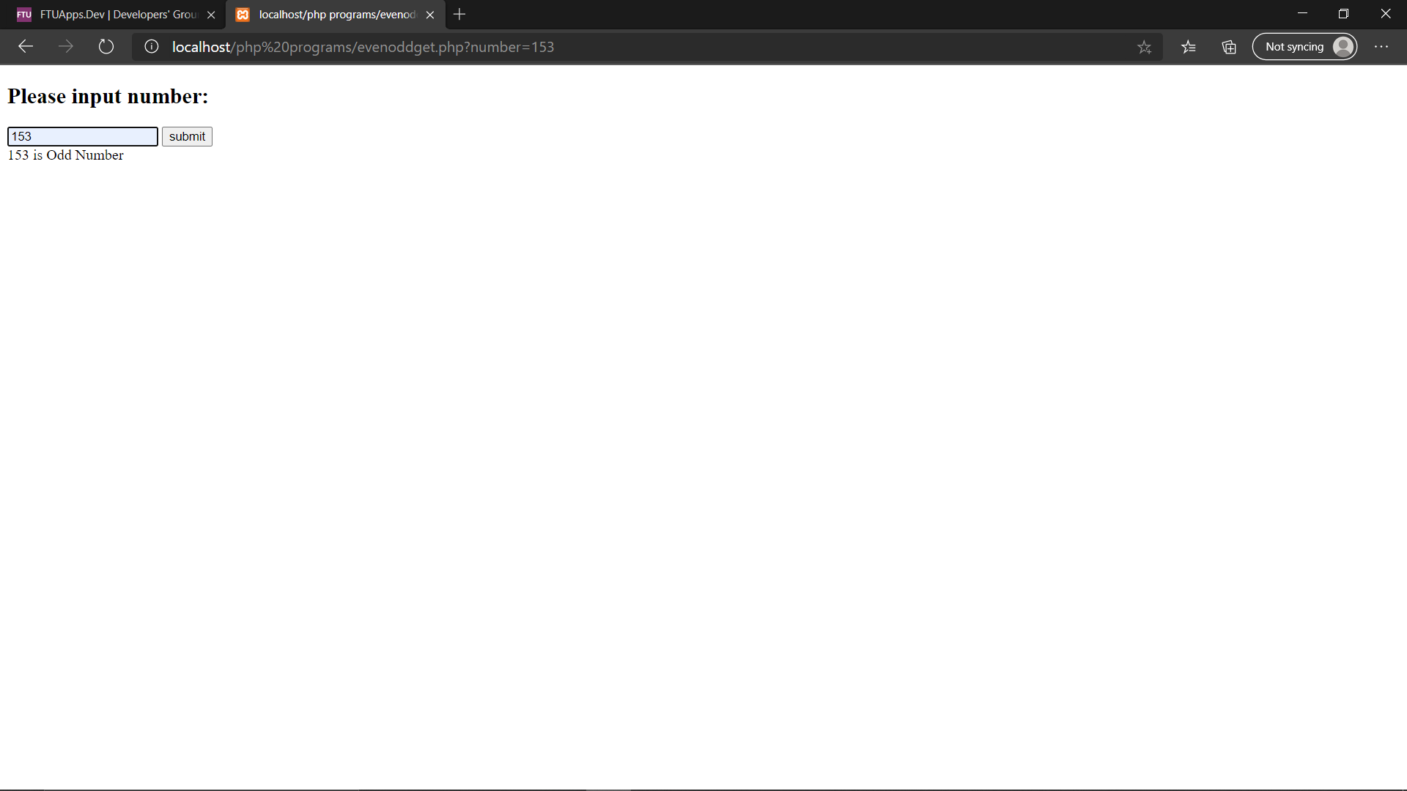

Q15 write a php program to find the sum of digit enter by user using form tag

Code :-

<!DOCTYPE html>

<html>

<head>

<tilte></tilte>

</head>

<body>

<form method='POST'>

<h2>Please input number:</h2>

<input type="text" name="number">

<input type="submit" value="submit">

</form>

</body>

</html>

<?php

$sum=0;

$rem=0;

if($_POST)

{

$num=$_POST['number'];

$num2=$num;

for($i=0;$i<=strlen($num);$i++)

{

$rem=$num%10;

$sum=$sum+$rem;

$num=$num/10;

}

}

echo "sum of digits $num2 is $sum";

?>

Output:-

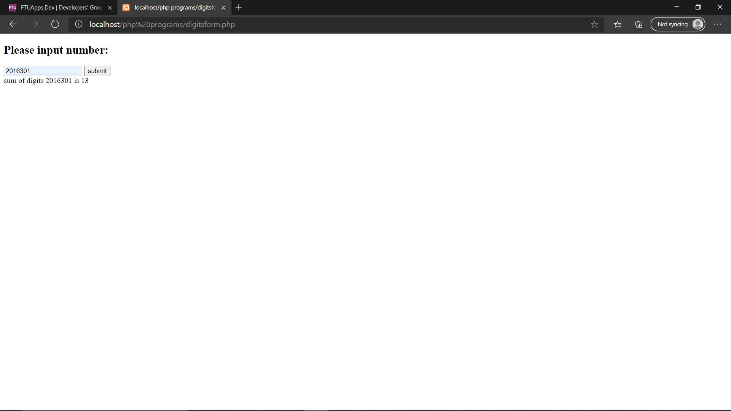

Q16 write a php program to print welcome and the name enter by the user using form tag

Code :-

<!DOCTYPE html>

<html>

<head>

<tilte></tilte>

</head>

<body>

<form method='POST'>

<h2>Please input your name:</h2>

<input type="text" name="name">

<input type="submit" value="submit">

</form>

</body>

</html>

<?php

$sum=0;

$rem=0;

if($_POST)

{

$name=$_POST['name'];

echo "Welcome $name";

}

?>

Output:-

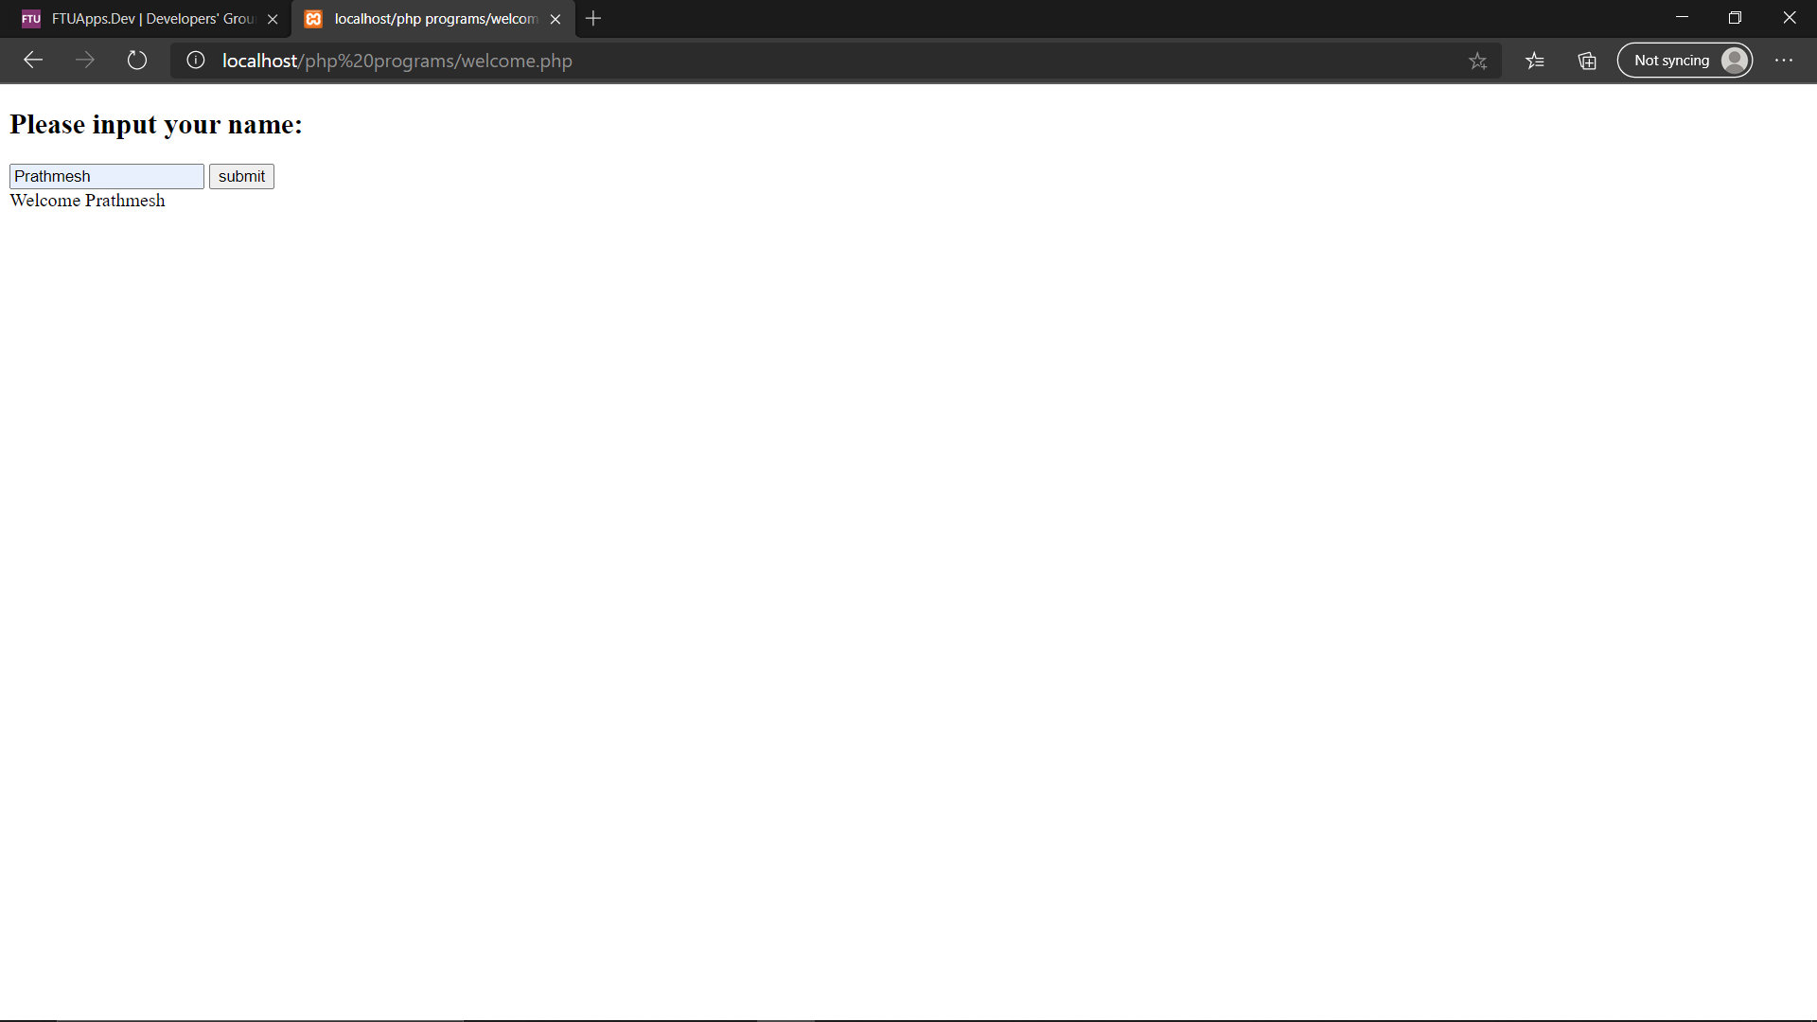

Q17 write a simple php program to show GET and POST.

GET:-

Code :-

<html>

<body>

<form action="gettest.php" method="GET">

Username:<input type="text" name = "username" />

<br>

Blood Group:<input type="text" name="bloodgroup"/><br>

<input type ="submit" />

</form>

</body>

<html>

Output:-

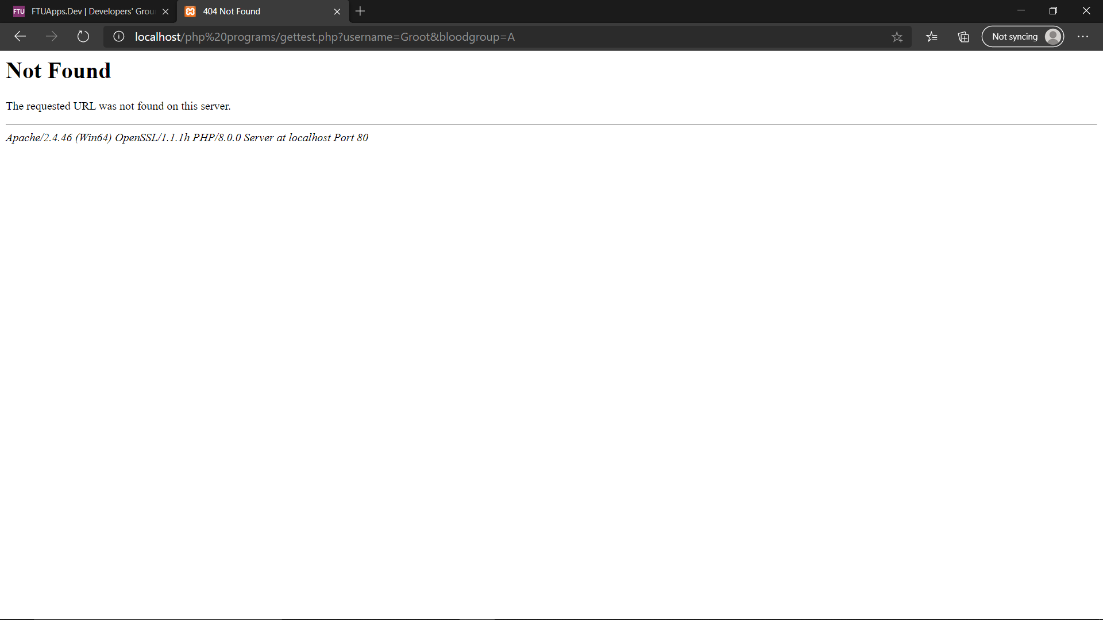

POST:-

Code:-

<html>

<body>

<form action="posttest.php" method="POST">

Username:<input type="text" name = "username" />

<br>

Blood Group:<input type="text" name="bloodgroup"/><br>

<input type ="submit" />

</form>

</body>

<html>

Output:-

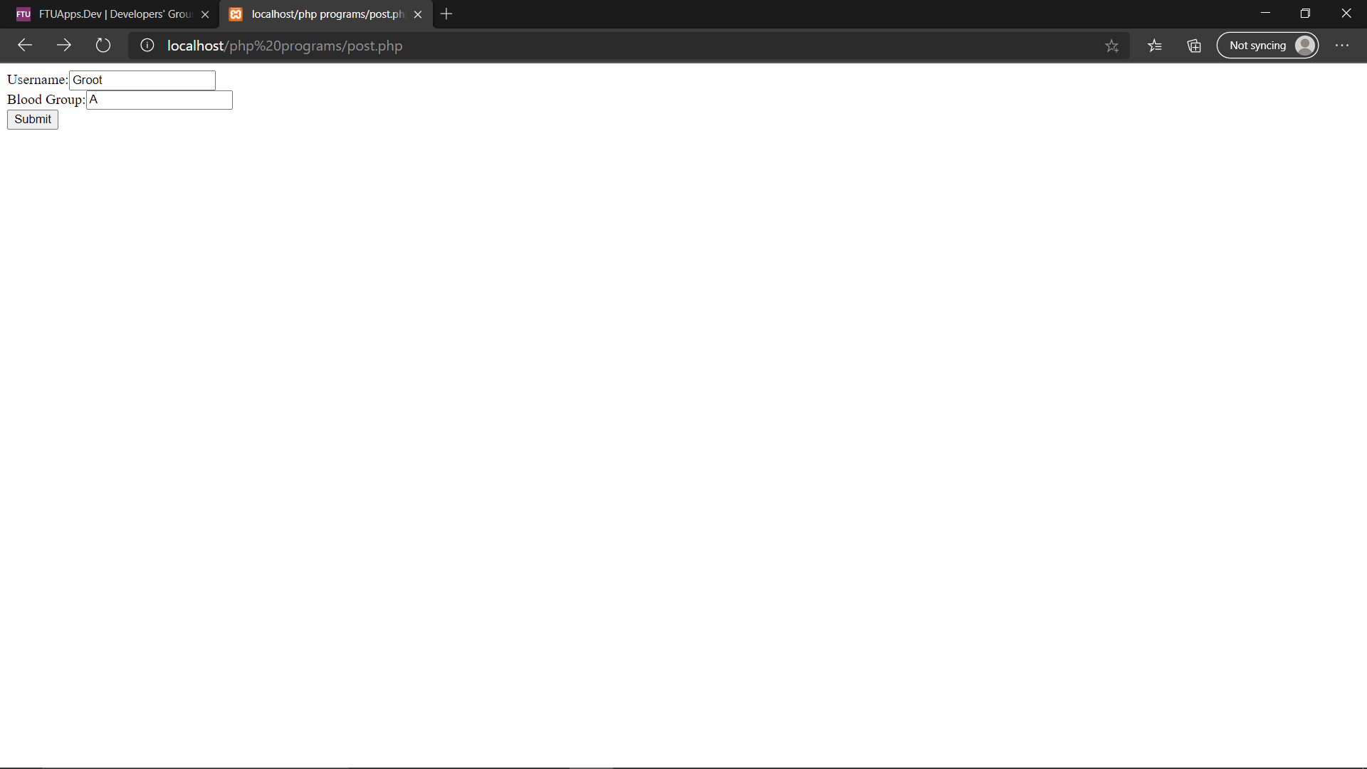

**25-01-2021**

**Experiment 3:-**

Q18 Write a PHP program to check the given year is a leap year or not.

Code:-

<head>

<title></title>

</head>

<body>

<form method="POST";

<h4><b>Enter the year:</b></h4>

<input type="number" name="year" id="year" placeholder="year">

<br/><br/>

<input type="submit" name="submit">

</form>

<h4><b>Result:</b></h4>

<br>

</body>

</html>

<?php

$year =$_POST['age'];

if(($year % 400 == 0) || (($year % 100 !=0) && ($year % 4 == 0)))

{

echo "$year is a leap year";

}

else{

echo "$year is not a leap year";

}

?>

Output:-

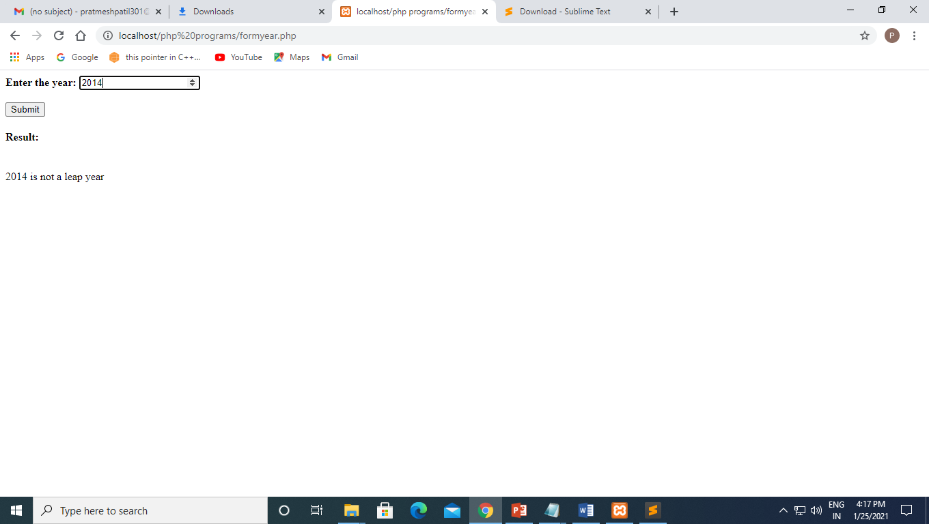

Q19) Write a PHP program to find addition of two number using form and isset

Code:-

<html>

<head>

</head>

<body>

<form method="post";

<h4><b>Enter the 1st value</b></h4>

<input type="text" name="one" id="one" placeholder="1st digit">

<br>

<h4><b>Enter the 2nd value</b></h4>

<input type="text" name="two" id="two" placeholder="2nd Digit">

<br/><br/>

<input type="submit" name="submit">

</form>

<h4><b>Result:</b></h4>

<br>

</body>

</html>

<?php

if(isset($_POST['submit'])){

$sum=0;

$one=$_POST['one'];

$two=$_POST['two'];

$sum=$one+$two;

echo "sum is".$sum;

exit;

}?>

Output:-

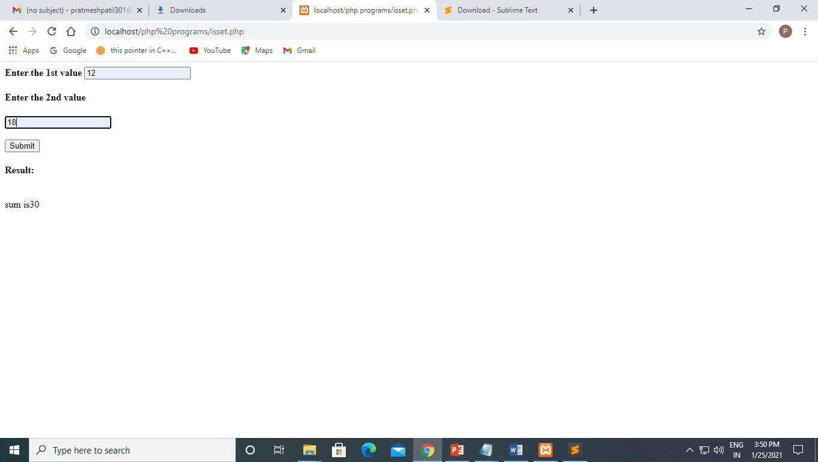

Q20) Write a PHP program on Print_r() the information about some variables in a more human-readable way.

Code:-

<?php

$x = array("k" => "Car", "l" => "Bike");

$y = array("a" => "Train", "b" => "Plane");

var_dump($x + $y);

var_dump($x == $y) + "\n";

var_dump($x != $y) + "\n";

var_dump($x <> $y) + "\n";

var_dump($x === $y) + "\n";

var_dump($x !== $y) + "\n";

?>

Output:-

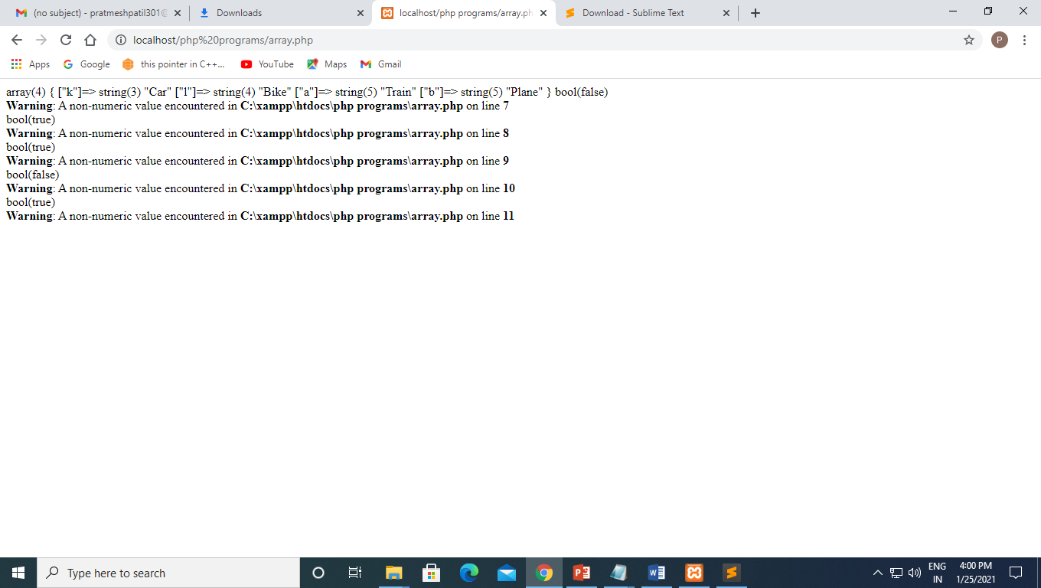

Q21) Write a program in PHP check age < 18 print not eligible for voting using form tag and using if statement.

Code:-

<html>

<head>

</head>

<body>

<form method="POST";

<h4><b>Enter your age:-</b></h4>

<input type="text" name="age" id="age" placeholder="Your age">

<br>

<br/>

<input type="submit" name="submit">

</form>

<h4><b>Result:</b></h4>

<br>

</body>

</html>

<?php

$age =$_POST['age'];

if($age >=18){

echo "$age is eligible for voting";

}

else{

echo "$age is not eligible for voting";

}

?>

Output:-

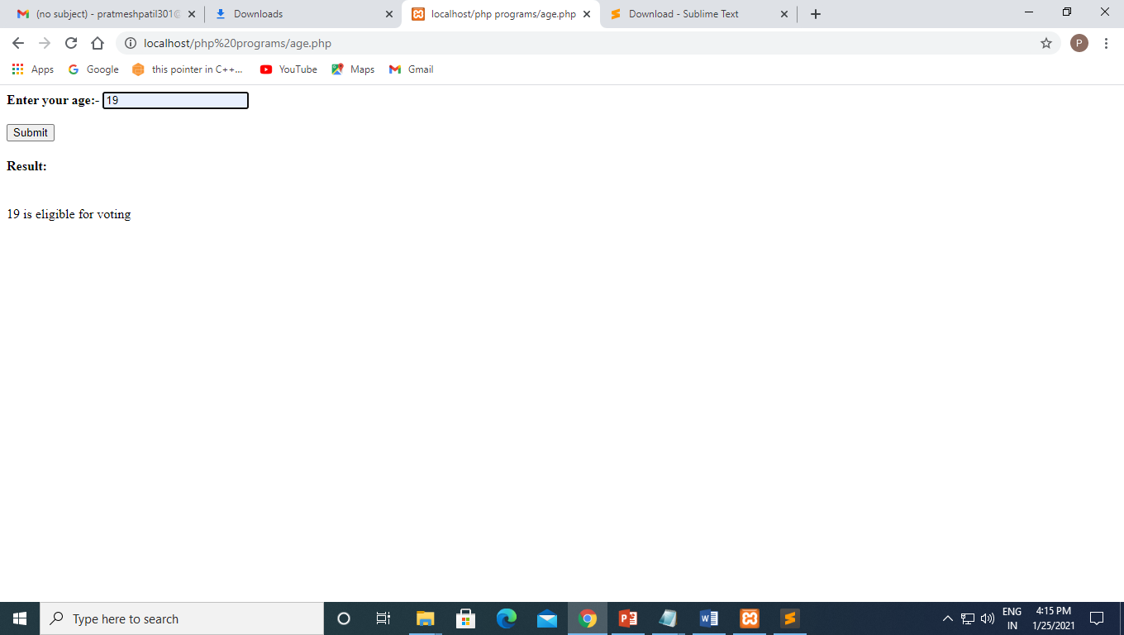

Q22) Write a program to find student grade using if else if statement with form tag

Code:-

<html>

<head>

</head>

<body>

<form method="POST";

<h4><b>Enter the student marks:-</b></h4>

<input type="number" name="marks" id="marks" placeholder="marks">

<br>

<br/>

<input type="submit" name="submit">

</form>

<h4><b>Result:</b></h4>

<br>

</body>

</html>

<?php

$grade=$_POST['marks'];

if ($grade>80 && $grade<=100) {

echo "Grade A+";

}

elseif ($grade>60 && $grade<=80) {

echo "Grade B+";

}

elseif ($grade>50 && $grade<=60) {

echo "Grade C";

}

elseif ($grade>35 && $grade<=50) {

echo "Grade D";

}

else{

echo "Grade F";

}

Output:-

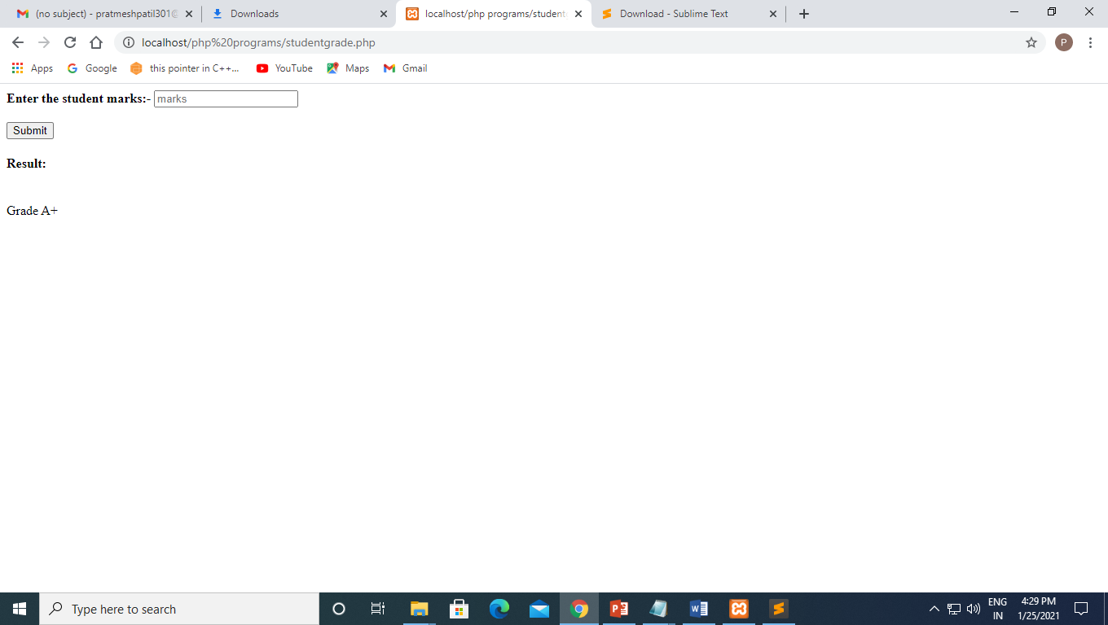

Q23) Write a program to implement Calculator using form and switch case

Code:-

<html>

<head>

</head>

<body>

<form method="POST";

<h4><b>Enter the 1st number:-</b></h4>

<input type="text" name="x" id="x" placeholder="1st number">

<br>

<h4><b>Enter the 2nd number:-</b></h4>

<input type="text" name="y" id="y" placeholder="2nd number">

<h4><b>Enter the operator:-</b></h4>

<input type="text" name="z" id="z" placeholder="operator">

<br/><br/>

<input type="submit" name="submit">

</form>

<h4><b>Result:</b></h4>

<br>

</body>

</html>

<?php

$x=$_POST['x'];

$y=$_POST['y'];

$z=$_POST['z'];

switch ($z) {

case '+':

$z=$x+$y;

echo "Addition of two number is:-$z";

break;

case '-':

$z=$x-$y;

echo "subtraction of two number is:-$z";

break;

case '*':

$z=$x*$y;

echo "Multiplication of two number is:-$z";

break;

case '/':

$z=$x/$y;

echo "Division of two number is:-$z";

break;

case '%':

$z=$x%$y;

echo "Modulus of two number is:-$z";

break;

case '**':

$z=$x**$y;

echo "Exponential of two number is:-$z";

break;

default:

echo "invalid operator";

break;

}

Output:-

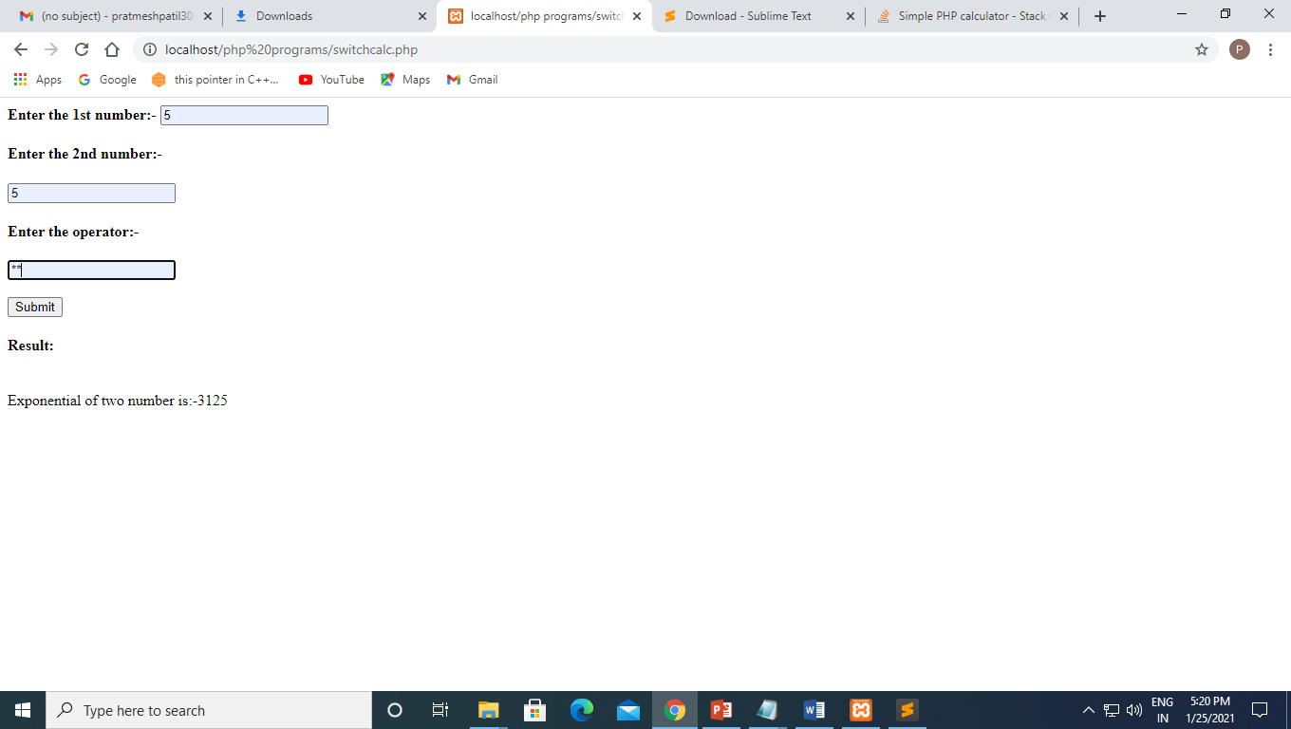

Q24) Write a PHP program to Print multiplication table of entered numbers

Code:-

<html>

<head>

</head>

<body>

<form method="POST";

<h4><b>Enter the number for it's multiplication table:-</b></h4>

<input type="number" name="x" id="x" placeholder="1st number">

<br>

<h4><b>Enter the range:-</b></h4>

<input type="number" name="y" id="y" placeholder="2nd number">

<br/><br/>

<input type="submit" name="submit">

</form>

<h4><b>Result:</b></h4>

<br>

</body>

</html>

<?php

$x = $_POST['x'];

$r = $_POST['y'];

for ($i = 1; $i <= $r; $i++) {

echo $x, " * ", $i, " = ", $x * $i,"\n","\n";

}

?>

Output:-

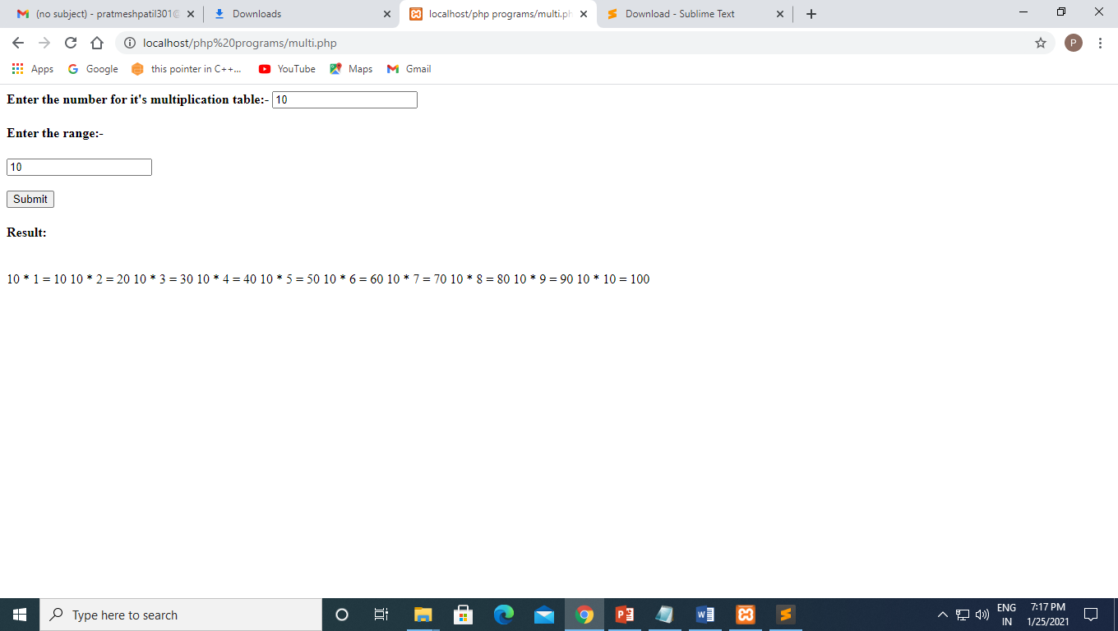

Q25) Write a program in PHP on foreach loop iterate on arrays

1)

Code:-

<?php

$season=array("summer","winter","rainy");

foreach($season as $value)

{

echo $value,"<br>";

}

?>

Output:-

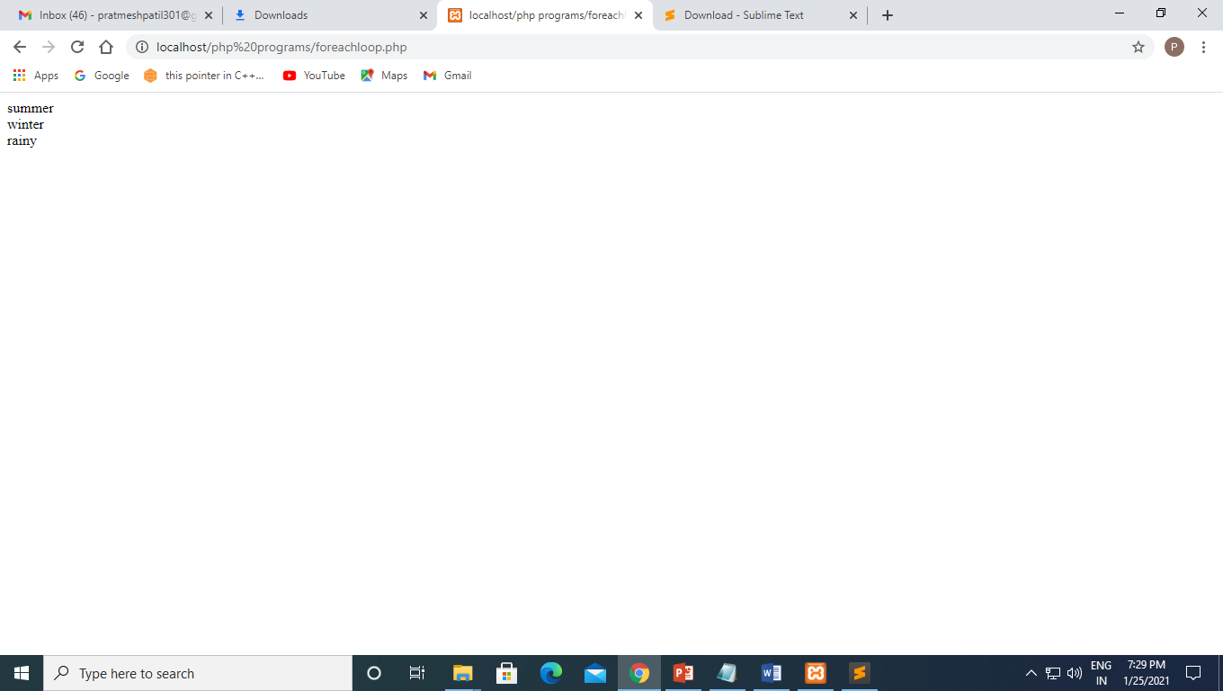

2)

Code:-

<?php

$Array=array("summer","winter","rainy");

print_r($Array);

foreach($Array as $k=> $val)

{

if ($val == winter) {

unset($Array[$k]);

}

}

print_r($Array);

?>

Output:-

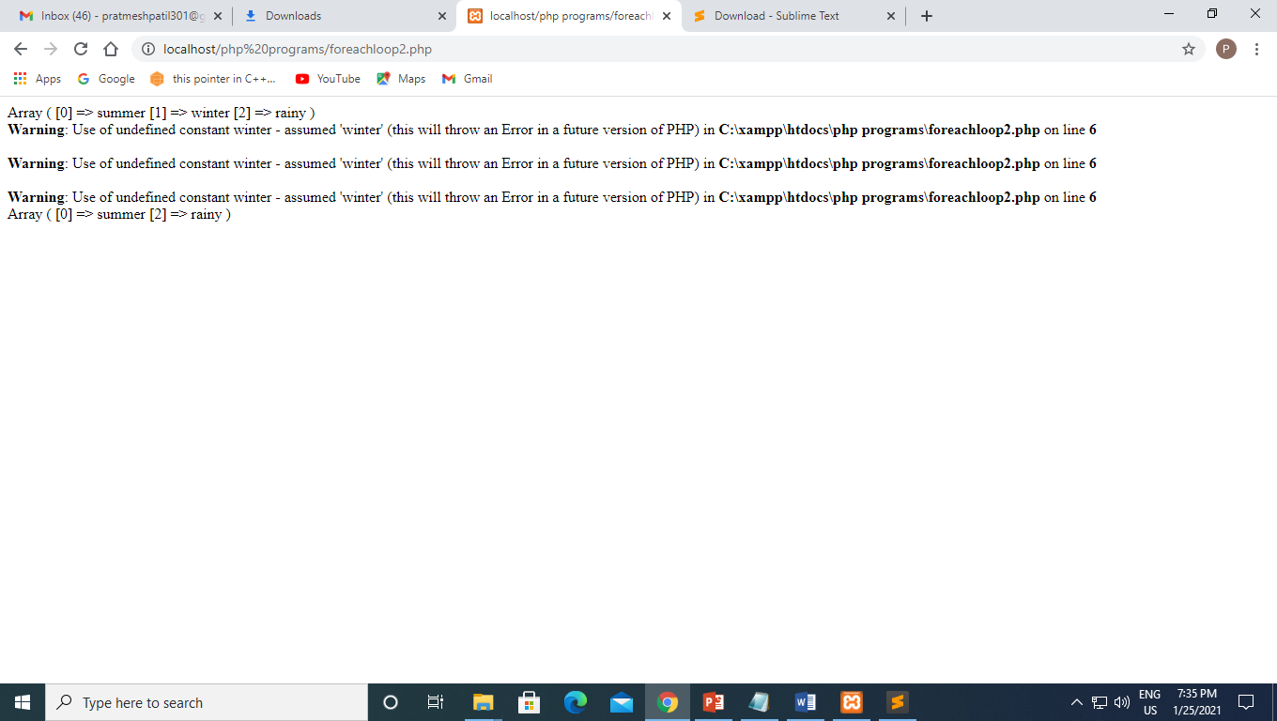

3)

Code:-

<?php

$superhero = array(

"name" =>"GROOOT",

"email" => "groot@gmail.com",

"age" => "19"

);

foreach ($superhero as $key => $value) {

echo $key . ":" . $value . "<br>";

}

?>

Output:-

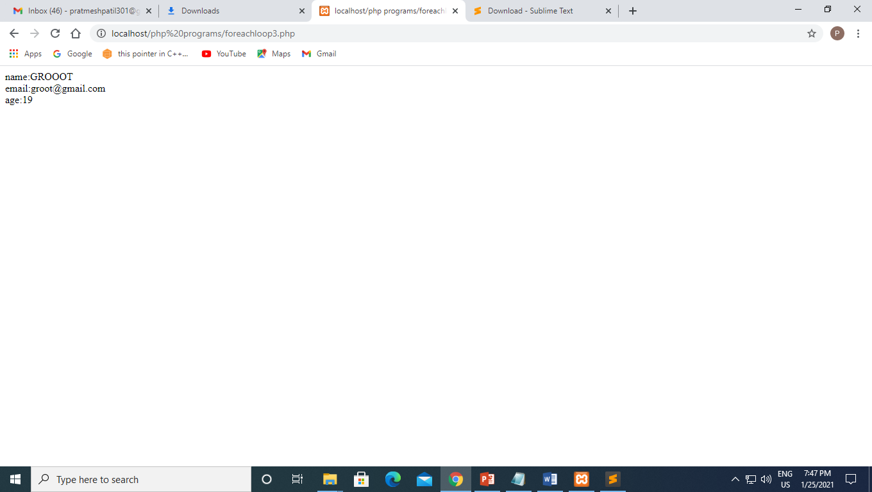

Q26) Write a PHP Program to print the numbers in reverse order-reverse.php

Code:-

<?php

$number=123;

$orignal_num=$number;

$rs=0;

while($number>0)

{

$rs = $rs * 10 + $number % 10;

$number = (int)($number / 10);

}

print_r("Result:$orignal_num<br>Revrse of Number is= $rs");

?>

Output:-

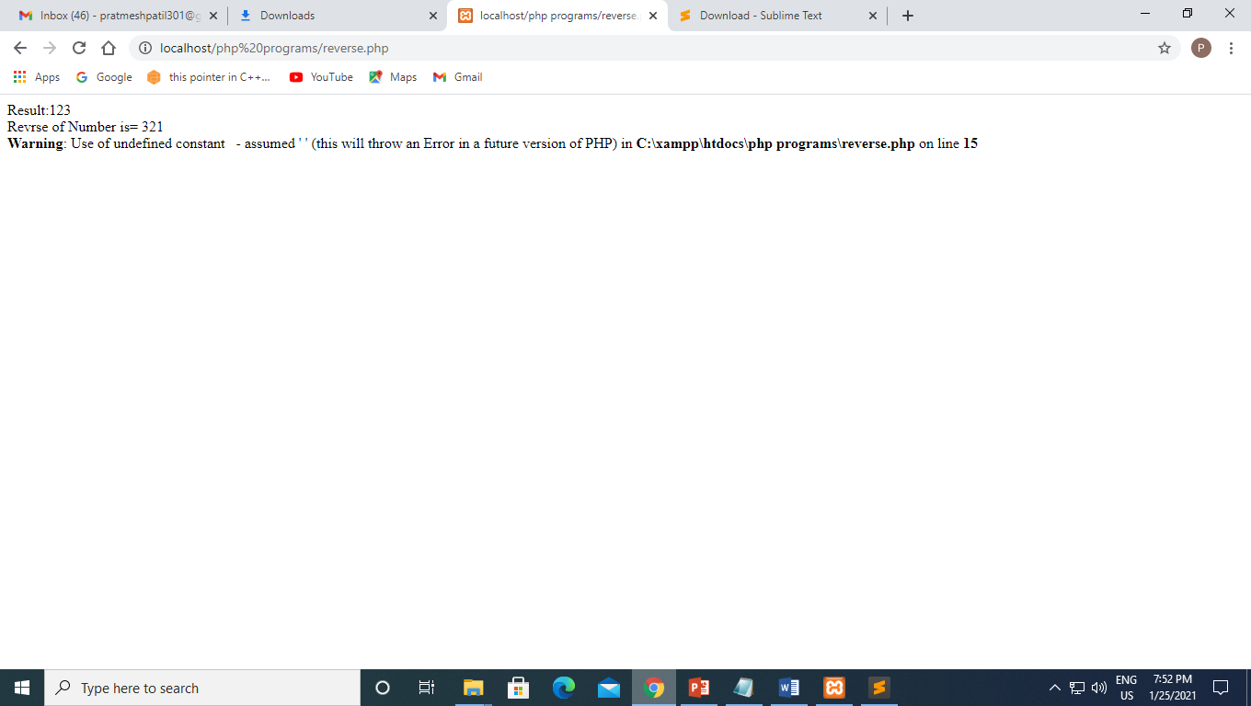

**1-02-2021**

**Experiment no :- 4**

**Q27 Write a php program to showcase time and date**

**Code:-**

<?php

date_default_timezone_set("Asia/Kolkata");

$target=mktime(12,0,0,12,25,2020);

$today=time();

$difference = ($target-$today);

echo "today is".date("d/m/y ---- l")."<br>";

echo "Time is".date("h:i:sa");

$hour = (int) ($difference/3600);

$t=date("d-m",$target);

print"<br> our event will occur on".$t."<br> Time left is $hour hours";

$tout =mktime(0,0,0,02,25,2020);

?>

**Output:-**

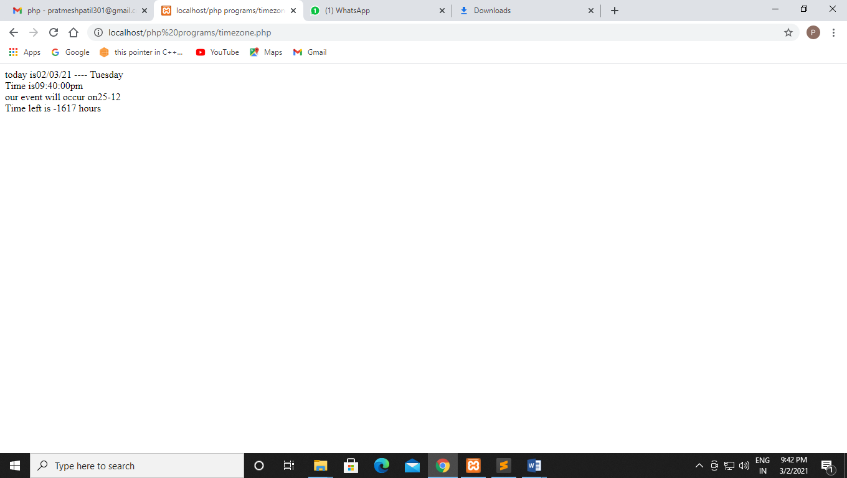

**Q28 Write a php program to swap 2 number enter by user**

**Code:-**

<html>

<head>

</head>

<form method="post">

<h4><b>Enter 1st value</b></h4>

<input type="text" name="one" id="a" placeholder="1st Digit">

<br>

<h4><b>Enter 2nd Value </b></h4>

<input type="text" name="two" id="b" placeholder="2nd Digit">

<br>

<br>

<input type="submit" name="submit">

</form>

<?php

$a=$_POST['one'];

$b=$_POST['two'];

$third=$a;

$a=$b;

$b=$third;

echo "After swapping <br>";

echo "a=".$a."b=".$b;

?>

**Output:-**

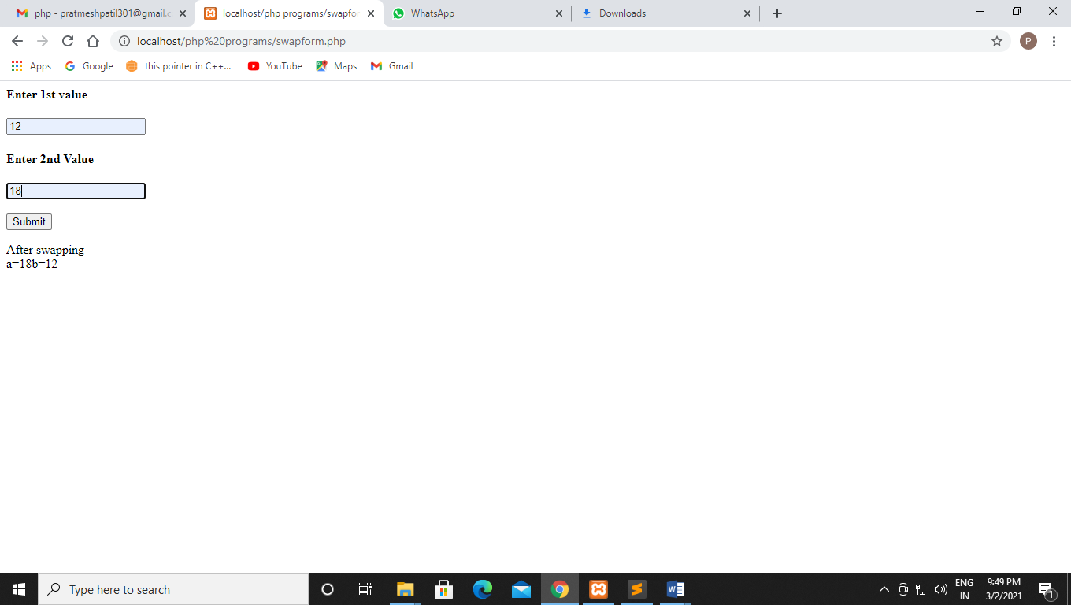

**Q29 Write a php program to print the element of array using print_r**.

**Code:-**

<?php

$arr = array("green","blue","pink","white");

print_r($arr);

?>

**Output:-**

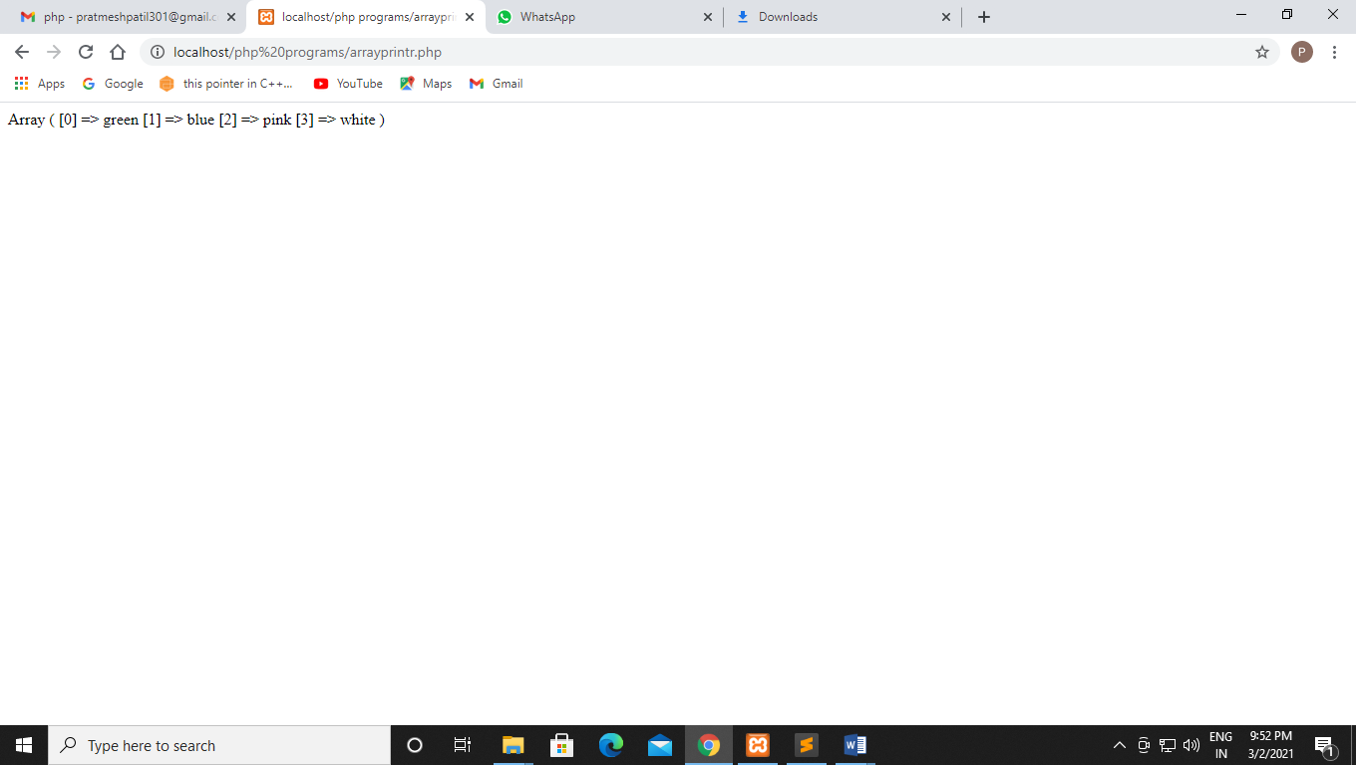

**Q30 Write a php program to showcase for loop**

**Code:-**

<!Doctype html>

<html lang="en">

<head>

<tile> php for loop </tilte>

</head>

<br>

<?php

$season = array("summer","rainy","winter");

foreach($season as $value)

{

echo $value. "<br>";

}

?>

</body>

</html>

**Output:-**

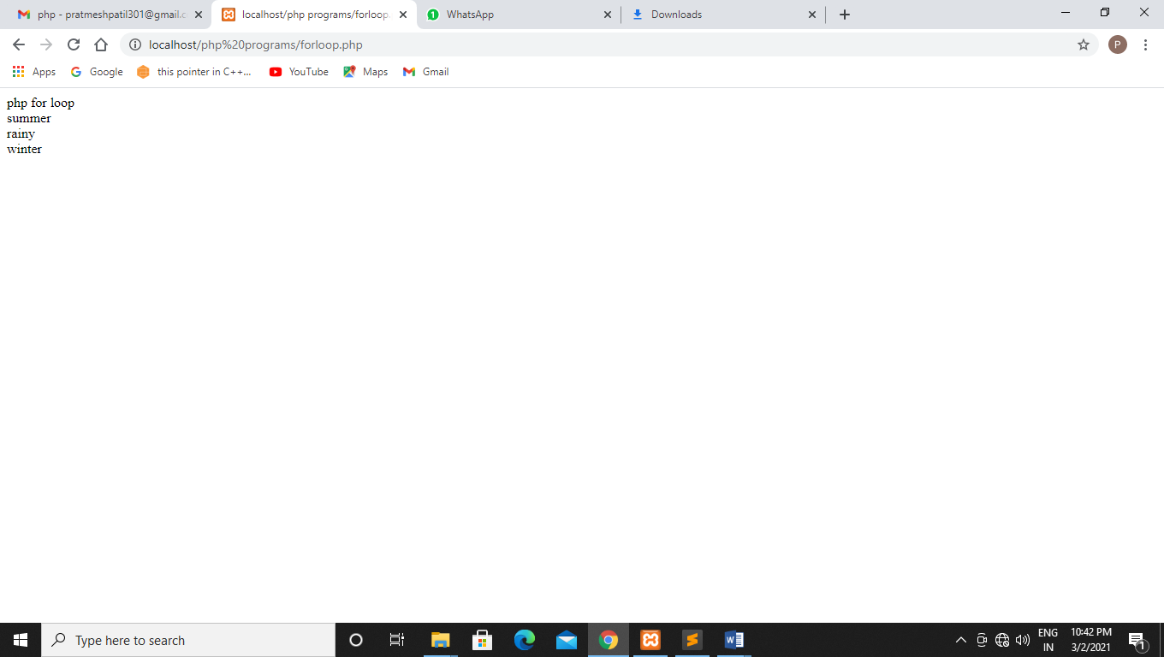

**Q31 Write a php program to use unset function on array element.**

**Code:-**

<html lang="en">

<head>

<tile> php for loop </tilte>

</head>

<?php

$Array = array("summer","rainy","winter");

print_r($Array);

foreach($Array as $k => $val)

{

if($val == "winter")

{

unset($Array[$k]);

}

}

echo "<br>";

print_r($Array);

?>

</body>

</html>

**Output:-**

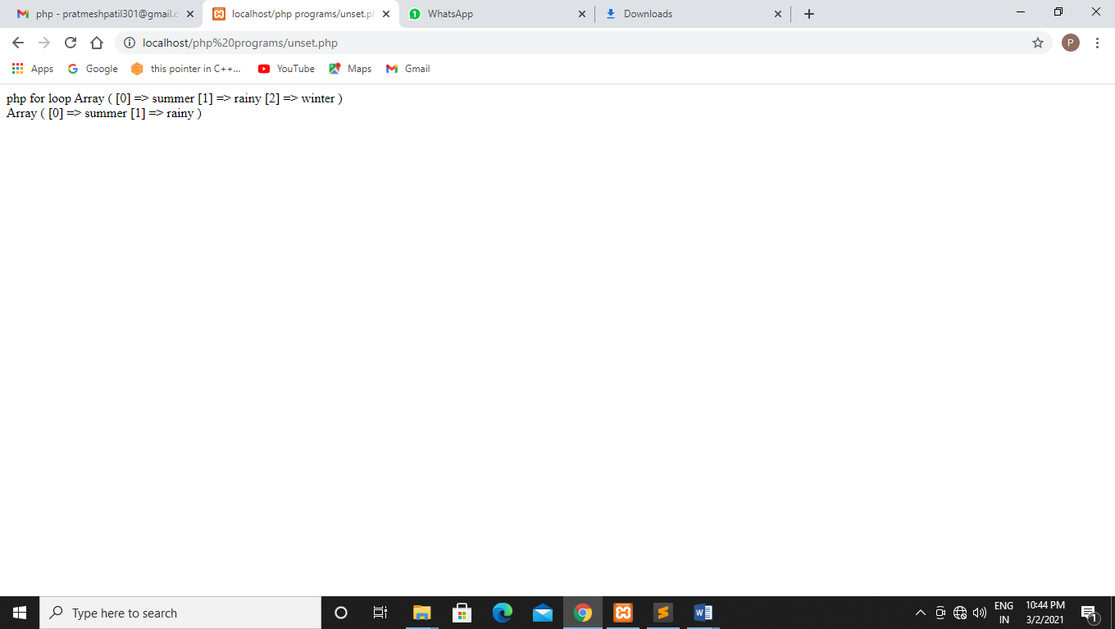

**Q32 Write a php program to showcase use of var_dump on array**

**Code:-**

<!Doctype html>

<html lang="en">

<head>

<tilte>PHP foreach loop<tilte>

</head>

<body>

<?php

$superhero = array(

"name" => "Peter Parker",

"email" => "peterparker@mail.com",

"age" => 18

);

foreach($superhero as $key => $value)

{

echo $key . " : " .$value ."<br>";

}

print_r($superhero);

echo "<br>";

var_dump($superhero);

?>

</body>

</html>

**Output:-**

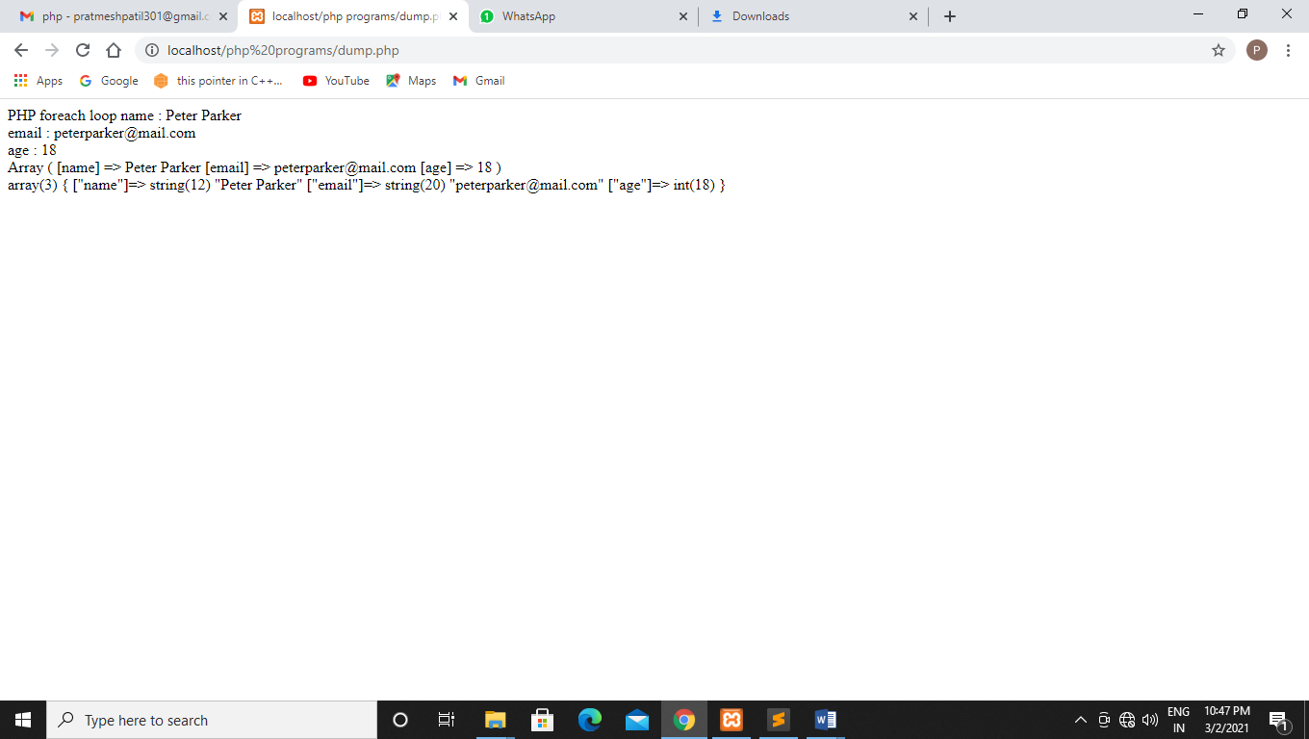

**Q33 Write a php program to call a function on a button click.**

**Code:-**

<html>

<head>

<tilte>

how to call php function on the click of a button?

</tilte>

</head>

<h4> how to call php function on the click of a button ?

</h4>

<?php

if(array_key_exists('button1',$_POST))

{

button1();

}

else if(array_key_exists('button2',$_POST))

{

button2();

}

function button1()

{

echo "This is button1 that is selected";

}

function button2()

{

echo "This is button2 that is selected";

}

?>

<form method="post">

<input type="submit" name="button1" class="button" value="button1" />

<input type="submit" name="button2" class="button" value="button2" />

</form>

</head>

</html>

**Output:-**

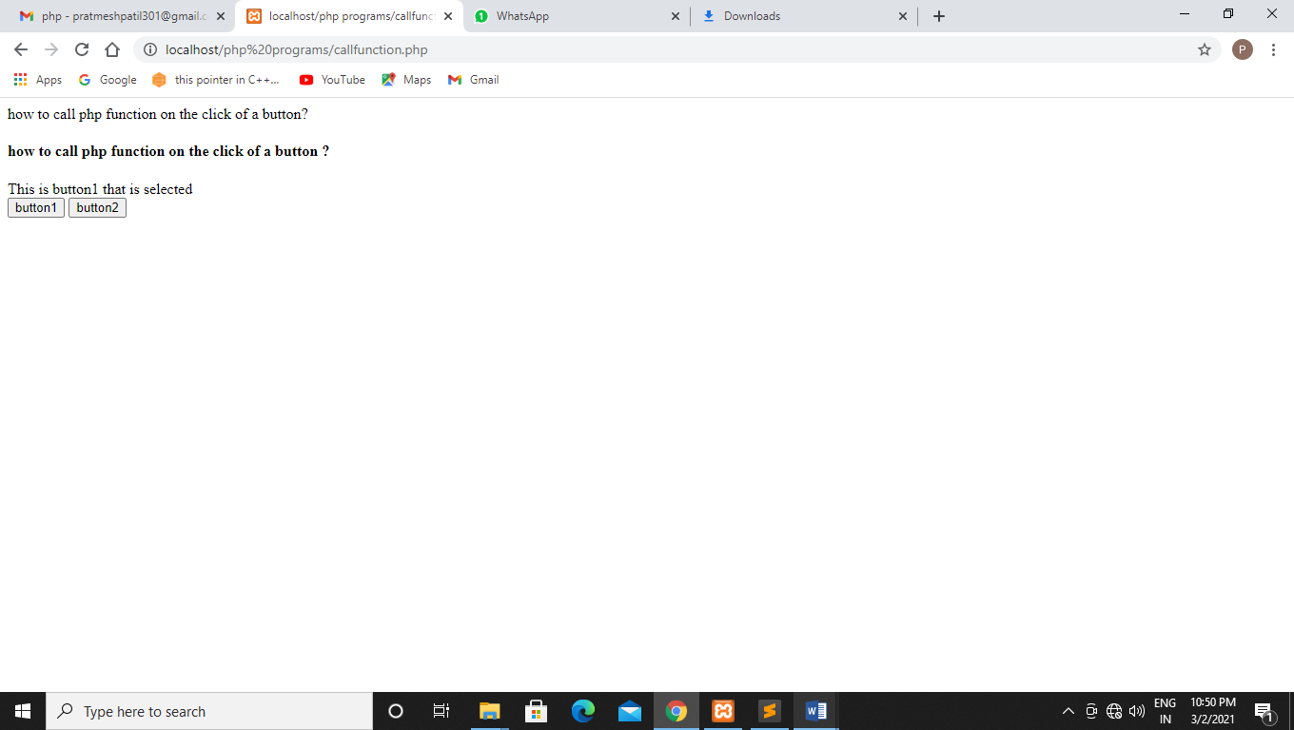

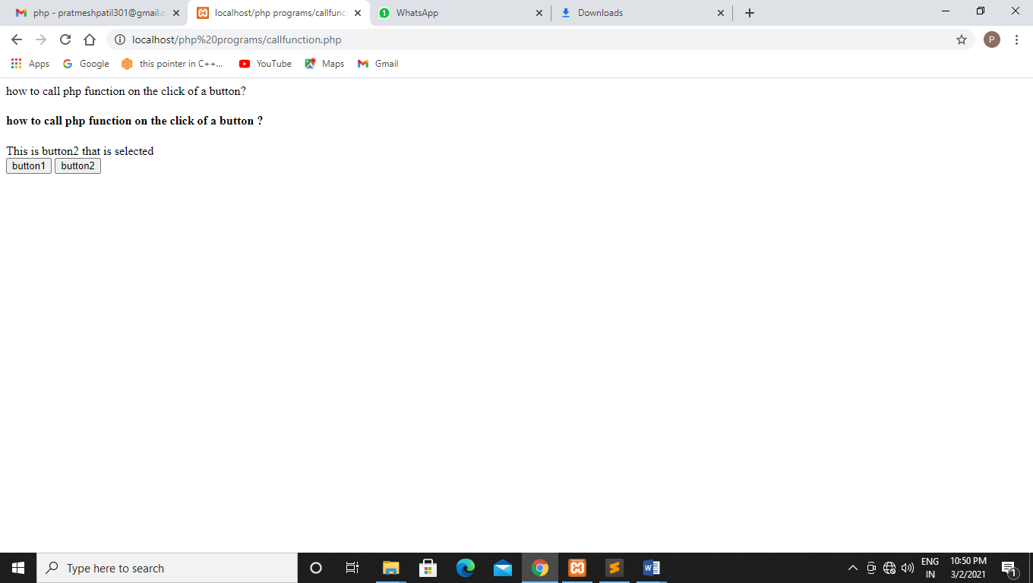

**Q34 Write a php program to take 2 variable from user than print the sum.**

**Code:-**

<html>

<head>

</head>

<form method="post">

<h4><b>Enter 1st value</b></h4>

<input type="text" name="one" id="one" placeholder="1st Digit">

<br>

<h4><b>Enter 2nd Value </b></h4>

<input type="text" name="two" id="two" placeholder="2nd Digit">

<br>

<br>

<input type="submit" name="submit">

</form>

<h4><b>Result:</b></h4>

<br>

<?php

function add()

{

if((isset($_POST['submit'])))

{

$sum=0;

$one=$_POST['one'];

$two=$_POST['two'];

$sum=$one+$two;

echo "sum is $sum";

exit;

}

}

add();

?>

</body>

</html>

**Output:-**

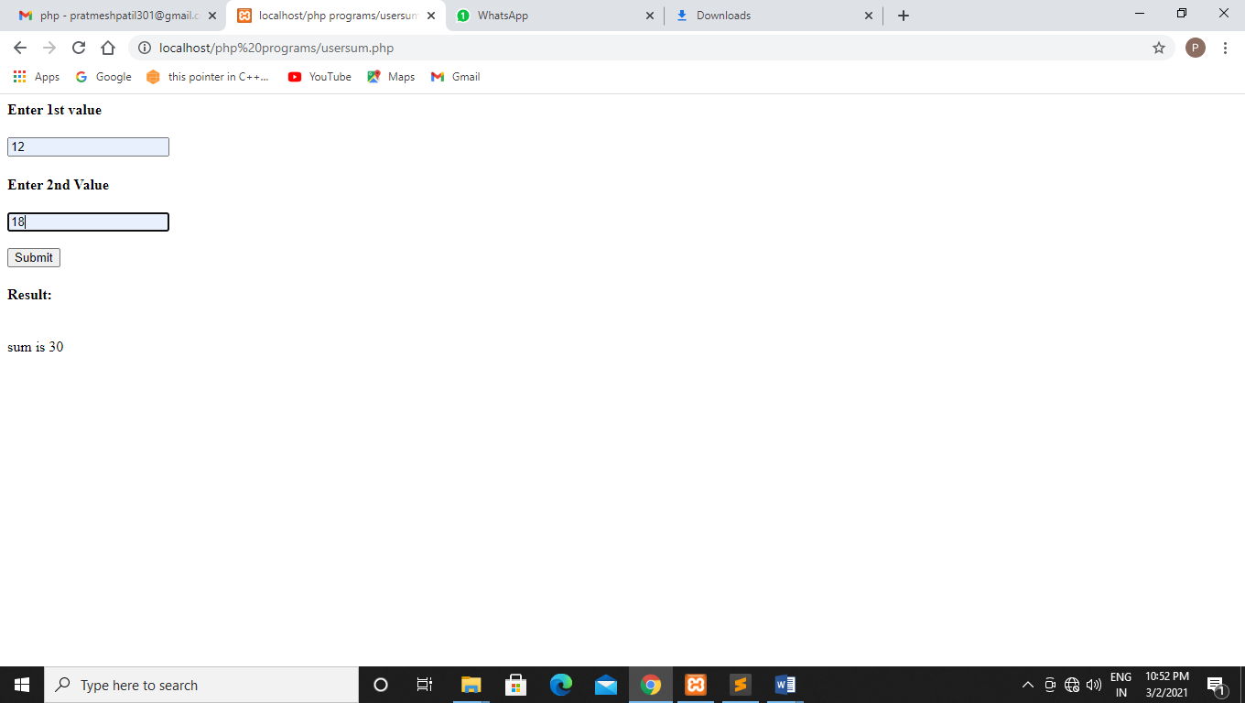

**Q35 Write a php program to connect user to sql server.**

**Code:-**

**Phpadmin:-**

$Server_Name="localhost";

$DB_Name="bcasem4";

$User_Name="root;

$Pwd='';

$conn=mysqli_connent($Server_Name,$User_Name,$Pwd,$DB_Name);

if(!$conn)

{

die("Failed to connect to Mysql:" . mysqli_error());

}

else

{

echo "Db connected";

}

?>

**Connect:-**

<?php

$Server_Name="localhost";

$DB_Name="prathmesh";

$User_Name="root";

$Pwd="";

$conn=mysqli_connect($Server_Name,$User_Name,$Pwd,$DB_Name);

if(!$conn)

{

die("failed to connect to Mysql:".mysqli_error());

}

else

{

echo "DB connected";

}

?>

**Output:-**

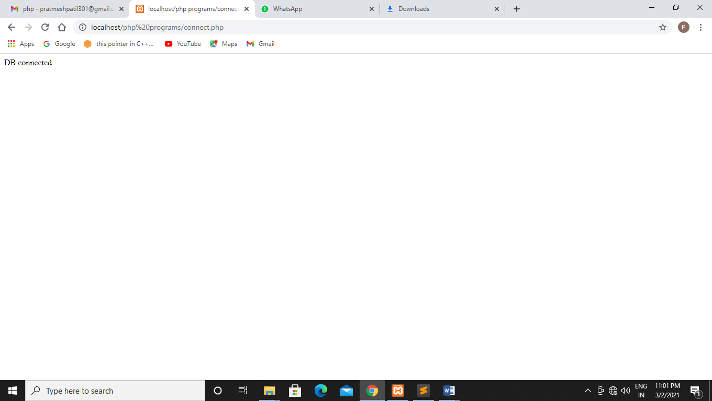

**Experiment no :- 5**

**8-02-2021**

**Q36 Write a PHP Program for Cross site scripting**

**Code:-**

<!DOCTYPE html>

<html>

<head>

<title></title>

</head>

<body>

<form action="crosssite.php" method="POST">

<h1>XSS example</h1>

<label for="urlnp">Enter username</label>

<input type="text" name="usrlnp" id="usrlnp">

<button type="submit" name="sub">Submit</button>

</form>

</body>

</html>

<?php

if (isset($_POST['sub'])) {

$x=$_POST['usrlnp'];

echo "Username is $x";

}

?>

Show XSS (Cross site scripting )injection using an example.

**Output:-**

**1)**

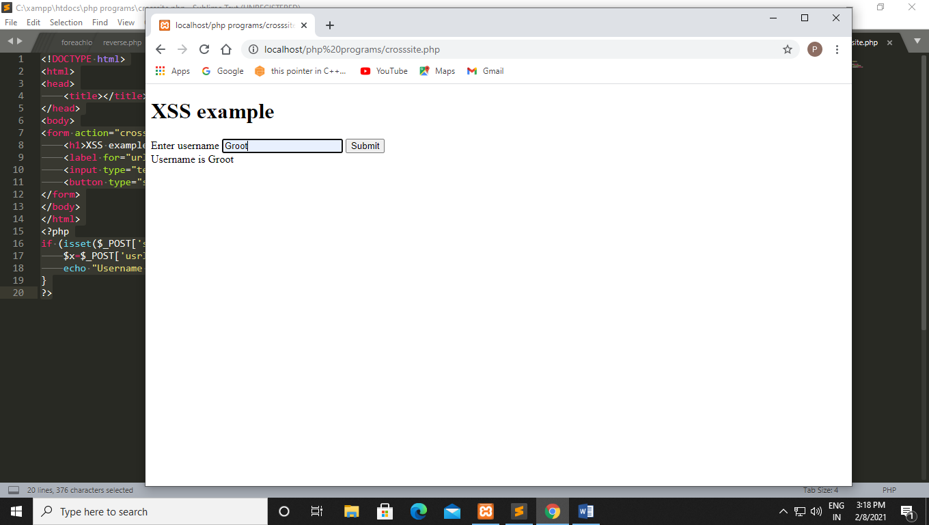

**2)**

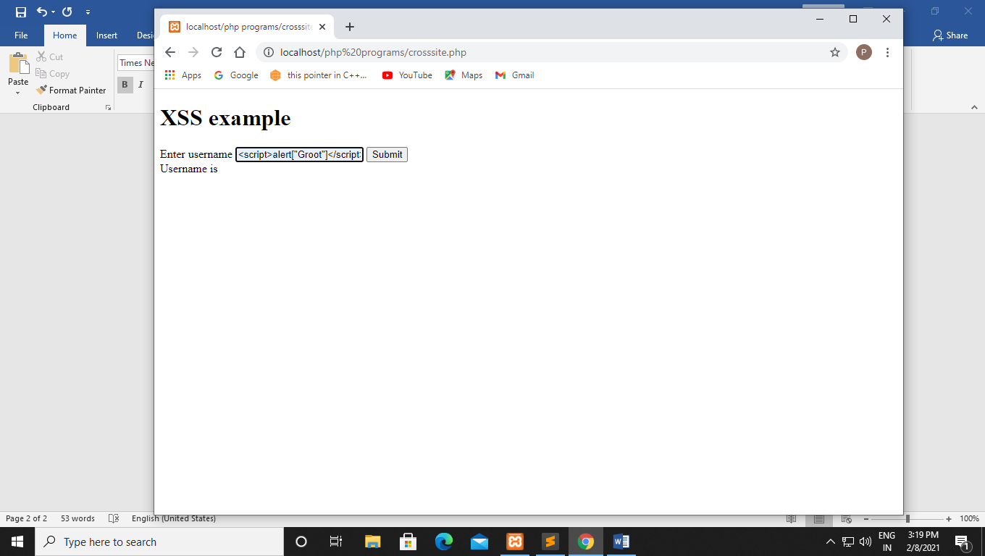

**Q37 Write a PHP program for Strip tags:-**

**Using strip tags the further tags would be strip**

**Code:-**

**Using strip tag:-**

<!DOCTYPE html>

<html>

<head>

<title></title>

</head>

<body>

<?php

echo ("Hello <b> world!</b>");

echo strip_tags("hello <b> world!</b>");

?>

</body>

</html>

**Without strip tag:-**

**Code:-**

<!DOCTYPE html>

<html>

<head>

<title></title>

</head>

<body>

<?php

echo ("Hello <b> world!</b>");

?>

</body>

</html>

**Output:-**

**1)Using strip tag:-**

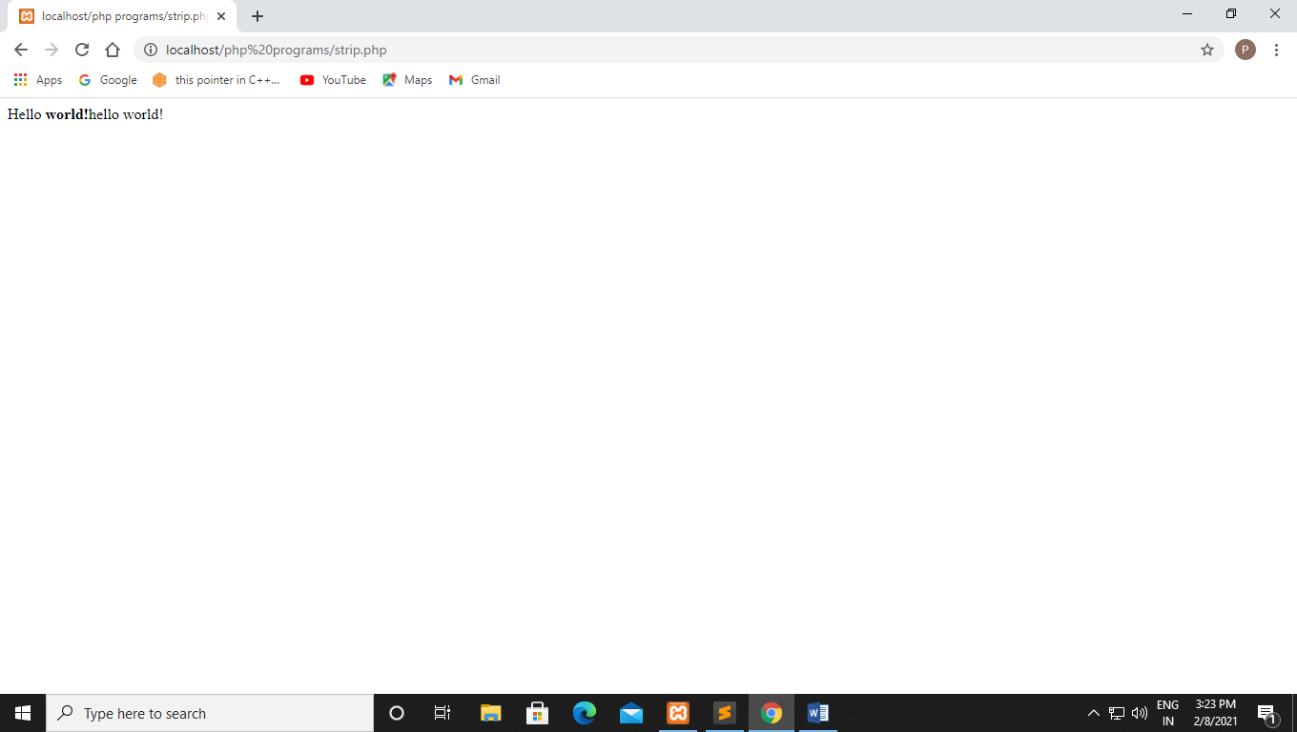

**2)Without strip tag:-**

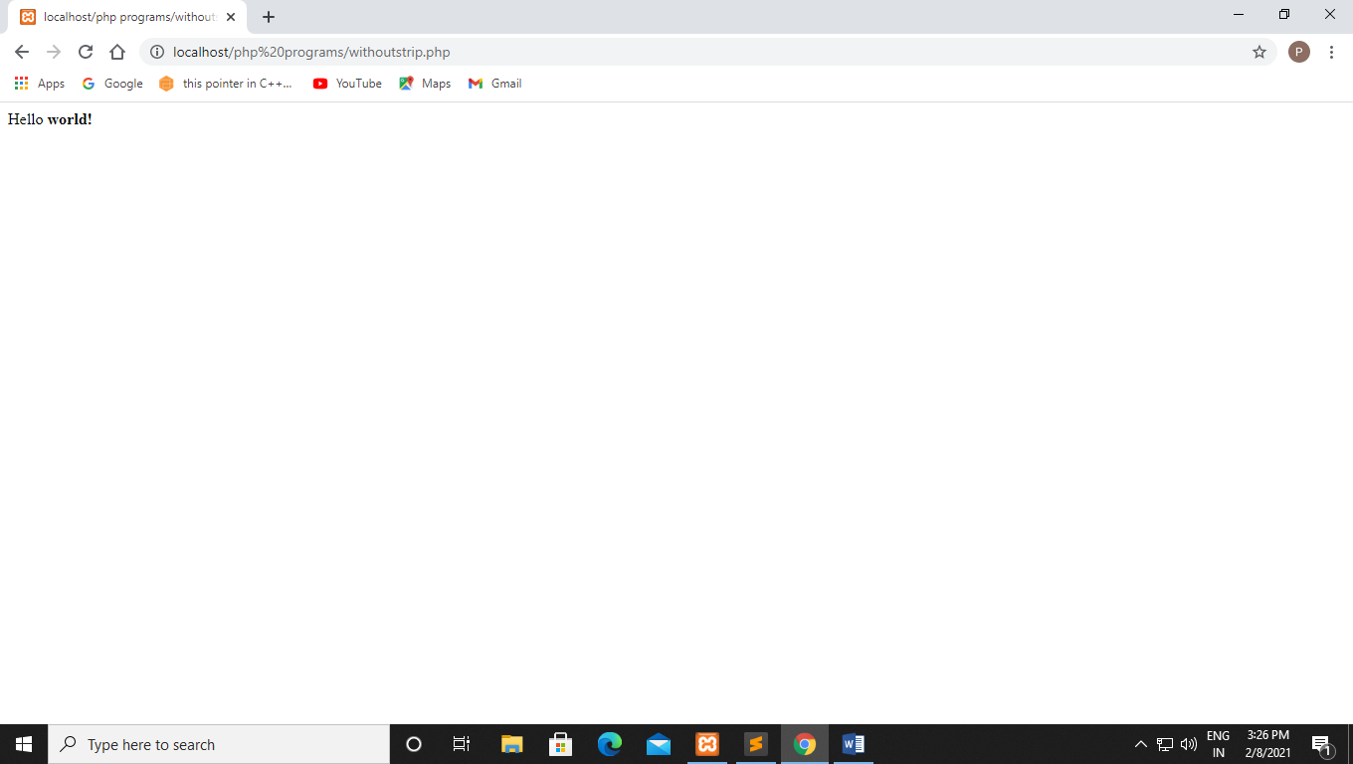

**Q38) Write a PHP code for stripcslaches function.**

**Code:-**

<!DOCTYPE html>

<html>

<head>

<title></title>

</head>

<body>

<?php

echo stripcslashes("hello \World!");

?>

</body>

</html>

**Output:-**

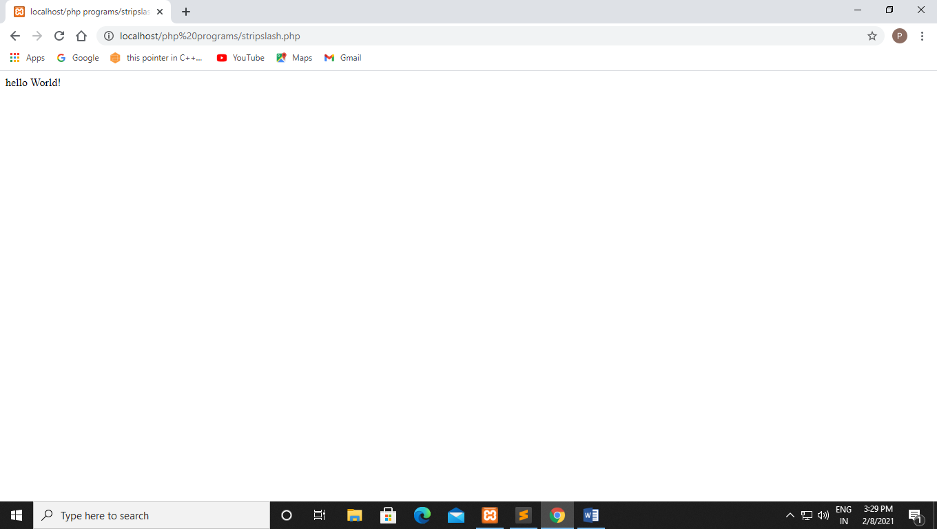

**Q39) Write a php code for trim function**

**Code:-**

<!DOCTYPE html>

<html>

<head>

<title></title>

</head>

<body>

<?php

$str = "hello World!";

echo $str."<br>";

echo trim($str,"hed!");

?>

</body>

</html>

**Output:-**

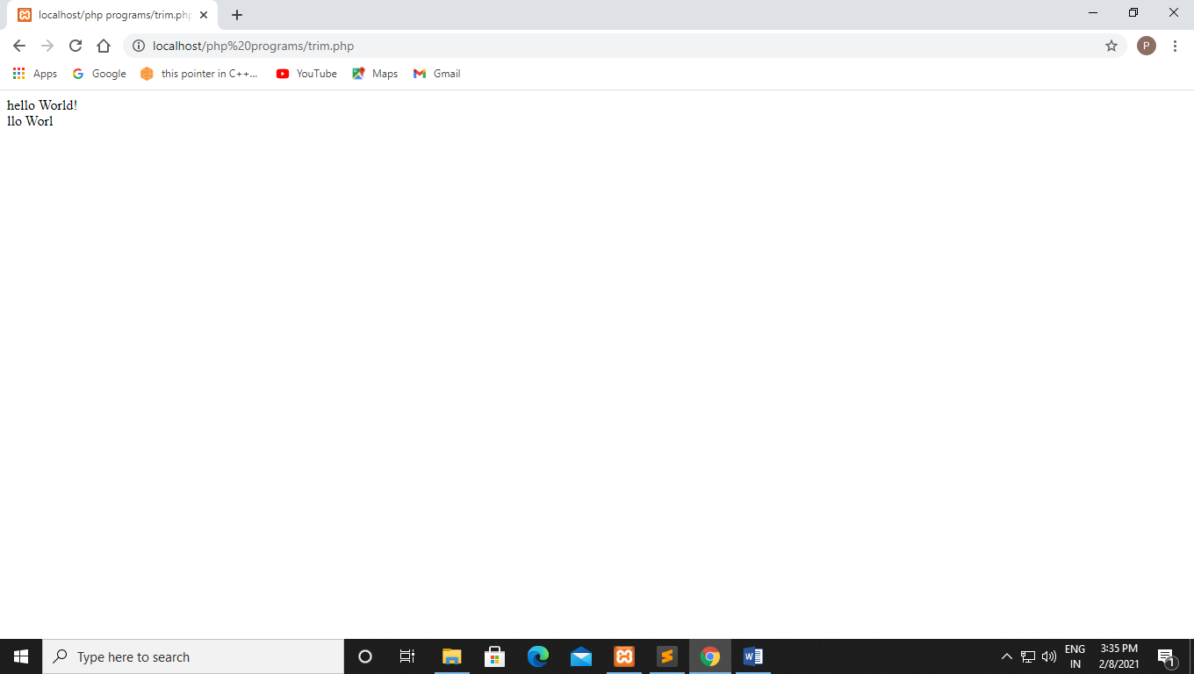

**Q40 Write a PHP program script to secure your inputs trim, stripcslashes and html special chars functions.**

**In order to prevent this attack, we need to use special functions .**

**Code:-**

<!DOCTYPE html>

<html>

<head>

<title></title>

</head>

<body>

<form action="crossprevent.php" method="POST">

<h1>XSS example</h1>

<label for="urlnp">Enter username</label>

<input type="text" name="usrlnp" id="usrlnp">

<button type="submit" name="sub">Submit</button>

</form>

<?php

if (isset($_POST['sub'])) {

$x=$_POST['usrlnp'];

echo "Username is".purifyInput($x);

}

function purifyInput($inp){

$inp=strip_tags($inp);

$inp=stripcslashes($inp);

$inp=htmlspecialchars($inp);

$inp=trim($inp,"\t\n\r");

return $inp;

}

?>

</body>

</html>

**Output:-**

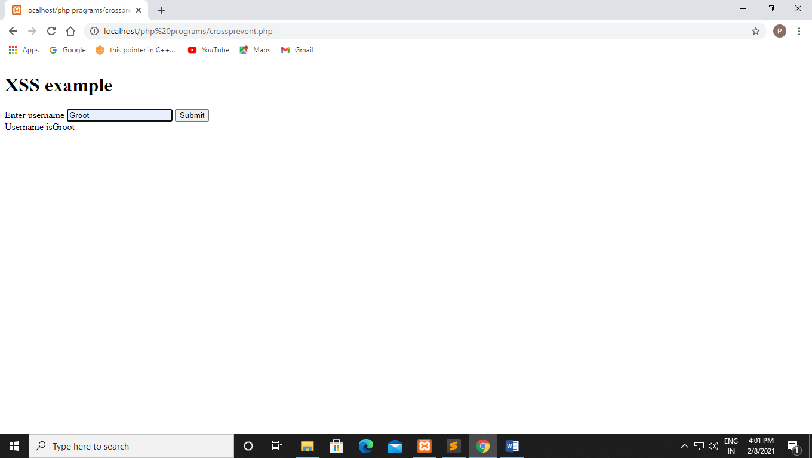

**Q41 Write a PHP program looping through indexed array**

**Code:-**

<!DOCTYPE html>

<html>

<head>

<title></title>

</head>

<body>

<?php

$sub = array("AI", "ML", "Database" );

$arrlength = count($sub);

for($x = 0; $x < $arrlength; $x++) {

echo $sub[$x];

echo "<br>";

}

?>

</body>

</html>

**Output:-**

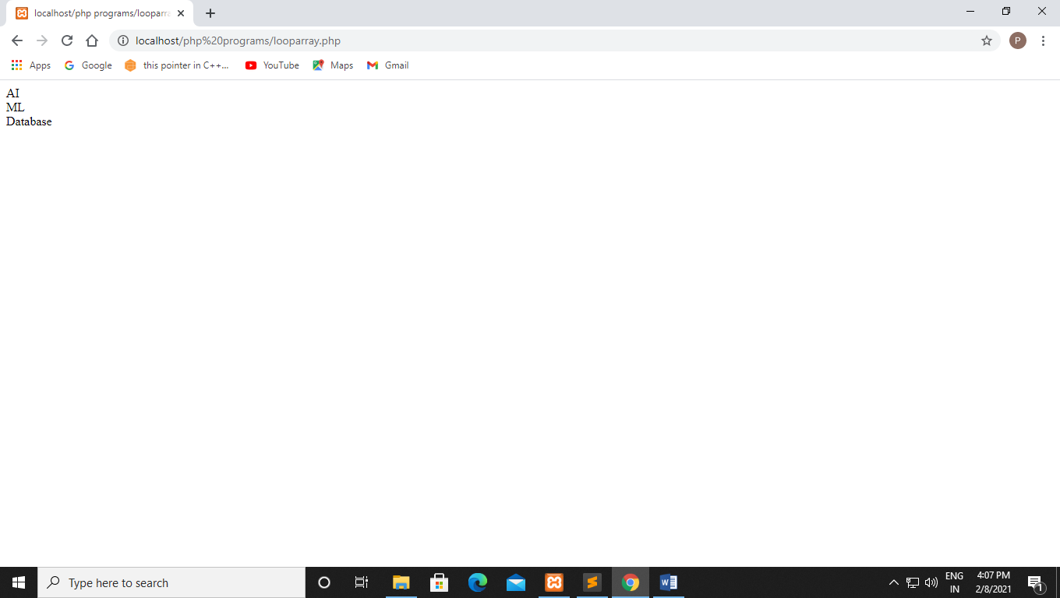

**Q42 write a PHP program for associative array.**

**Code:-**

<!DOCTYPE html>

<html>

<head>

<title></title>

</head>

<body>

<?php

$age = array("Amit" =>35,"Raj"=>37, "Anny"=>43);

echo "Amit is" .$age["Amit"]. 'years old.';

?>

</body>

</html>

**Output:-**

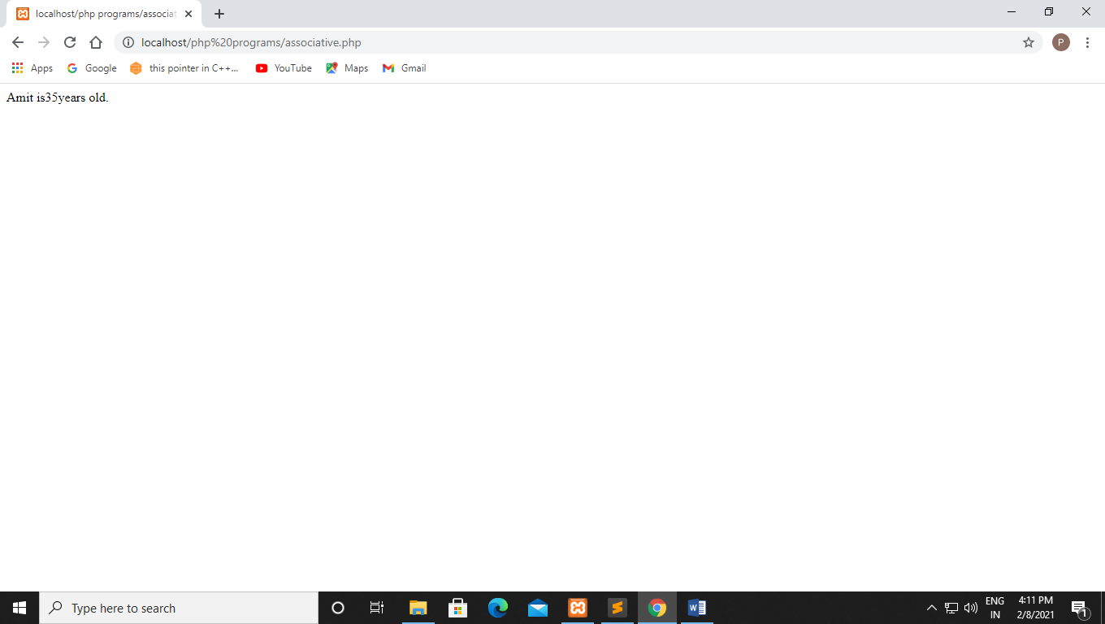

**Q43 Write a PHP program for multidimensional array**

**Code:-**

**<!DOCTYPE html>**

**<html>**

**<head>**

**<title></title>**

**</head>**

**<body>**

**<?php**

**$contacts = array(**

**array(**

**'name'=> 'Groot',**

**'email'=> 'groot@gmail.com',**

**),**

**array(**

**'name'=> 'Monu',**

**'email'=> 'monu@gmail.com',**

**),**

**array(**

**'name'=> 'Prathmesh',**

**'email'=>'prathmesh@gmail.com',**

**)**

**);**

**echo "Groots Email-id is " .$contacts[0]['email'];**

**?>**

**</body>**

**</html>**

**Output:-**

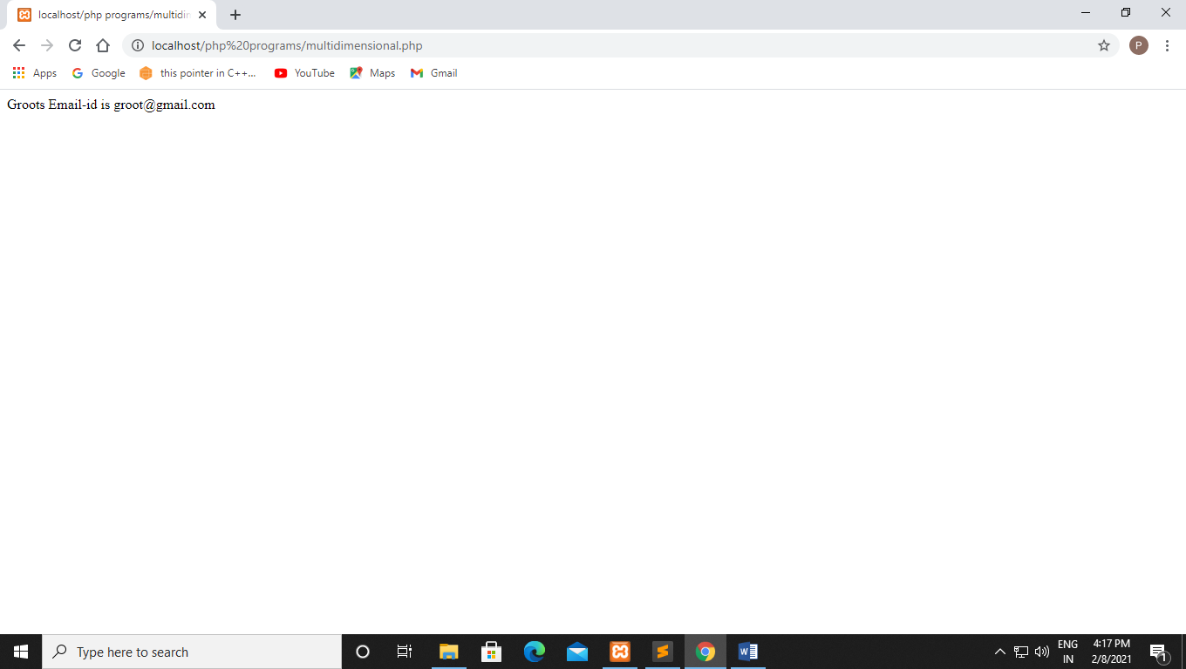

**Q44 Write a PHP program for sort associative array in descending order using arsort function and Write a PHP program for sort associative array in ascending order using asort**

**Code:-**

**1)arsort:-**

<!DOCTYPE html>

<html>

<head>

<title></title>

</head>

<body>

<pre>

<?php

$alphabhets = array("b"=>"ball", "d"=>"dog", "a"=>"Apple", "c"=>"cat");

arsort($alphabhets);

print_r($alphabhets);

?>

</pre>

</body>

</html>

**2) assort:-**

<!DOCTYPE html>

<html>

<head>

<title></title>

</head>

<body>

<pre>

<?php

$alphabhets = array("b"=>"ball", "d"=>"dog", "a"=>"Apple", "c"=>"cat");

asort($alphabhets);

print_r($alphabhets);

?>

</pre>

</body>

</html>

**3) rsort():-**

<!DOCTYPE html>

<html>

<head>

<title></title>

</head>

<body>

<pre>

<?php

$alphabhets = array("e"=>"ethernet", "f"=>"Fish", "g"=>"Groot", "h"=>"hacking");

rsort($alphabhets);

print_r($alphabhets);

?>

</pre>

</body>

</html>

**4) ksort():-**

<!DOCTYPE html>

<html>

<head>

<title></title>

</head>

<body>

<pre>

<?php

$alphabhets = array("i"=>"Internet", "j"=>"Joking", "k"=>"Killing", "l"=>"Laughing");

ksort($alphabhets);

print_r($alphabhets);

?>

</pre>

</body>

</html>

**5) krsort():-**

<!DOCTYPE html>

<html>

<head>

<title></title>

</head>

<body>

<pre>

<?php

$alphabhets = array("m"=>"Muting", "n"=>"Noobs", "o"=>"Online", "p"=>"Parrots");

krsort($alphabhets);

print_r($alphabhets);

?>

</pre>

</body>

</html>

**Output:-**

1. **arsort:-**

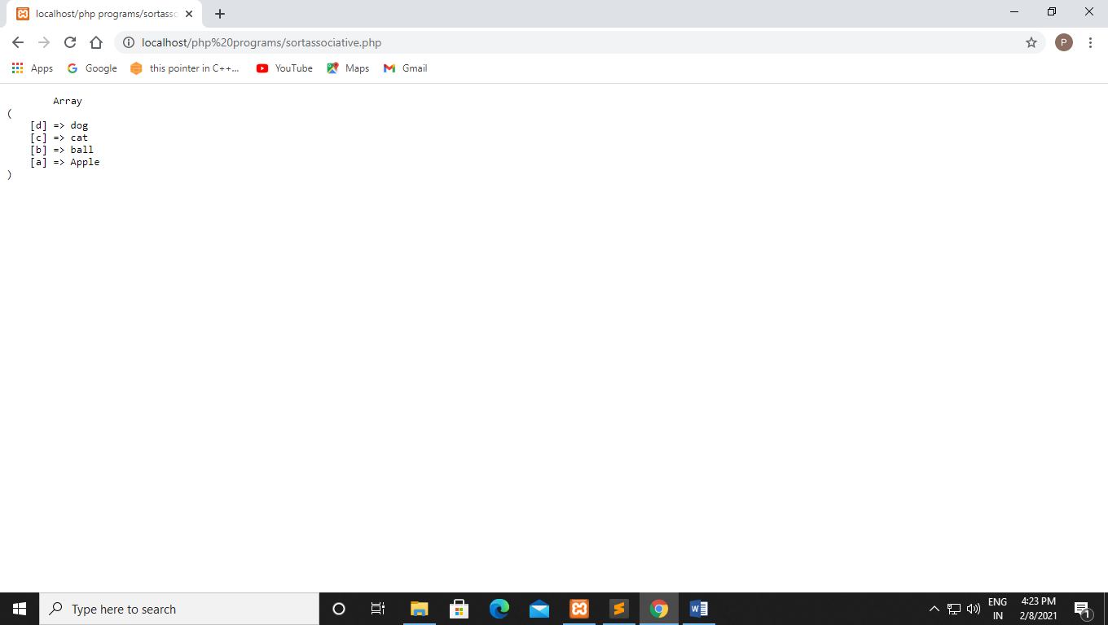

**2) asort:-**

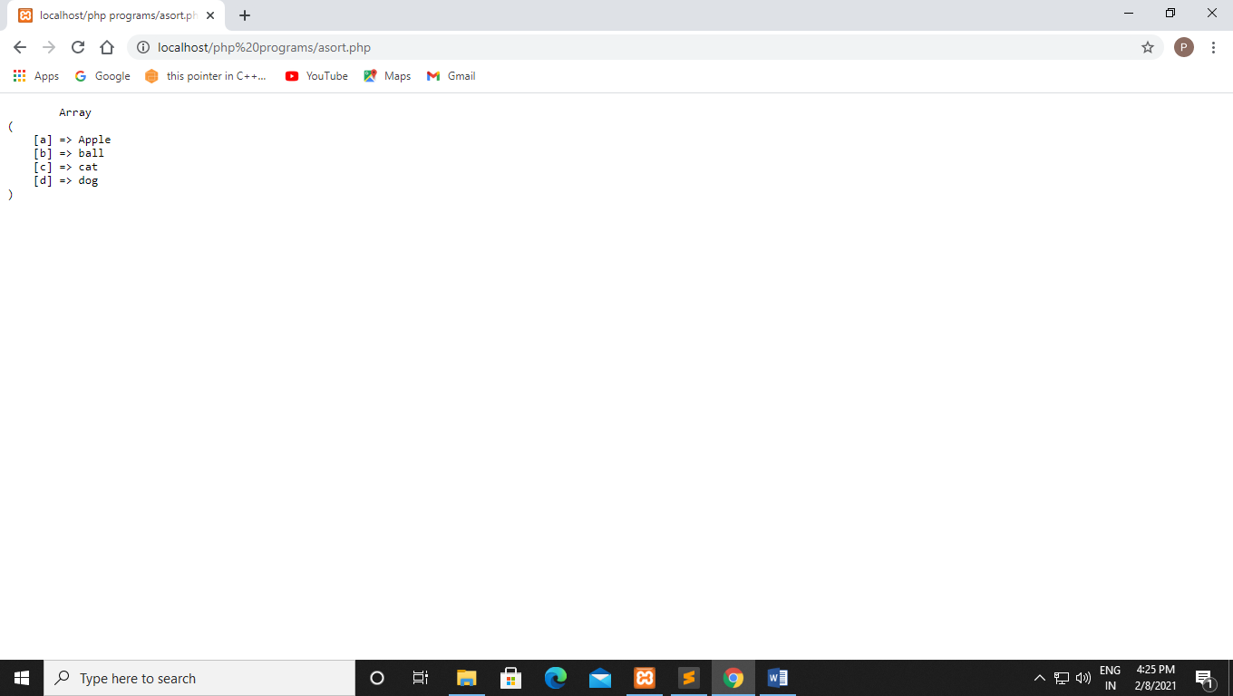

1. **rsort():-**

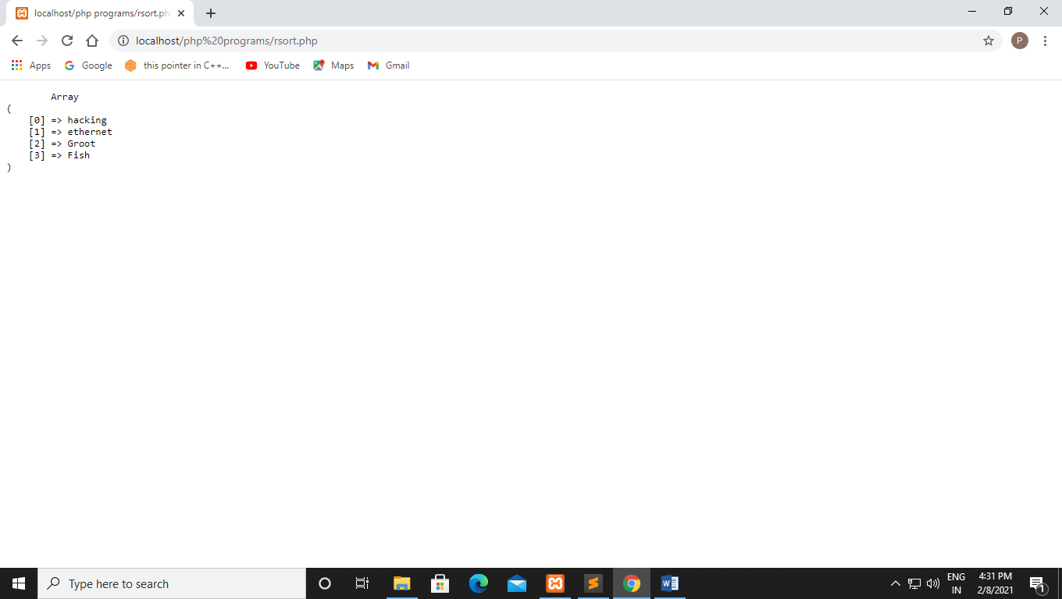

1. **ksort():-**

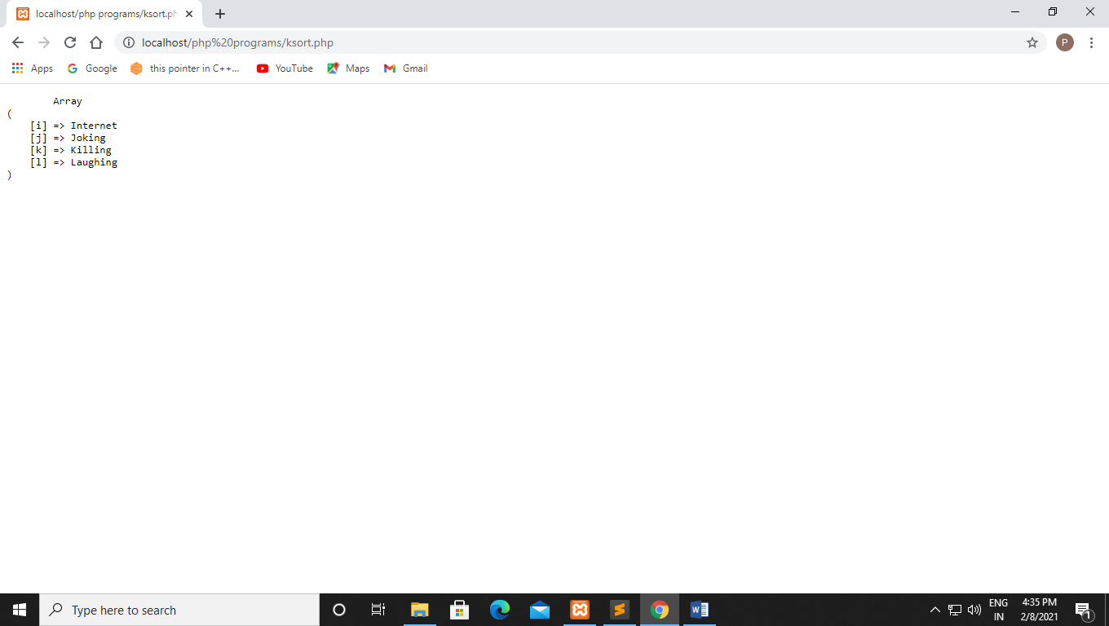

1. **krsort():-**

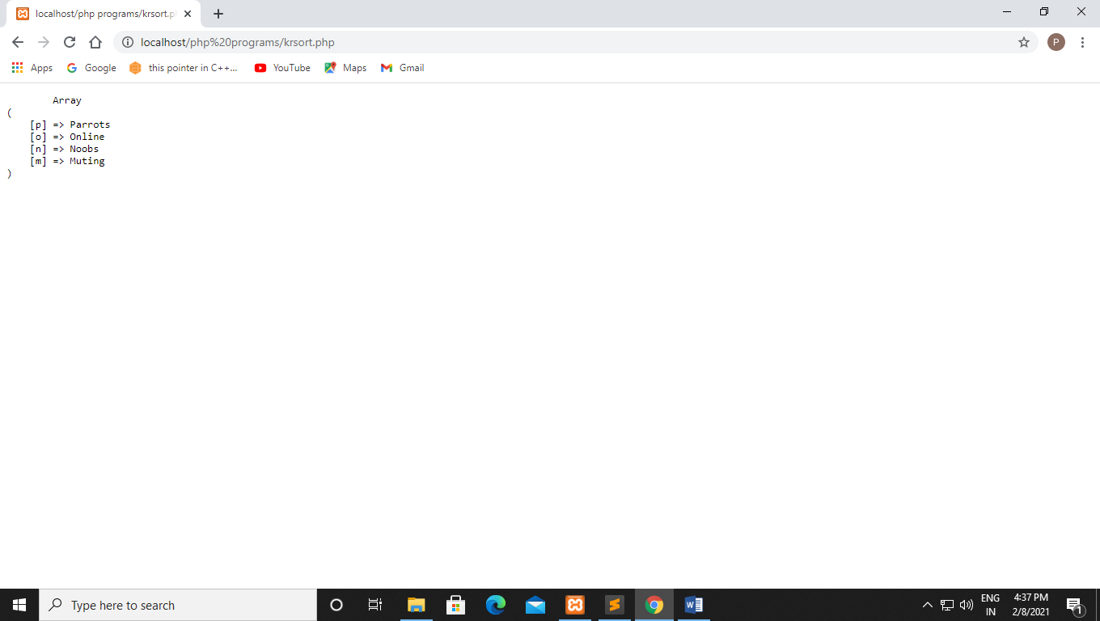

**15-02-2021**

**Experiment no : 6**

**Q45. Write a php program to check if a pattern is present or not using preg_match.**

**Code:-**

<!DOCTYPE html>

<html>

<head>

<title></title>

</head>

<body>

<?php

$str = "graphical presentation of research data and software tools";

$pattern = "/Research data/i";

echo preg_match($pattern, $str);

?>

</body>

</html>

**Output:-**

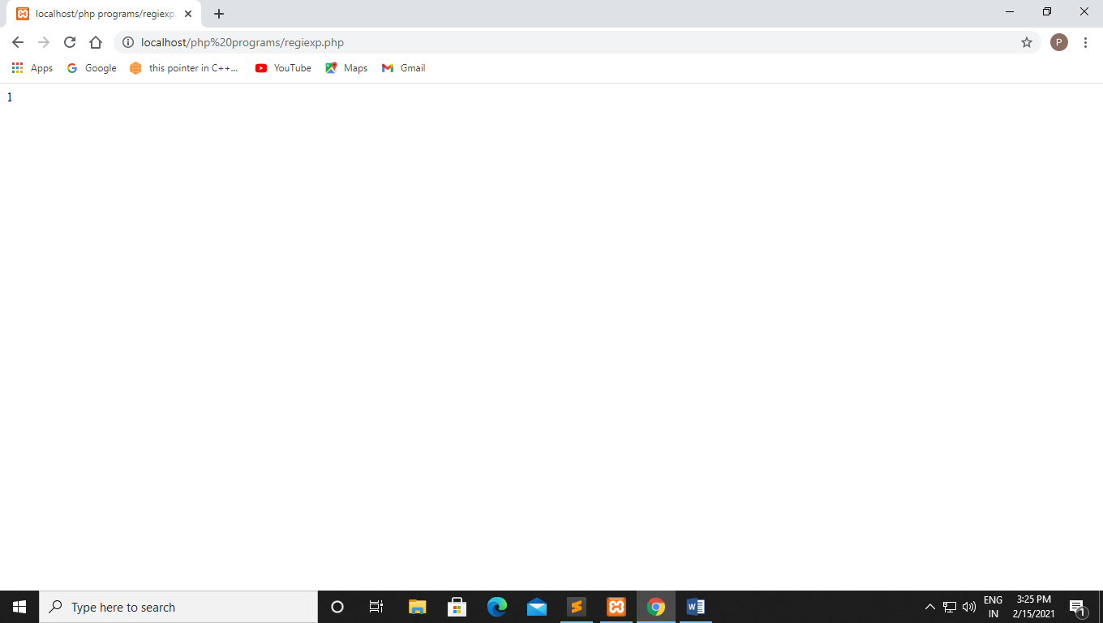

**Q46. Write a php program to check if a pattern is present or not using preg_match_all.**

**Code:-**

<!DOCTYPE html>

<html>

<head>

<title></title>

</head>

<body>

<?php

$str = "The rain in Spain falls mainly on the plains.";

$pattern = "/ain/i";

echo preg_match_all($pattern, $str);

?>

</body>

</html>

**Output:-**

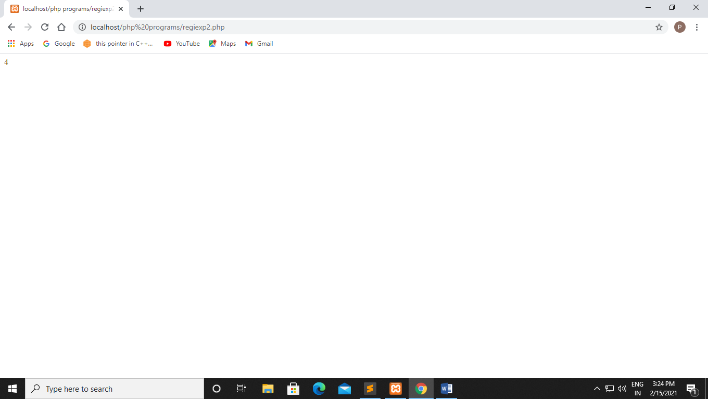

**Q**

**Code:-**

<!DOCTYPE html>

<html>

<head>

<title></title>

</head>

<body>

<?php

$str = "The rain in Spain falls mainly on the plains.";

$pattern = "#ain#i";

echo preg_match_all($pattern, $str);

?>

</body>

</html>

**Output:-**

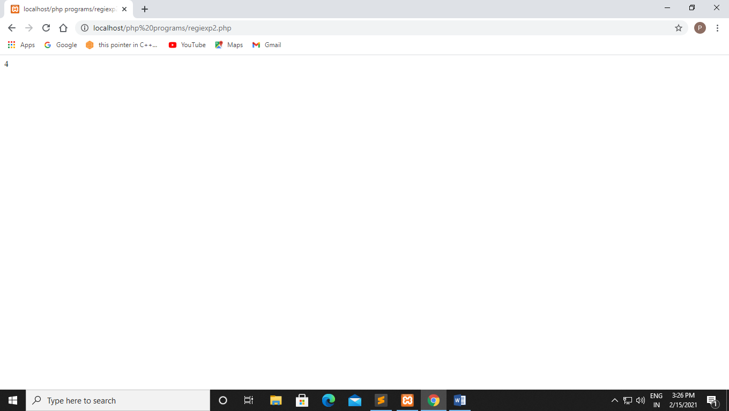

**Q**

**Code:-**

<!DOCTYPE html>

<html>

<head>

<title></title>

</head>

<body>

<?php

$str = "The rain in Spain falls mainly on the plains.";

$pattern = "~ain~i";

echo preg_match_all($pattern, $str);

?>

</body>

</html>

**Output:-**

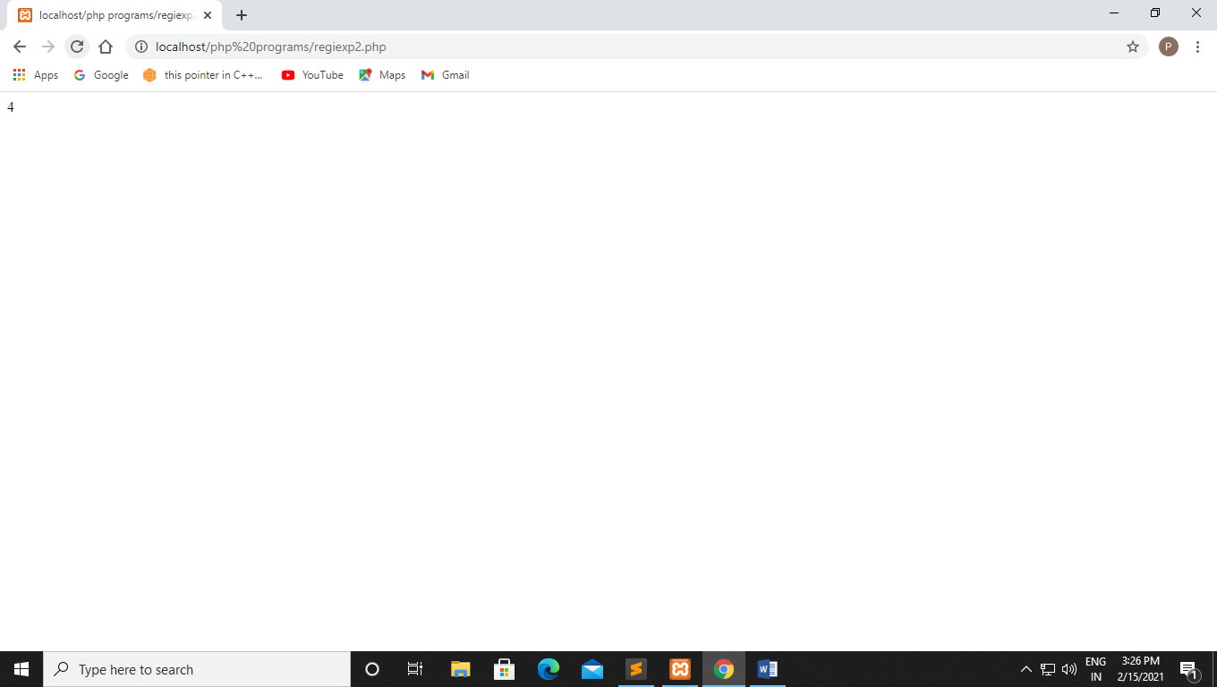

**Q47. Write a php program to check if a pattern is present Replace it using preg_replace.**

**Code:-**

<!DOCTYPE html>

<html>

<head>

<title></title>

</head>

<body>

<?php

$str = "Different forms!";

$pattern = "/forms/i";

echo preg_replace($pattern, "aspects", $str);

?>

</body>

</html>

**Output:-**

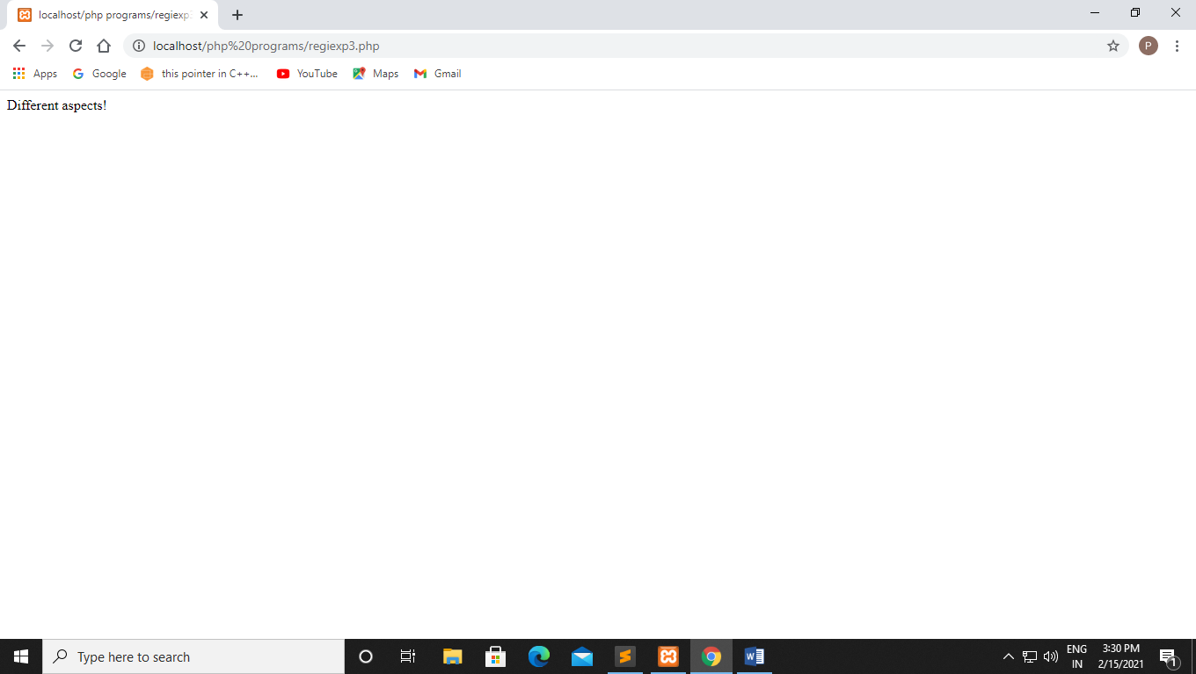

**Q48. Write a php program to check if a name is correct or not using regular expression.**

**Code:-**

<!DOCTYPE html>

<html>

<head>

<title></title>

</head>

<body>

<?php

$regex = '/^[a-zA-Z]*$/';

$nameString = 'AryanSharma';

if(preg_match($regex, $nameString)){

echo ("Name string matching with"." regular expression ");

}

else{

echo ("Only letters and white space"."allowed in name string");

}

?>

</body>

</html>

**Output:-**

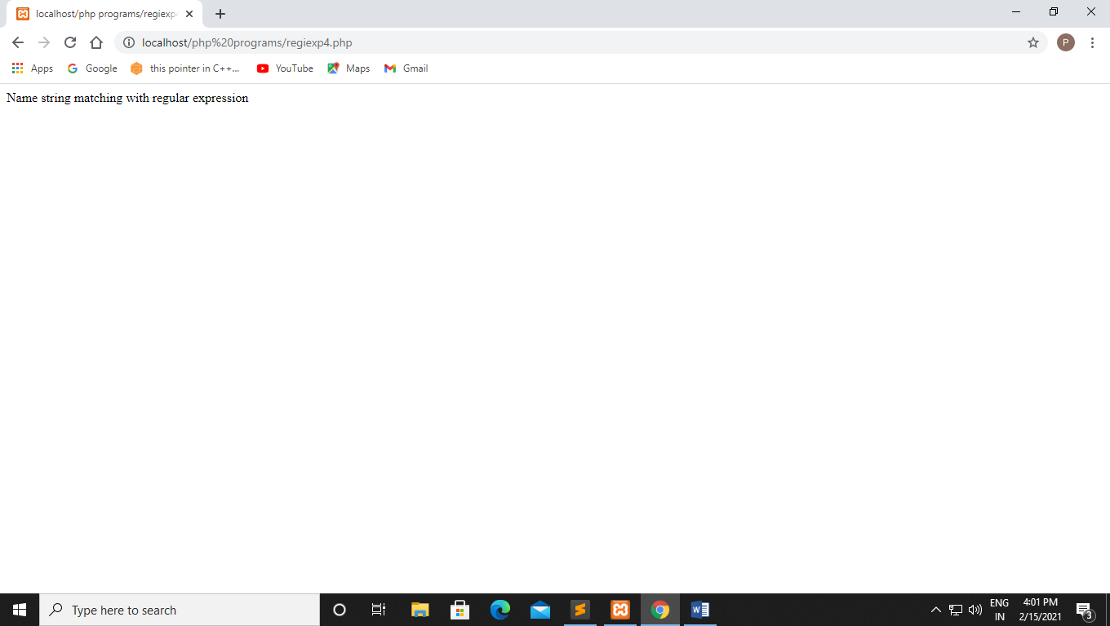

**Q49. use preg_match() function search string pattern if yes print hello otherwise print bye.**

**Code:-**

<!DOCTYPE html>

<html>

<head>

<title></title>

</head>

<body>

<?php

$regex = '/^[a-zA-Z0-9]*$/';

$nameString = 'AryanSharma9';

if(preg_match($regex, $nameString)){

echo ("Hello");

}

else{

echo ("Bye");

}

?>

</body>

</html>

**Output:-**

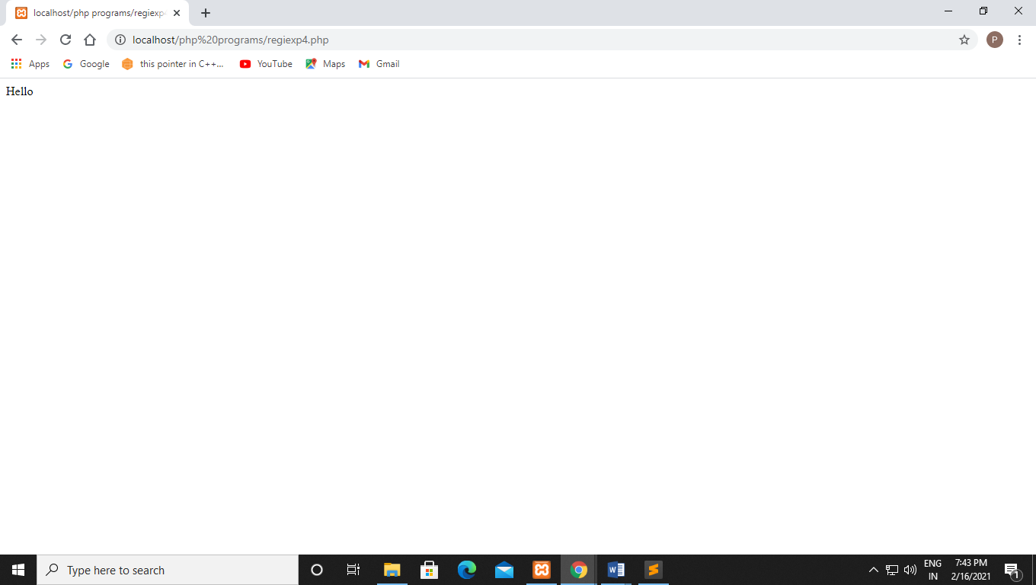

**Q50. Write a php program to check if email is correct or not using filter .**

**Code:-**

<?php

$email = "groot@amity.com";

if(filter_var($email, FILTER_VALIDATE_EMAIL)){

echo ("$email is a valid email address");

}

else{

echo ("$email is not a valid email address ");

}

?>

**Output:-**

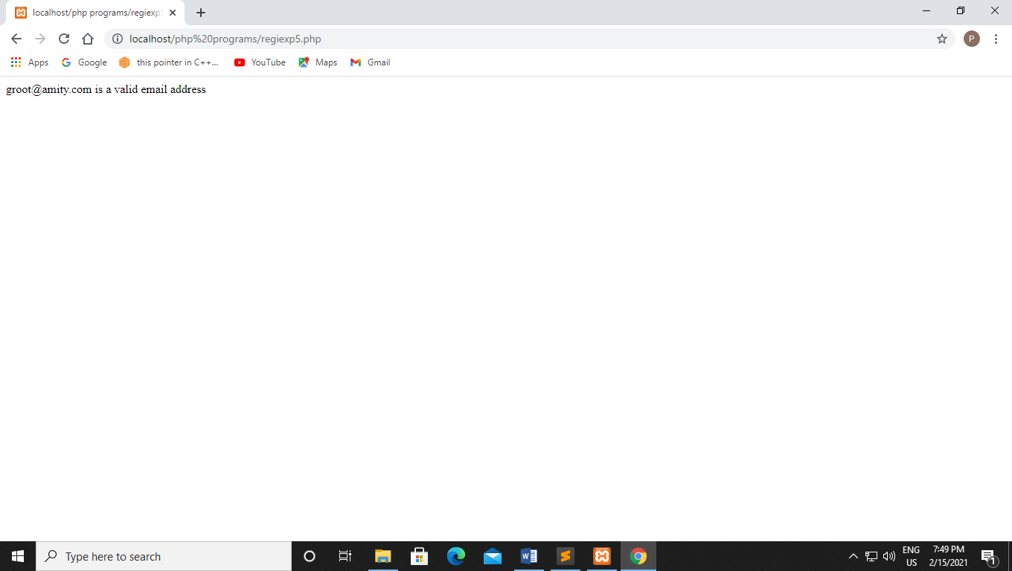

**Q51. Write a php program to check if a name is correct or not using regular expression.**

**Code:-**

<?php

function checkemail($str) {

return (!preg_match("/^([a-z0-9\+_\-]+)(\.[a-z0-9\+_\-]+)*@([a-z0-9\-]+\.)+[a-z]{2,6}$/ix", $str)) ? FALSE : TRUE;

}

if(!checkemail("groot123@gmail.com")){

echo "Invalid email address.";

}

else{

echo "Valid email address.";

}

?>

**Output:-**

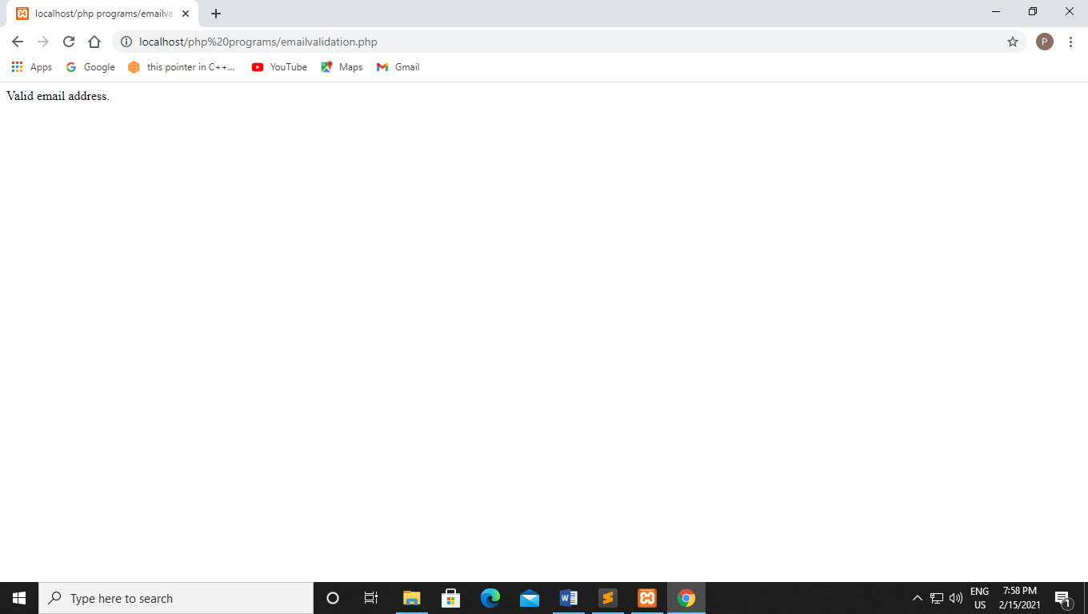

**Q52. Write a php program to check if name , email id and mobile number is valid or not using regular expression.**

**Code:-**

<html>

<head>

<title></title>

</head>

<body class="container-fluid">

<form action="formregular.php" method="post" class="container-fluid py-2 px-5 my-5 mx-5">

<div class="row text-center py-2">

<div class="col">

<h2 class="text-muted">FORM</h2>

</div>

</div>

<div class="row text-center py-2">

<div class="col">

<label for="URL">Website Link / URL</label>

</div>

<div class="col">

<input type="text" name="URL" id="URL" required>

</div>

</div>

<div class="row text-center py-2">

<div class="col">

<label for="email">E-mail ID</label>

</div>

<div class="col">

<input type="email" name="email" id="email" required>

</div>

</div>

<div class="row text-center py-2">

<div class="col">

<label for="Number">Mobile Number:-</label>

</div>

<div class="col">

<input type="Number" name="Number" id="Number" required>

</div>

</div>

<div class="row text-center py-5">

<div class="col">

<button type="submit" name = 'sub' id='sub' class="button p-

2">SUBMIT</button>

</div>

</div>

</form>

</body>

</html>

<?php

if(isset($_POST['sub'])){

$webUrl=$_POST['URL'];

$email=$_POST['email'];

if(preg_match('/^www\.[a-z]+\.[a-z]{1,3}$/',$webUrl)){

echo"<p>Url format is valid</p>";

}else{

echo "<p>Invalid URL format</p>";

}

if(preg_match('/^[a-z0-9._%+-]+@[a-z0-9.-]+\.[a-z]{2,4}$/',$email)){

echo "<p>Email format is valid</p>";

}

else{

echo "<p>Invalid Email format</p>";

$Number=$_POST['Number'];

if(preg_match('^[+]*[(]{0,1}[0-9]{1,4}[)]{0,1}[-\s\./0-9]*$^',$Number))

{

echo "<p> Valid phone number </p>";

}

else

{

echo "<p> Invalid Phone number </p>";

}

}

}

?>

**Output:-**

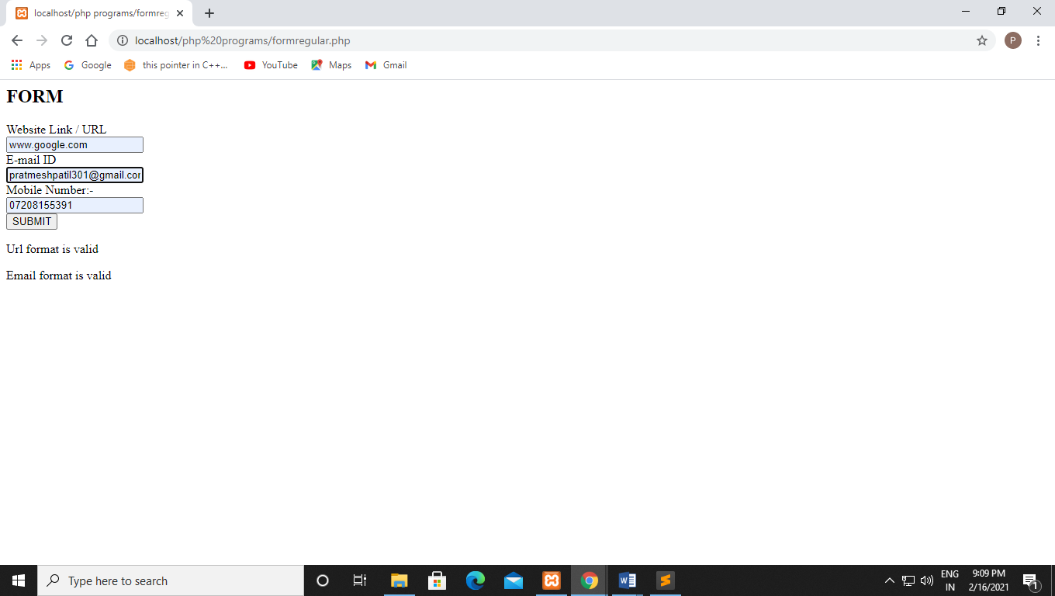

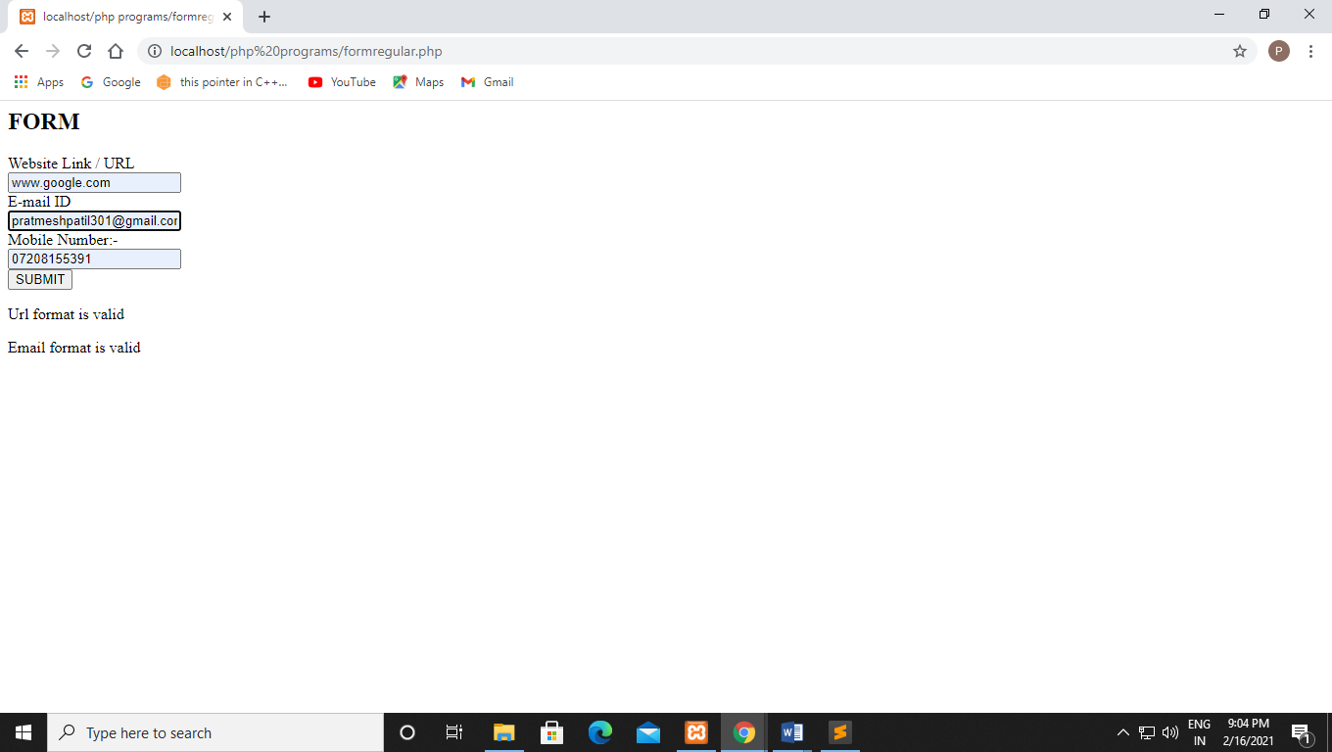

**22-02-2021**

**Experiment no : 7**

**Q53 Write a php program to on constructor function using class**

**Code:-**

<?php

//program on constructor function using class.

class ABC

{

public function __construct()

{

echo " the class ".__CLASS__."was initated!<br>";

}

}

$obj = new ABC;

?>

**Output:-**

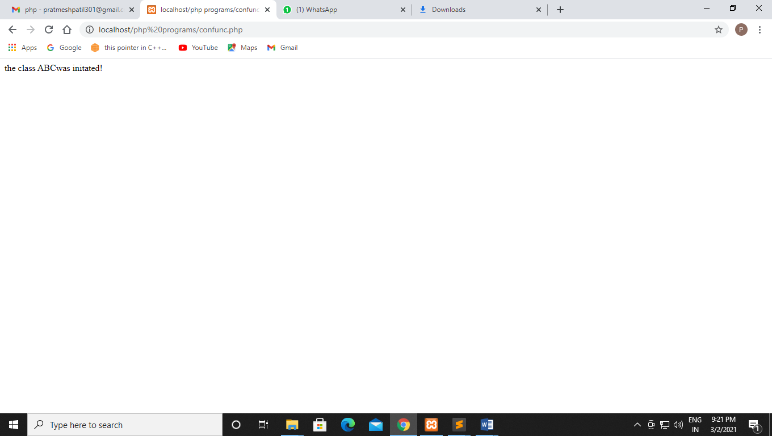

**Q54 Write a php program to access public variable outside class scope**

**Code:-**

<?php

//Access public variable outisde class scope

class MyClass

{

public $font_size=10;

}

$f = new MyClass;

echo $f->font_size;

?>

**Output:-**

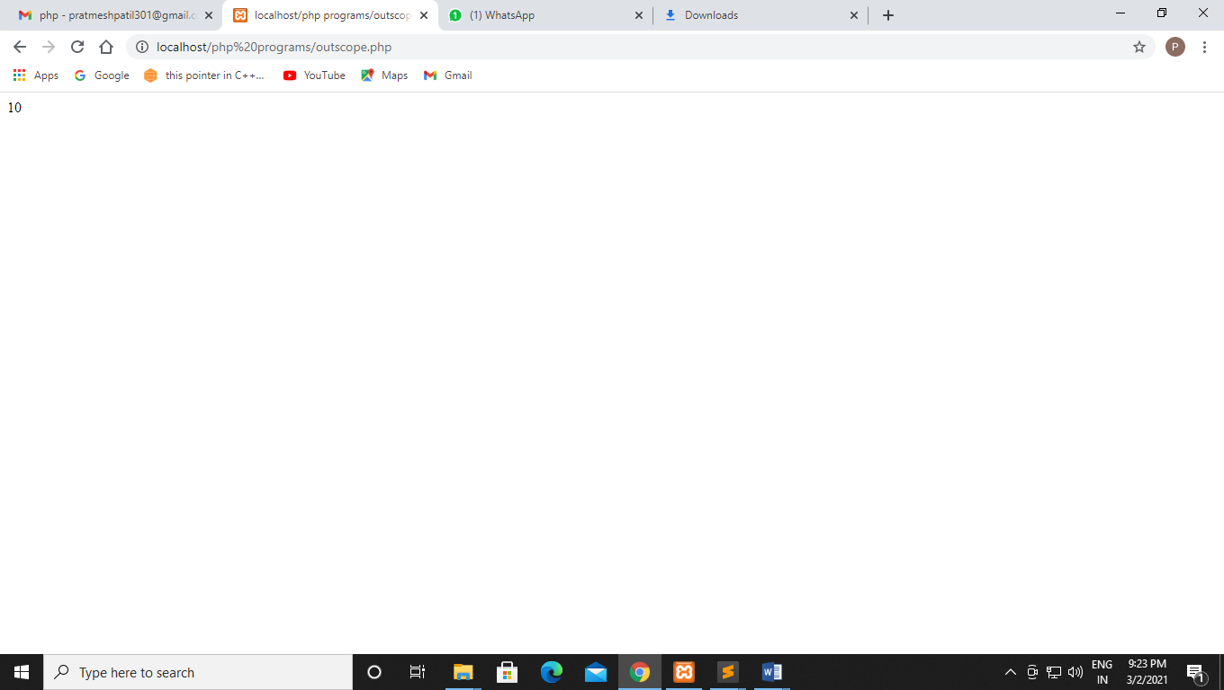

**Q55 Write a php program to intialise class value in constructor than print it using different functions.**

**Code:-**

<!DOCTYPE html>

<html>

<head>

<title></title>

</head>

<body>

<?php

class Students

{

public $first_name;

public $last_name;

public $address;

public function __construct($first_name,$last_name,$address)

{

$this->first_name=$first_name;

$this->last_name=$last_name;

$this->address=$address;

}

public function greeting(){

return "Hello ".$this->first_name."\n";

}

public function getAddress(){

return $this->address."\n";

}

}

$Students = new Students("Prathmesh","Patil","Belapur");

echo $Students->greeting();

echo $Students->getAddress();

?>

</body>

</html>

**Output:-**

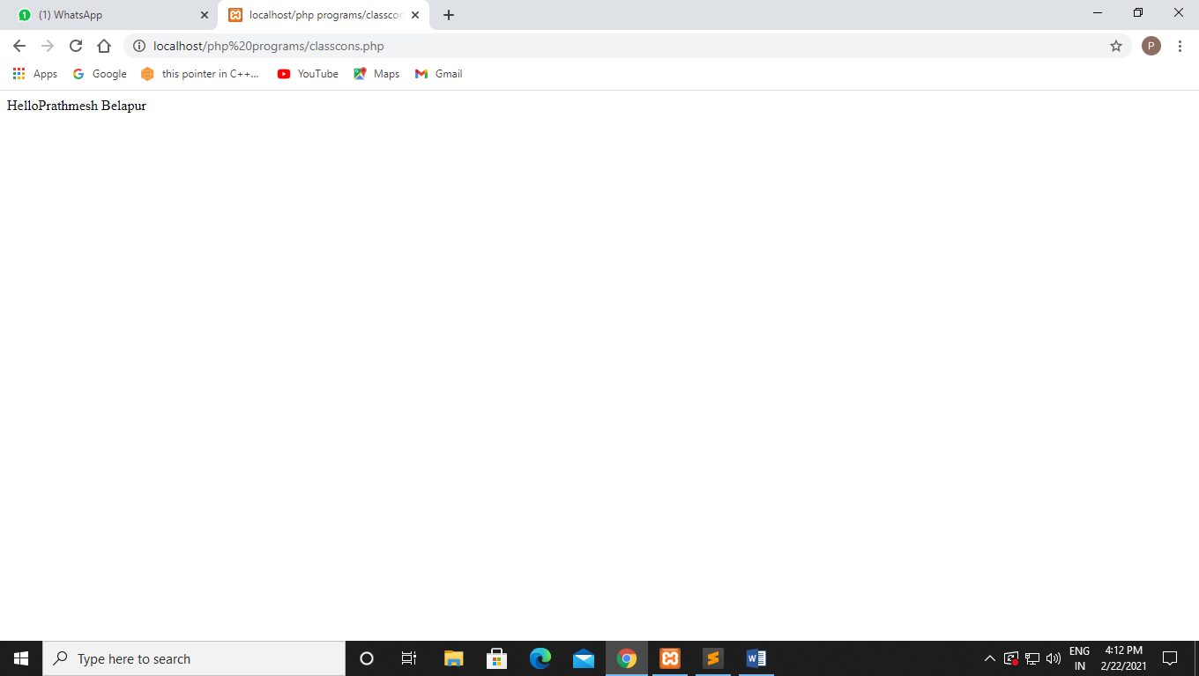

**Q56** Write a php program to check access specifiers

**Code:-**

<!DOCTYPE html>

<html>

<head>

<title></title>

</head>

<body>

<?php

class Fruit{

public $name;

protected $color;

private $weight;

}

$mango = new Fruit();

$mango->name = 'Mango';

$mango->color='Yellow';

$mango->weight='300';

?>

</body>

</html>

**Output:-**

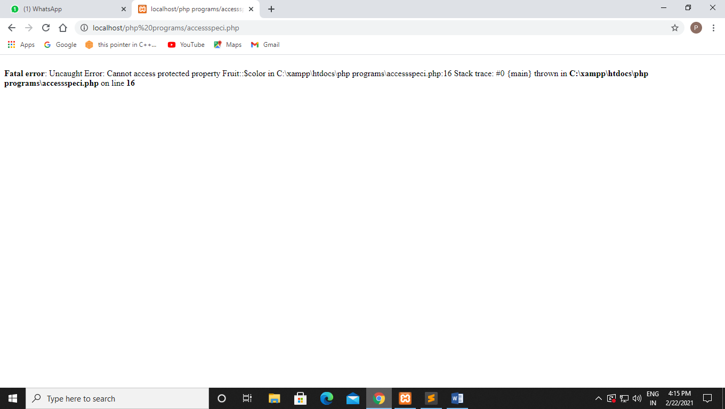

**Q57 Write a PHP code to access variables which are has a access specifier as private protected .**

**Code:-**

<?php

class Person{

private $fname;

private $lname;

public function setFName($fname){

$this->fname=$fname;

}

public function setLName($lname){

$this->lname=$fname;

}

public function showName(){

echo "My name is:".$this->fname."",$this->lname;

}

}

$john = new Person();

$john->fname="john";

$john->lname="Wick";

$john->setFName("John");

$john->setLName("Wick");

?>

**Output:-**

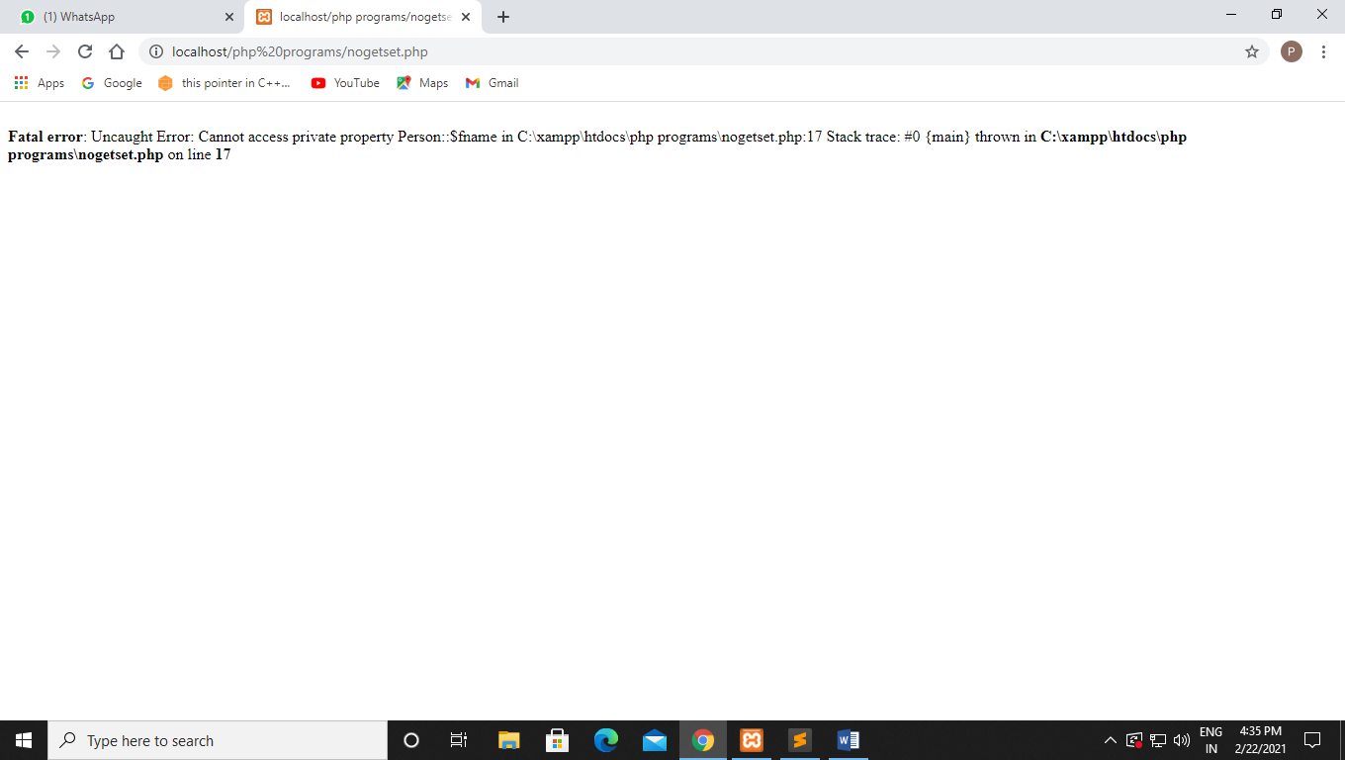

**Q58 Write a PHP program to print name using get() method.**

**Code:-**

<?php

class Person{

private $name;

public function setName($name){

$this->name = $name;

}

public function getName(){

return $this->name;

}

}

$john=new Person();

$john->setName("Prathmesh Patil");

echo "My name is ".$john->getName();

?>

**Output:-**

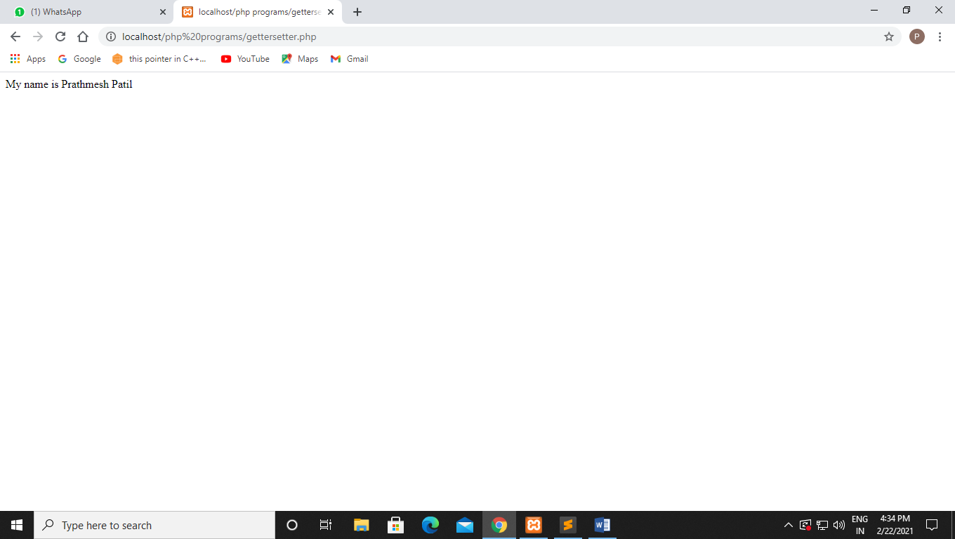

**Q59 Using inheritance create base class car and derived class that is sports car and display the value of variables**

**Code:-**

<!DOCTYPE html>

<html>

<head>

<title></title>

</head>

<body>

<?php

class Car{

private $model;

public function setModel ($model)

{

$this -> model = $model;

}

public function hello()

{

return "beep! I am a <i>" .$this -> model. "</i><br/>";

}

}

class SportsCar extends Car{

}

$sportsCarl=new SportsCar();

$sportsCarl->setModel('Lambhorgini');

echo $sportsCarl->hello();

?>

</body>

</html>

**Output:-**

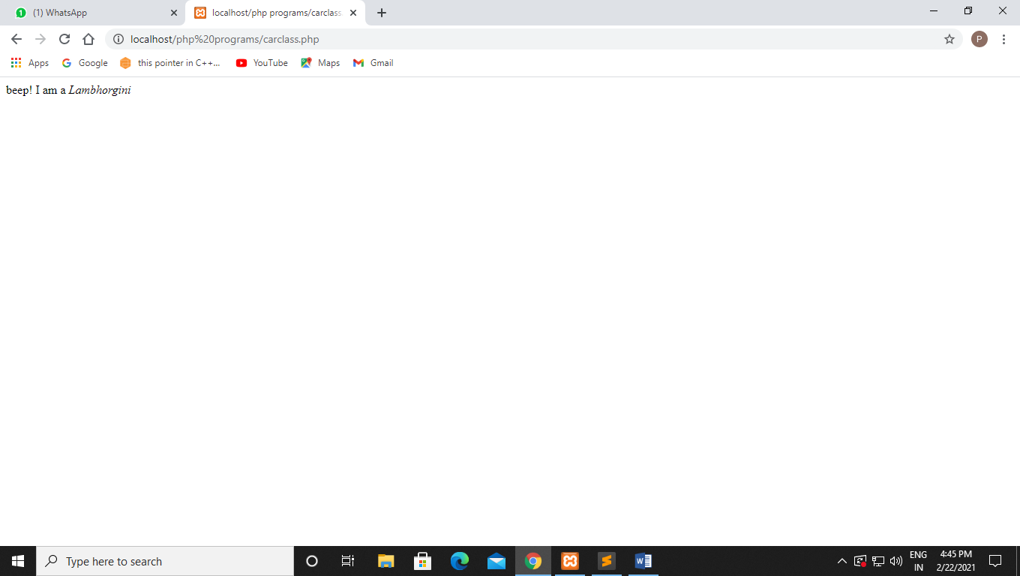

**1-03-2021**

**Experiment no :- 8**

**Q60 write a php code add 2 variable and the variable are inherited by other class**

**Code:-**

<!DOCTYPE html>

<html>

<head>

<title></title>

</head>

<body>

<?php

class add{

private $a = 45;

private $b = 55;

public function sum()

{

return $this->a + $this->b;

}

}

$obj = new add();

$c = $obj->sum();

echo $c;

?>

</body>

</html>

**Output:-**

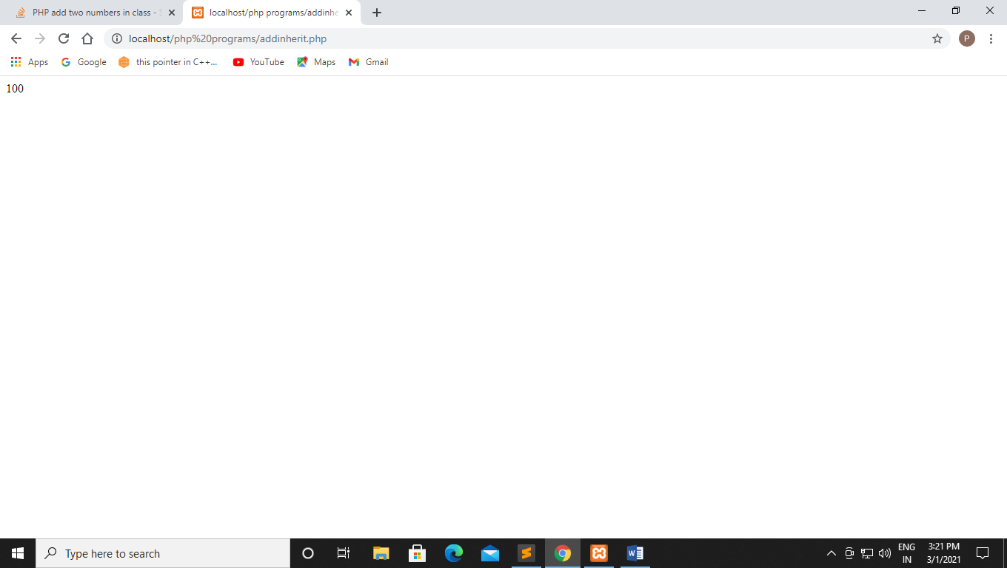

**Q61** write a php code to showcase include

**Code:-**

<!DOCTYPE html>

<html>

<head>

<title></title>

</head>

<body>

<h1>Welcome to the home page!</h1>

<p>Here is the welcome.php file</p>

<?php

include 'welcome.php';

?>

</body>

</html>

**Output:-**

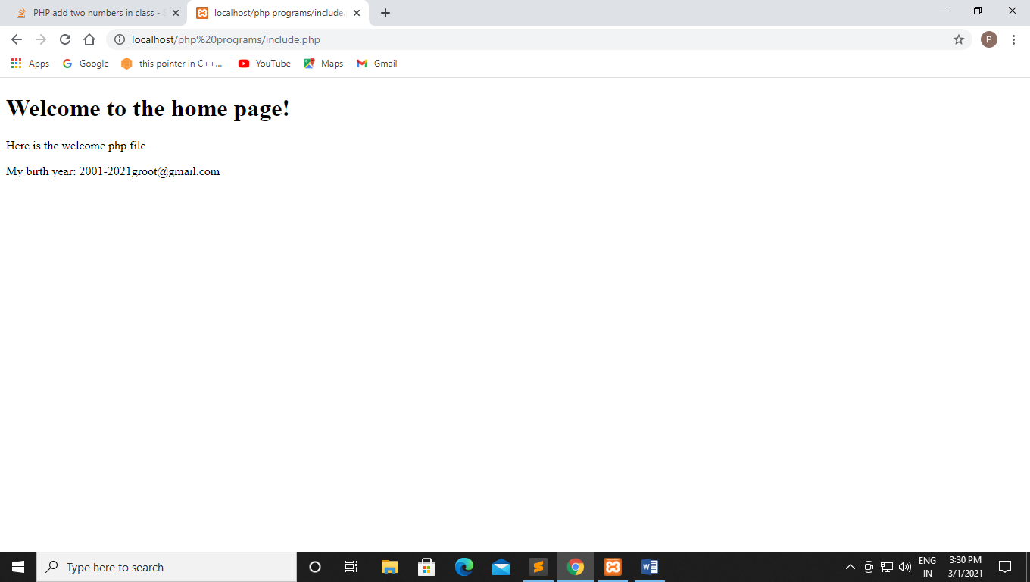

**Q62 Create the file include1.php and require.php copy all the content of files in index3.php .**

**Code:-**

**Include1.php:-**

<!DOCTYPE html>

<html>

<head>

<title></title>

</head>

<body>

<nav>

<ul>

<li>Home</li>

<li>About</li>

<li>Help</li>

</ul>

</nav>

<?php

echo "The above text is residing in \"include1.php\" ";

?>

</body>

</html>

**Require.php:-**

<?php

echo "the residing file is \"require.php\" which is included using require method";

?>

**Index3.php:-**

<!DOCTYPE html>

<html>

<head>

<title></title>

</head>

<body>

<?php

require 'require.php'

?>

</body>

</html>

**Code:-**

<?php

include 'include1.php';

?>

Text from Include4.php file <br>

Now we will extract some data from other file (which is included

using require method).

</p>

<?php

require 'require.php' ;

?>

**Output:-**

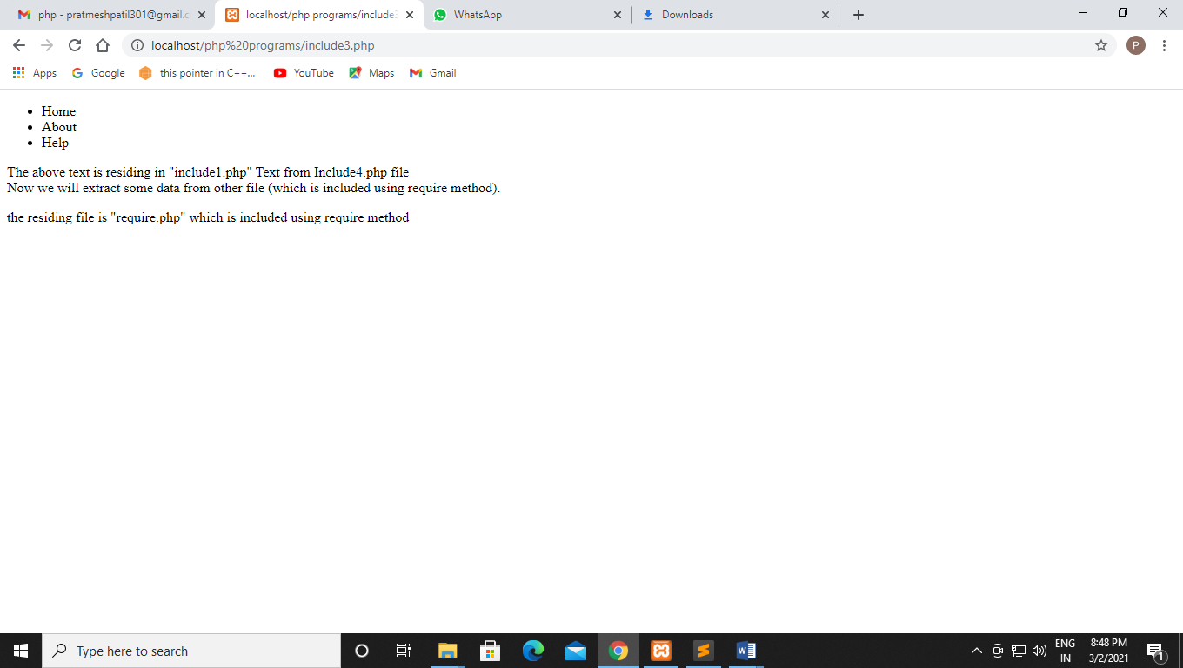

**Q63 Write a program for Effect of require and include statement if the files does not exist.**

**Code:-**

<?php

include('welcome1.php');

echo "The welcome file is not included";

?>

**Output:-**

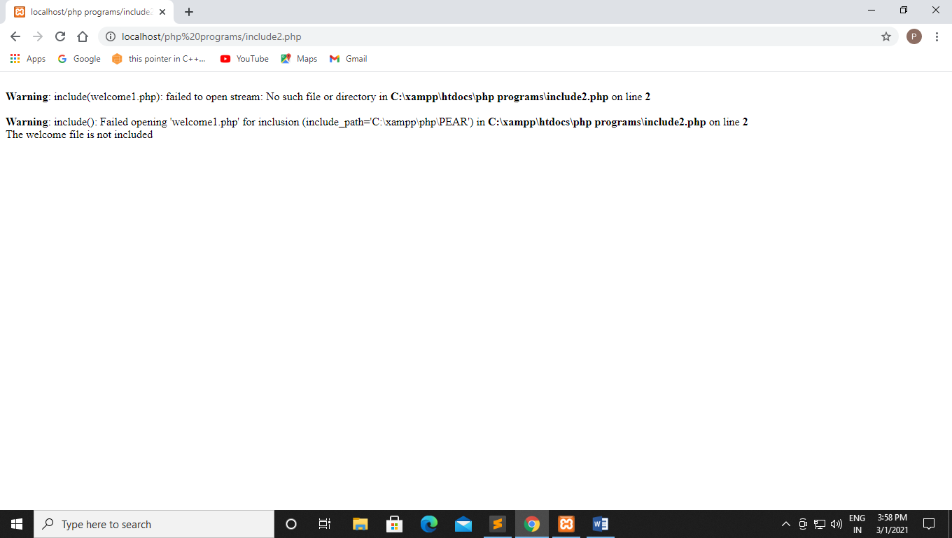

**Q64** write a php code to show the effect of include and require statement if the file does not exist

**Code:-**

<?php

echo "hello";

require("welcome1.php")

echo "The welcome file is required";

?>

**Output:-**

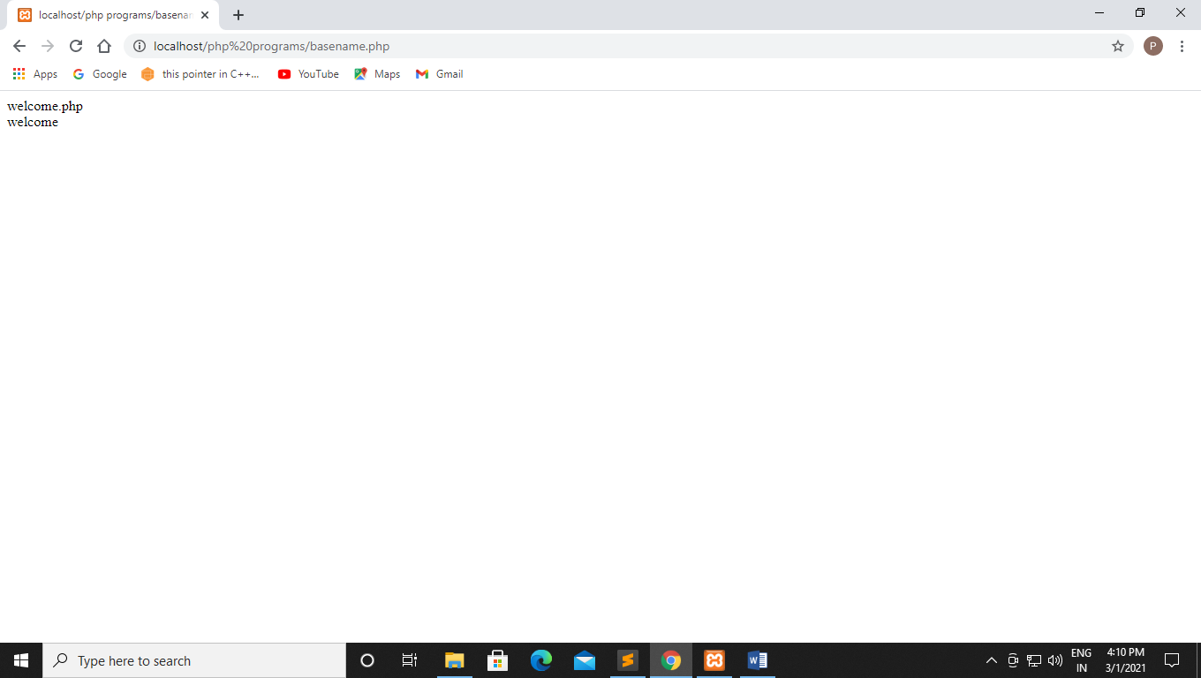

**Q65 Write a PHP program using basename() function.**

**Basename() function:-**

<!DOCTYPE html>

<html>

<head>

<title></title>

</head>

<body>

<?php

$path = "C:\xampp\htdocs\php programs\welcome.php";

echo basename($path);

echo"</br>"

echo basename($path, ".php");

?>

</body>

</html>

**Output:-**



**Q66 Write a php program Copy() function:-**

**Code:-**

<?php

echo copy("addinherit.php", "welcome.php");

?>

**Output:-**

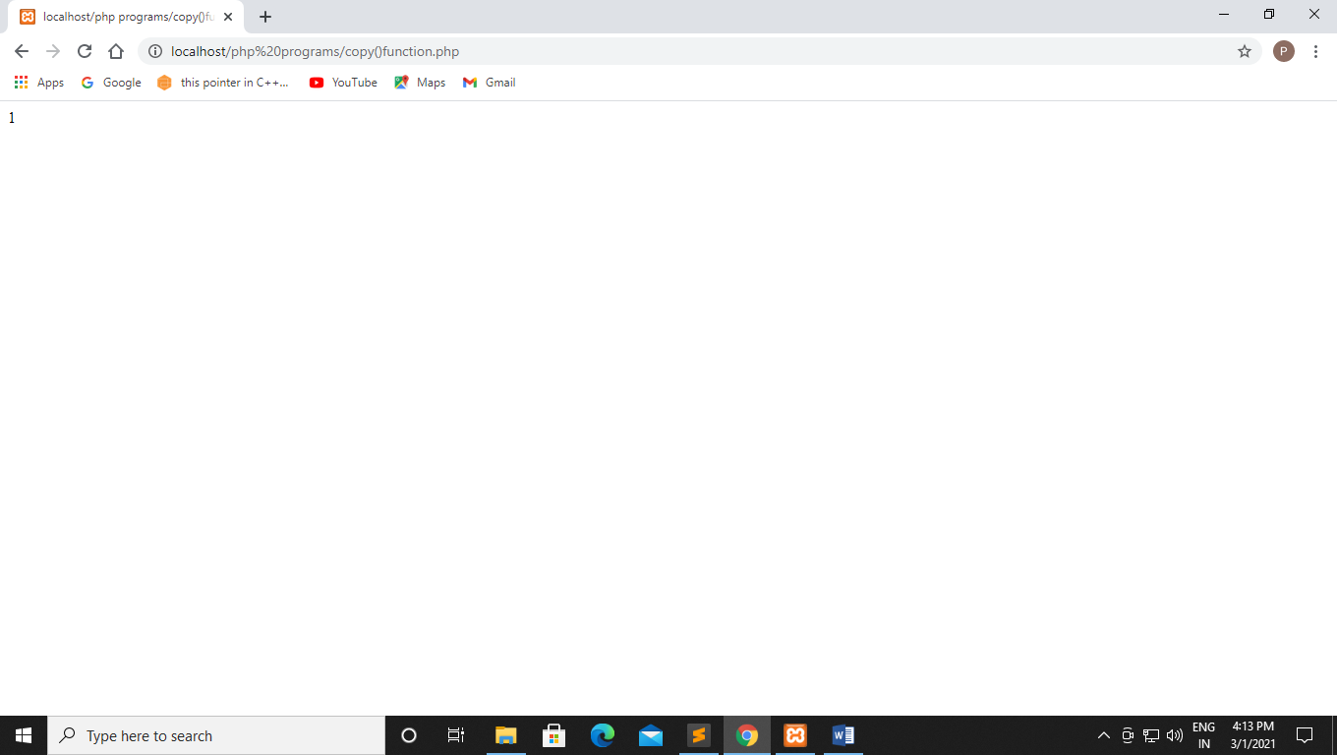

**Q67 Write a PHP program for Disk_free_space() function:-**

**Code:-**

<?php

echo disk_free_space("C:");

?>

**Output:-**

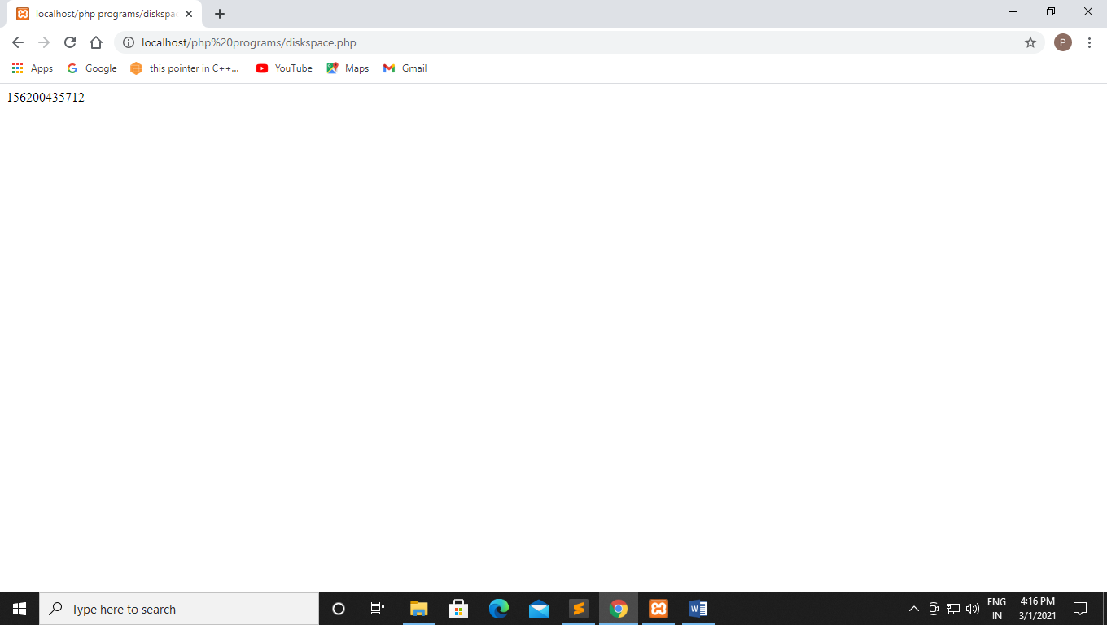

**Q68 Write a php code to showcase fread**

**Code:-**

<?php

$myfile = fopen("diskspace.php","r");

echo fread($myfile,"1");

fclose($myfile);

?>

Output :-

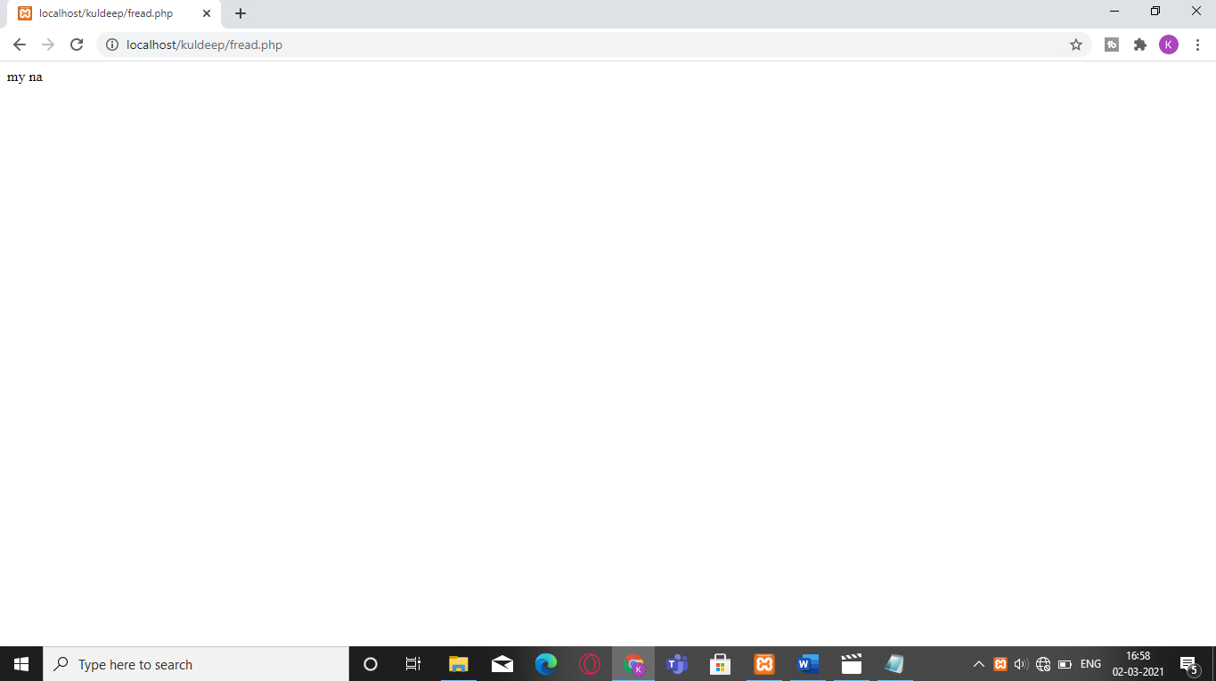

**Q69. write a php code using file system function to read entire content**

**Code :-**

<?php

//write a php code using file system function to read entire content

//from the file

$myfile = fopen("doc1.txt","r");

echo fread($myfile,filesize("doc1.txt"));

fclose($myfile);

?>

**Output :-**

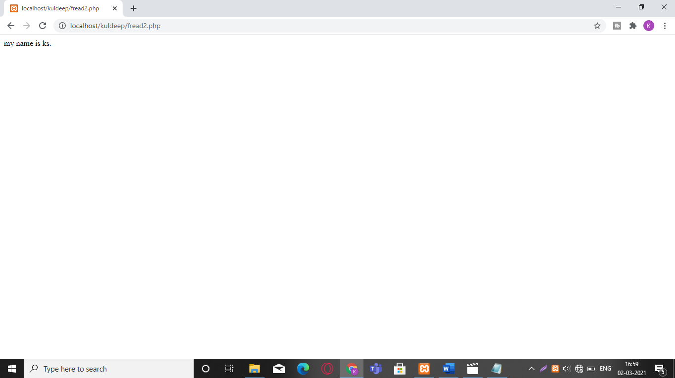

**Q70 write a php code to showcase file_exists**

**Code:-**

<?php

//file_exists() function

clearstatcache();

$file_pointer = 'C:\xampp\htdocs\php programs\include.php';

if(file_exists($file_pointer))

{

echo "The file $file_pointer pointer exists";

}

else

{

echo "The file $file_pointer does not exists";

}

?>

**Output:-**

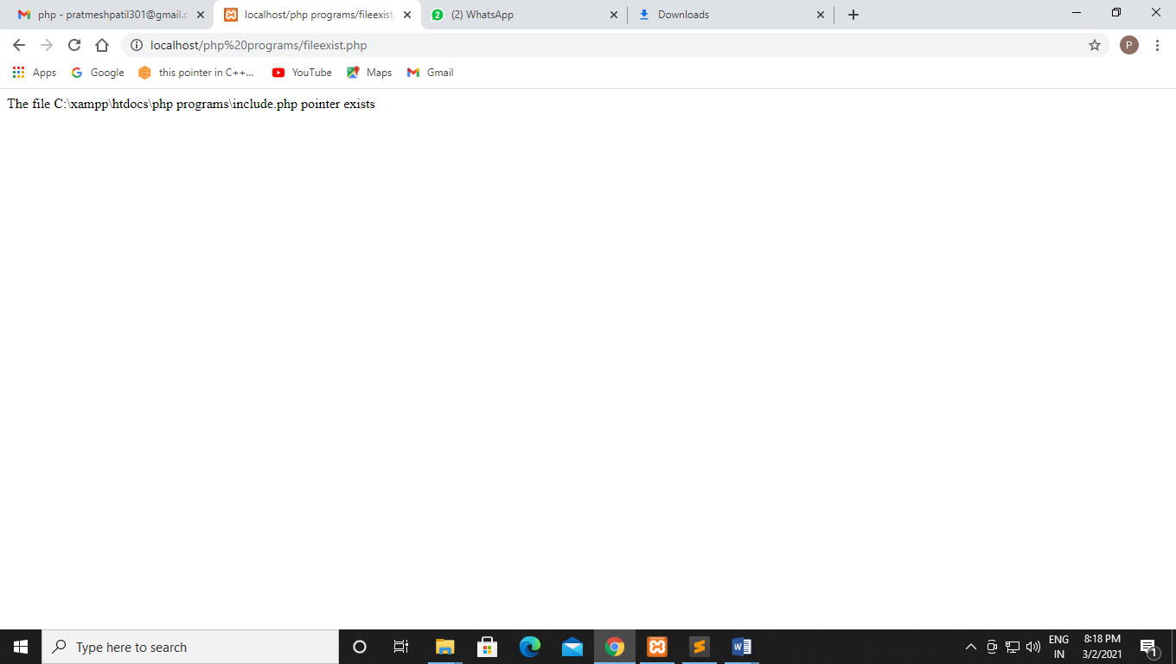

**15-3-2021**

**Experiment No:-9**

**Q71 Write a php program for creating cookie.**

**Code:-**

<!DOCTYPE html>

<html>

<head>

<title></title>

</head>

<body>

<?php

$cookie_name="user";

$cookie_value="Prathmesh Patil";

setcookie($cookie_name, $cookie_value, time() + (86400 * 30), "/");

?>

<?php

if(!isset($_COOKIE[$cookie_name])){

echo "Cookie named".$cookie_name."is not set!";

}else{

echo "Cookie ".$cookie_name." is set!<br>";

echo "The value is:" .$_COOKIE[$cookie_name];

}

?>

</body>

</html>

**Output:-**

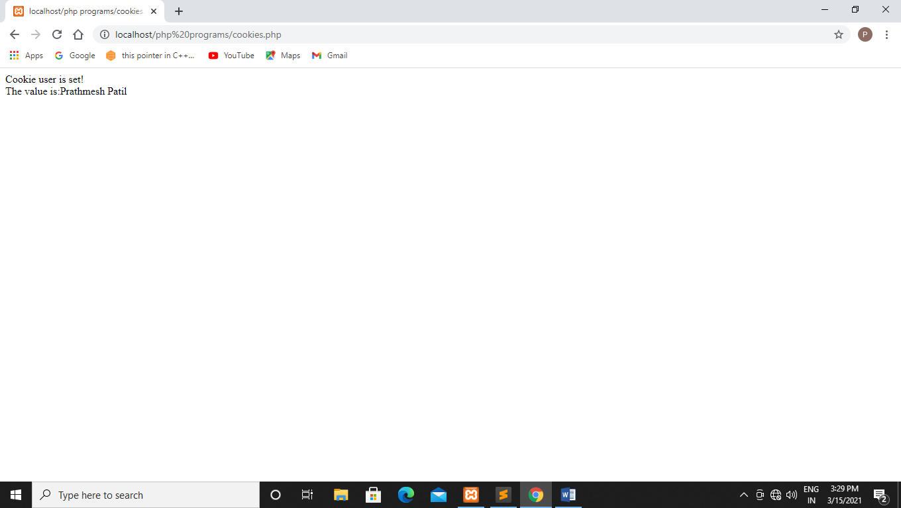

**Q72 Write a php program for deleting cookie.**

**Code:-**

<!DOCTYPE html>

<?php

setcookie("user", "",time() - 3600);

?>

<html>

<body>

<?php

echo "Cookie 'user' is deleted.";

?>

</body>

</html>

**Output:-**

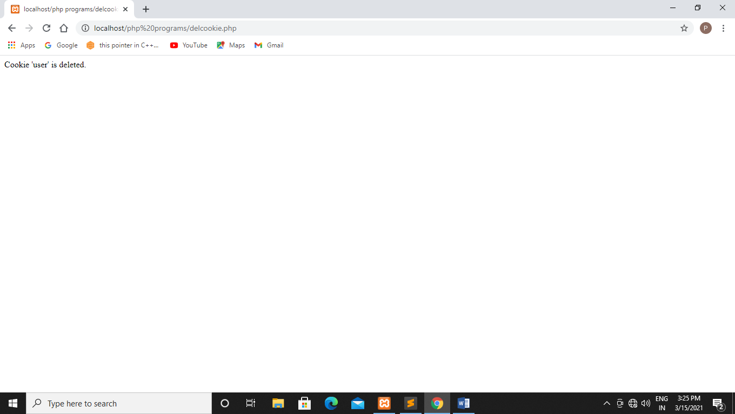

**Q73 Write a php program to print cookie.**

**Code:-**

<?php

print_r($_COOKIE);

?>

**Output:-**

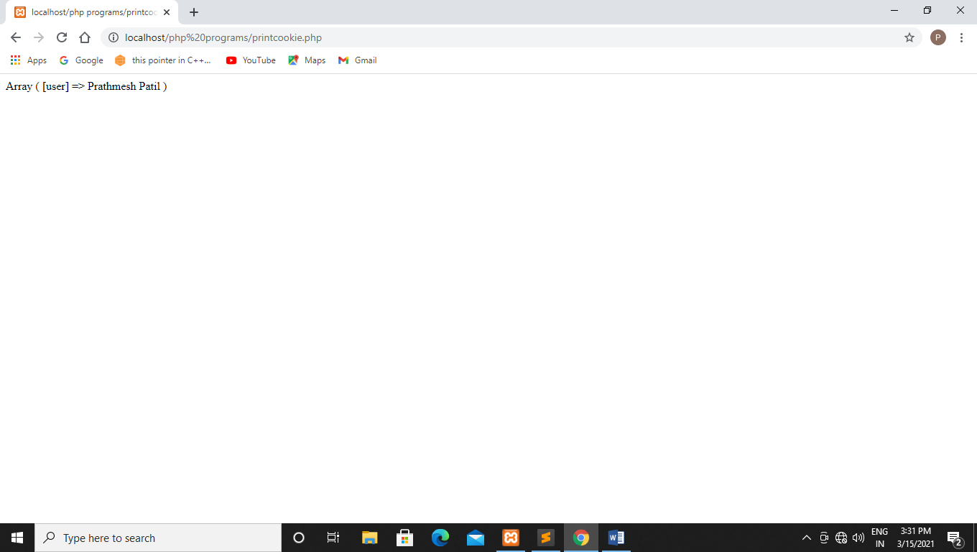

**Q74 Write a php program for create,delete,retrive cookie in one single program using form method.**

**Code:-**

<!DOCTYPE html>

<html>

<head>

<title>COOKIE EXAMPLE</title>

</head>

<body>

<form action="formcookie.php" method='POST' class="form">

<div class="row text-center p-3 m-4">

<div class="col">

<button class="btn btn-dark" name="Mod-button">Modify Cookie value</button>

</div>

<div class="col">

<button class="btn btn-danger" name="Del-button">Delete cookie</button>

</div>

</div>

<div class="row text-center p-3 m-4">

<div class="col">

<button class="btn btn-success" name="chk-button">Check if cookie is enabled</button>

</div>

<div class="col">

<button class="btn btn-primary" name="Res-button">Set default cookie</button>

</div>

</div>

</form>

</body>

</html>

<?php

if(isset($_POST['Mod-button'])){

modifyCookie();

}

if(isset($_POST['Del-button'])){

delCookie();

}

if(isset($_POST['chk-button'])){

checkCookie();

}

if(isset($_POST['Res-button'])){

resetCookie();

}

function checkCookie(){

$cookieName = "user";

$cookieValue= "Prathmesh Patil";

setcookie($cookieName,$cookieValue,time()-180,"/");

if (count($_COOKIE)>0) {

echo "<h1 class='text-success text-center'>Cookies Are enabled!<h1>";

}else{

echo "<h1 class='text-danger text-center'>Cookies Are not Enabled</h1>";

}

}

function delCookie(){

$cookieName="user";

setcookie($cookieName,"",time()-9999,"/");

if(isset($_COOKIE['$cookieName'])){

echo "<h4 class='text-center'>Cookie : $cookieName is now Deleted </h4><h1

class='text-muted text-center'>You may set cookie by </h1><h4 class='text-muted text-center'>

Clicking modify button or reset button </h4>";

}

}

function chkCookie($cookieName){

if (isset($_COOKIE[$cookieName])) {

echo '<script type="text/JavaScript">alert("If you don\'t see any change, then kindly

reload the page once again ");</script>';

echo "<h1 class='text muted text-center'>COOKIE SET!</h1>";

$x = $_COOKIE[$cookieName];

echo "<h4 class='text-muted text-center'>Cookie Name:$cookieName<br>Value:

$_COOKIE[$cookieName]</h4>";

}else{

echo "<h4 class='text-center'>Cookie : $cookieName is not set </h4><h1 class='text-muted text-center'>

SETTING COOKIE...</h1><h4 class='text-muted text-center'>RELOAD THE PAGE NOW</h4>";

}

}

function modifyCookie(){

$cookieName="user";

$cookieValue="Prathmnesh P";

setcookie($cookieName, $cookieValue,time()+180,"/");

chkCookie($cookieName);

}

function resetCookie(){

$cookieName="user";

$cookieValue="Prathmesh Patil";

setcookie($cookieName,$cookieValue,time()+180,"/");

chkCookie($cookieName);

}

**Output:-**

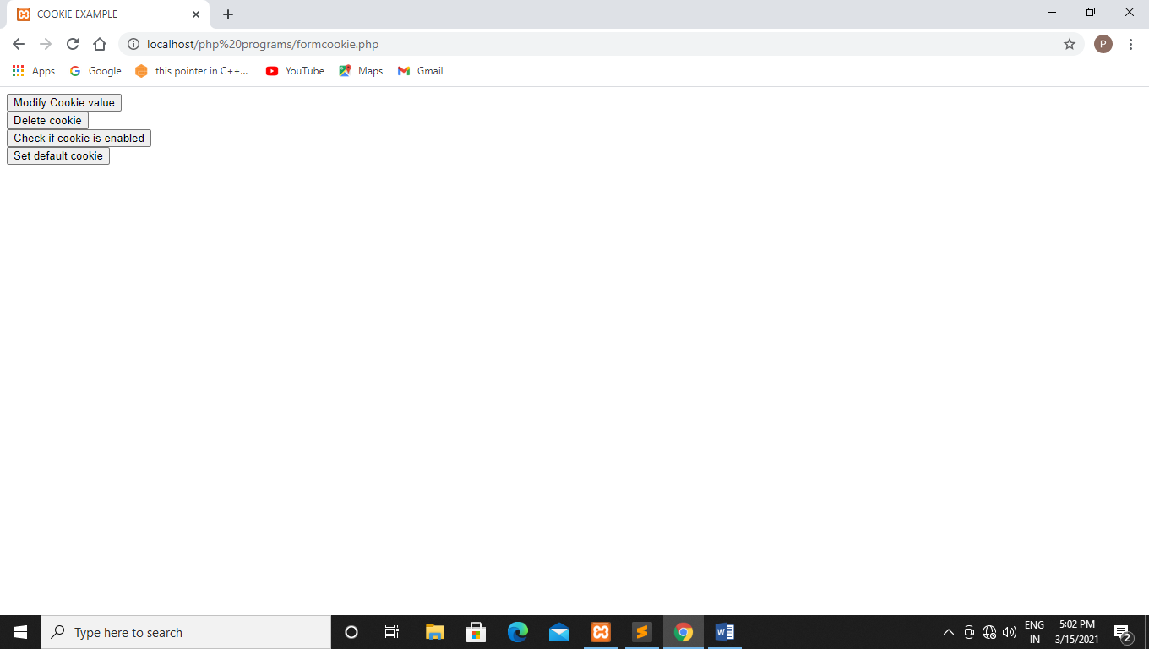

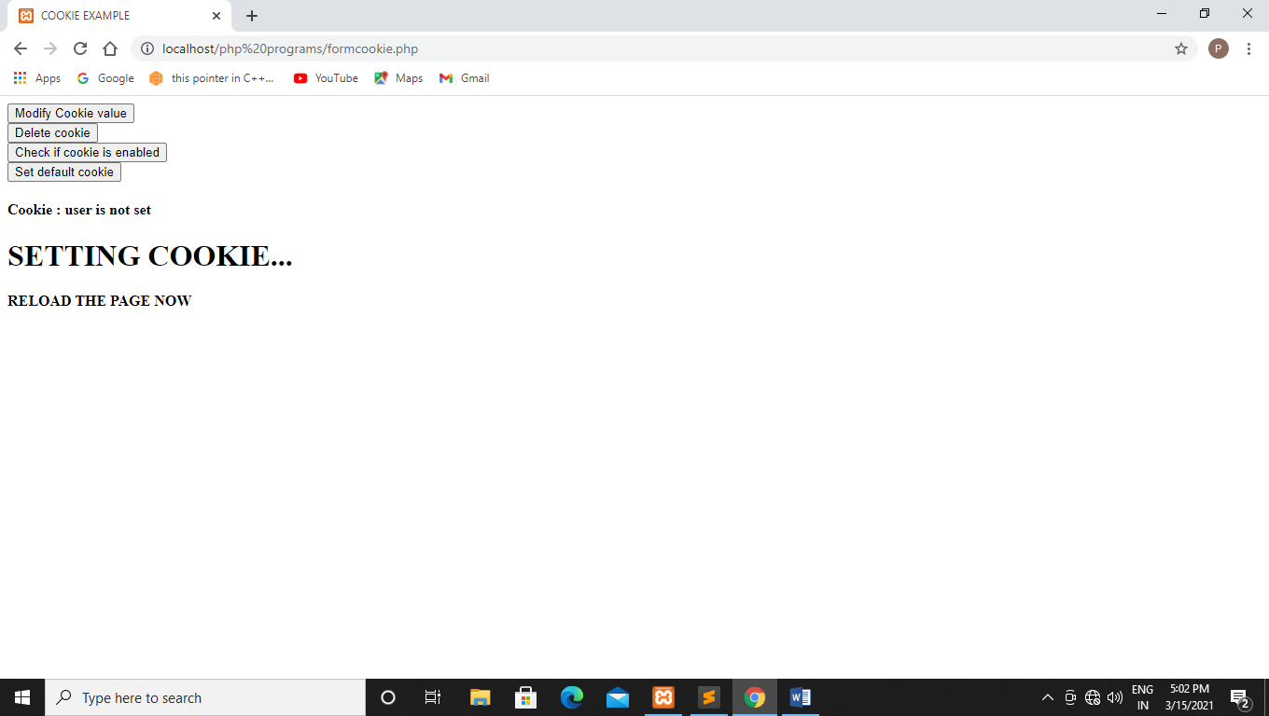

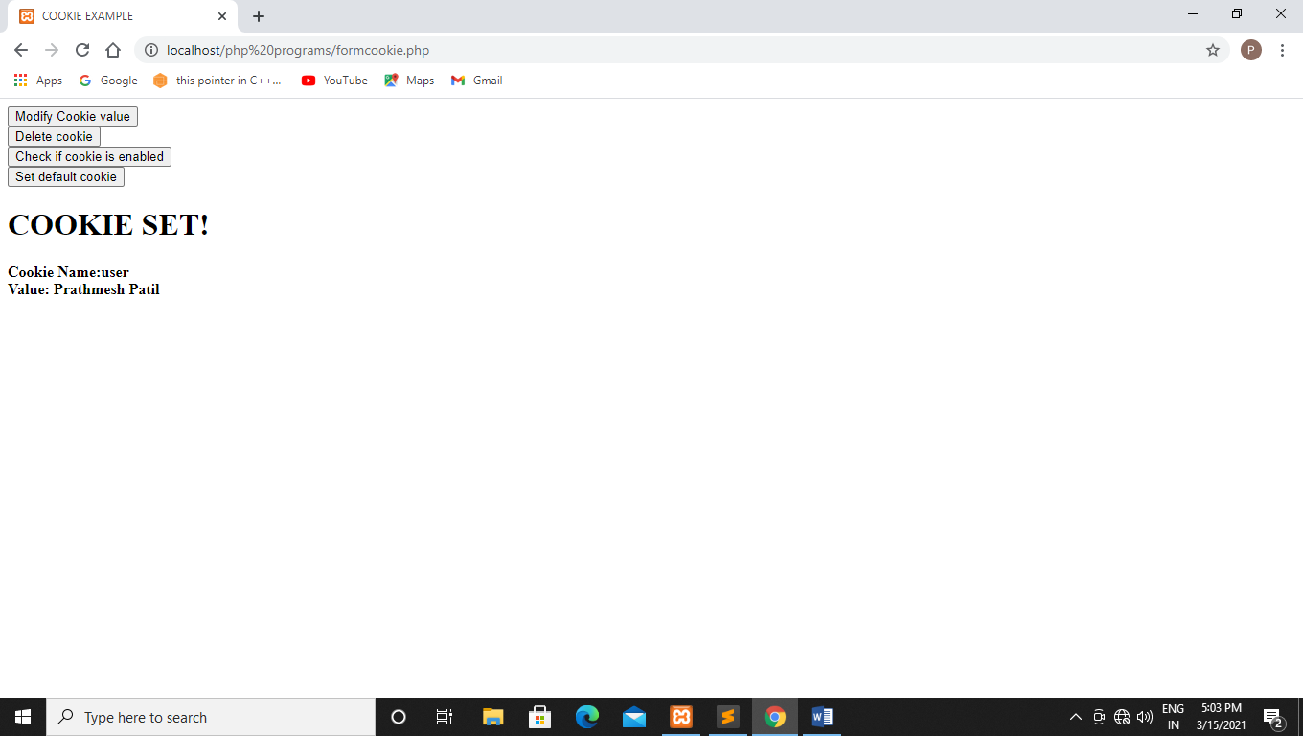

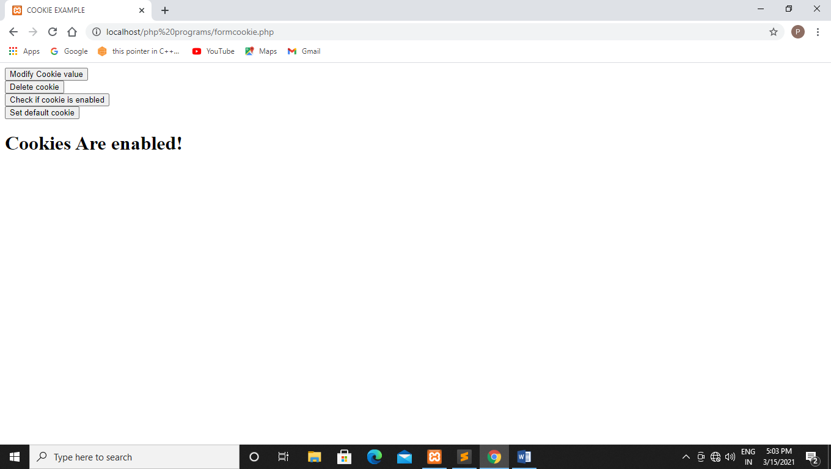

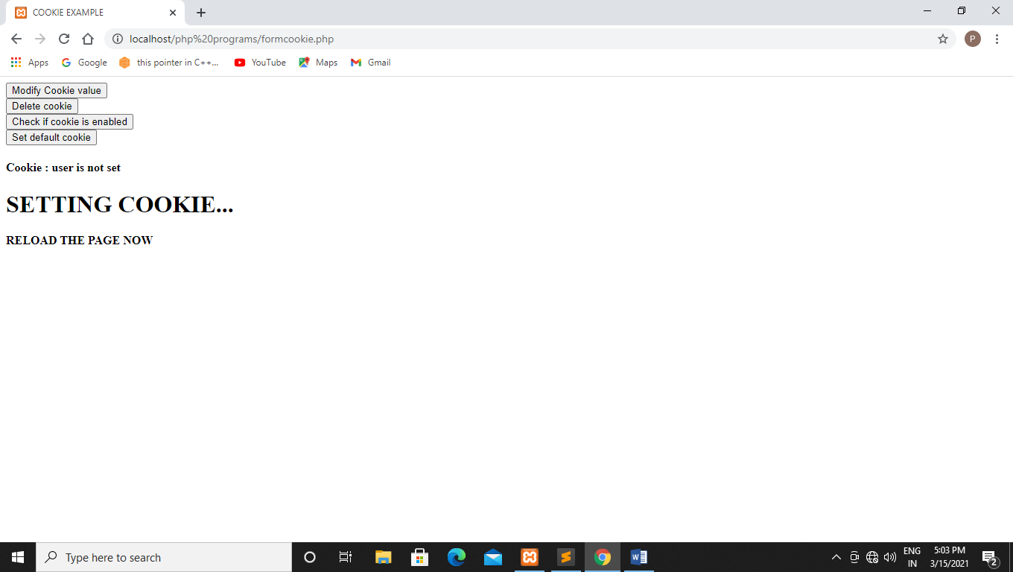

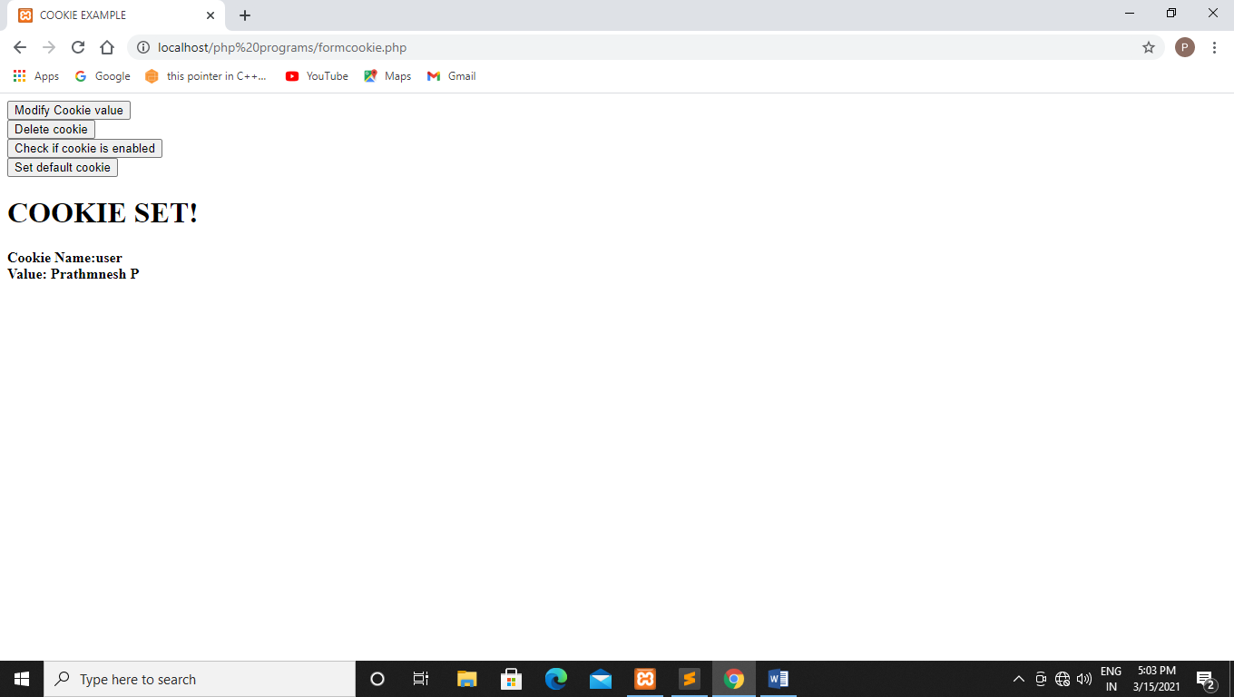

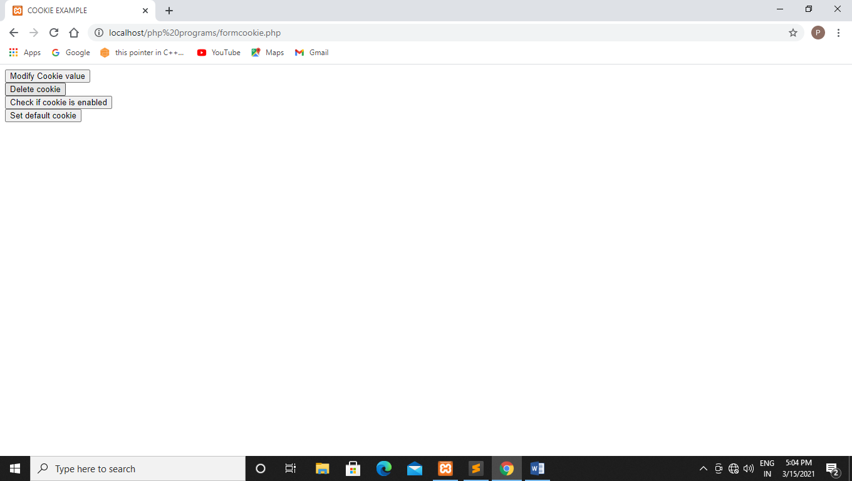

**22-3-2021**

**Experiment no:-10**

**Q75 Write a php program to start a session.**

**Code:-**

<?php

session_start();

echo "Session started";

?>

**Output:-**

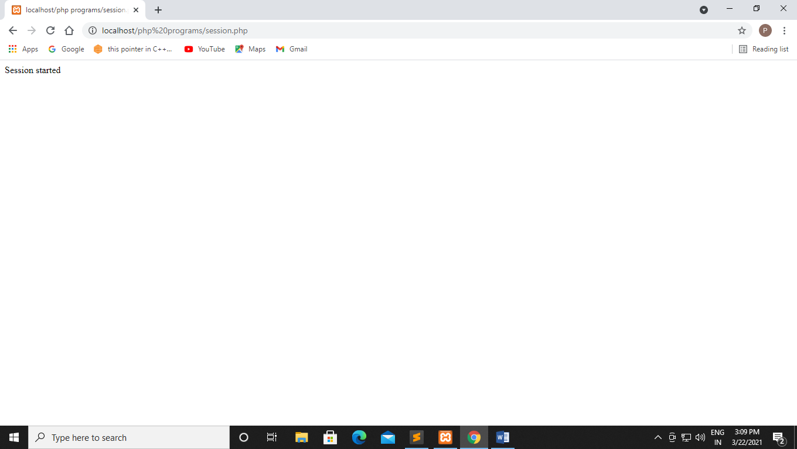

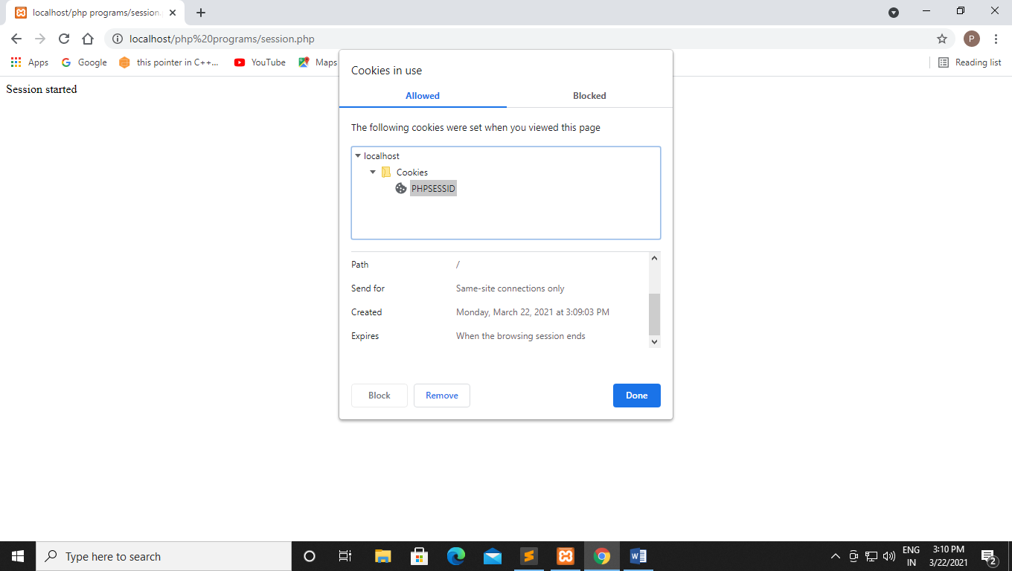

**Q76 Write a php program to storing and accessing session data.($_SESSION is a super global array and 2 session variables is created firstname and lastname)**

**Code:-**

<?php

//starting session

session_start();

//storing session data

$_SESSION["firstname1"]="Prathmesh";

$_SESSION["lastname1"]="Patil";

?>

**Output:-**

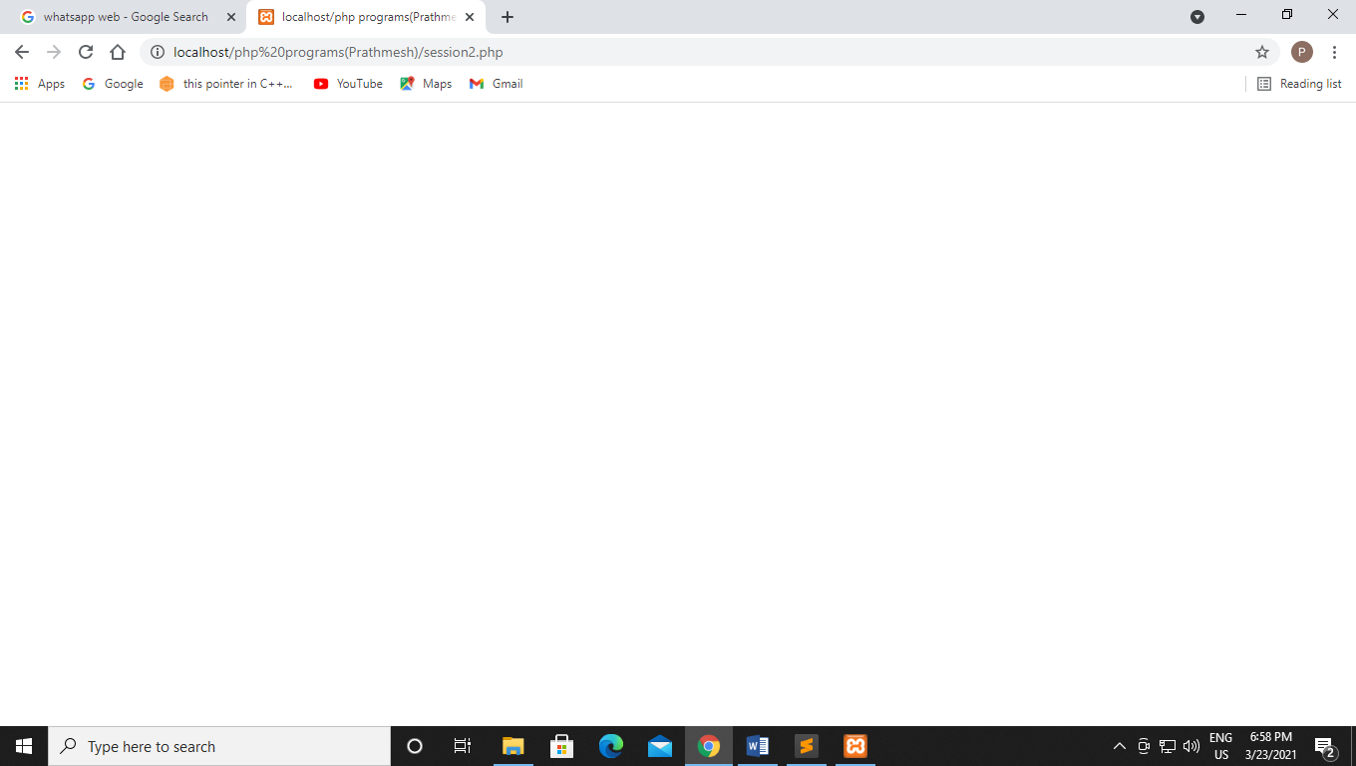

**Q77 Write a php program to access the session data of previous session.**

**Code:-**

<?php

session_start();

//accessing session data

echo'Hi,'.$_SESSION["firstname1"].''.$_SESSION["lastname1"];

?>

**Output:-**

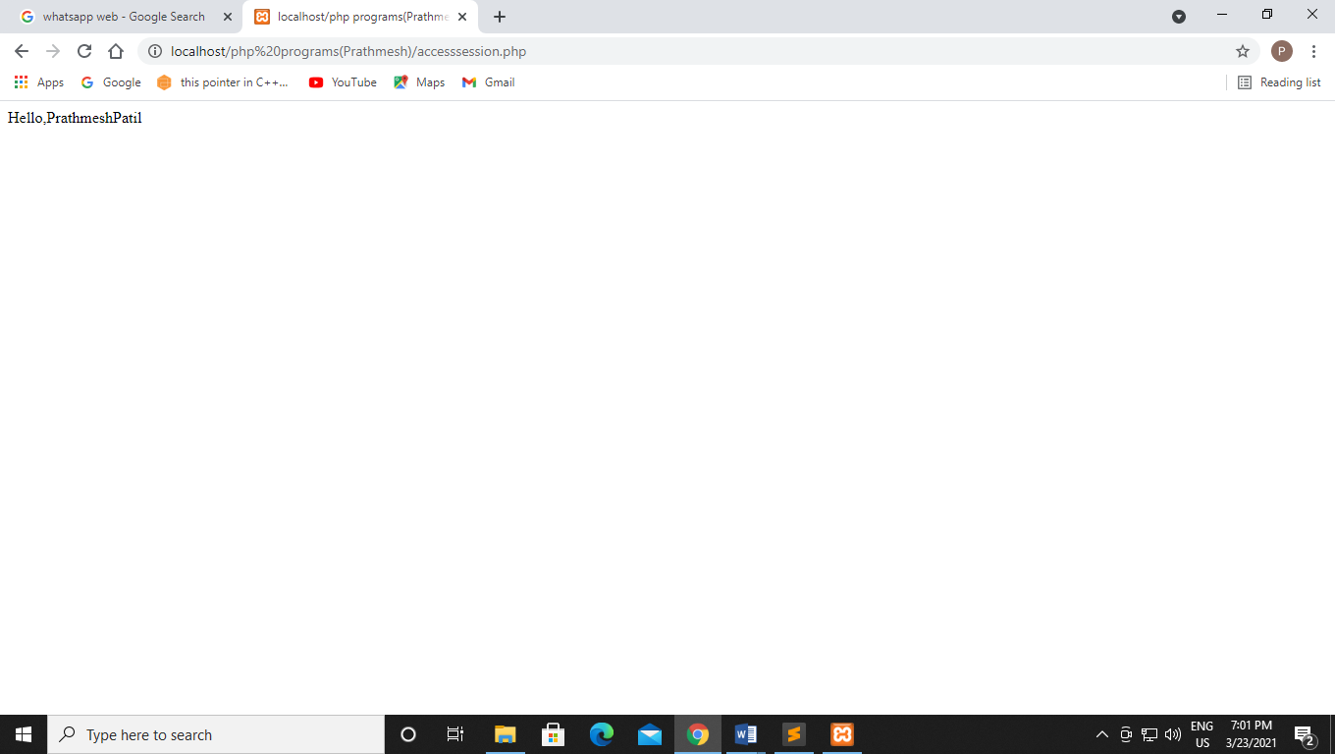

**Q78 Write a PHP program to print the value of session id using PHP session  
Code:-**

<?php

session_start();

echo session_id();

?>

**Output:_**

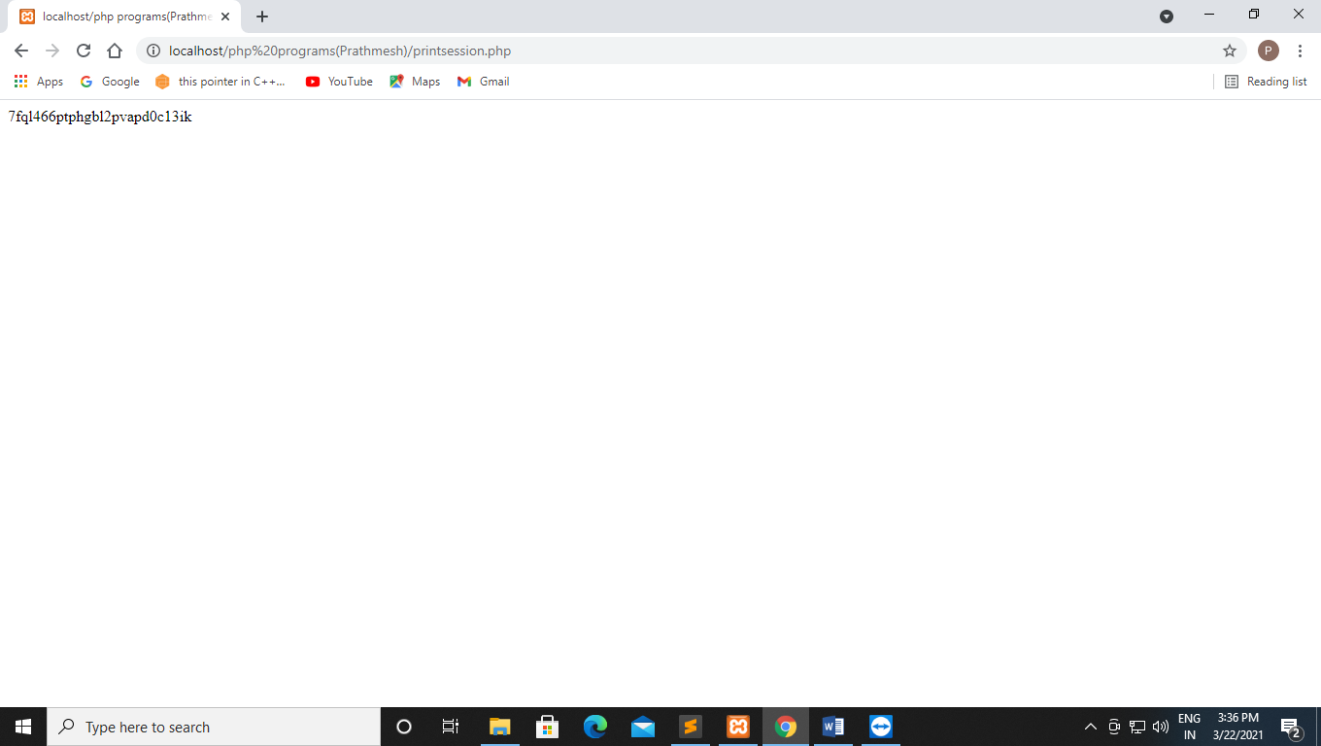

**Q79 Write a PHP program to destroy the session.**

**Code:-**

<?php

session_start();

//removing session data

if(isset($_SESSION["lastname1"])){

unset($_SESSION["lastname1"]);

}

?>

**Output:-**

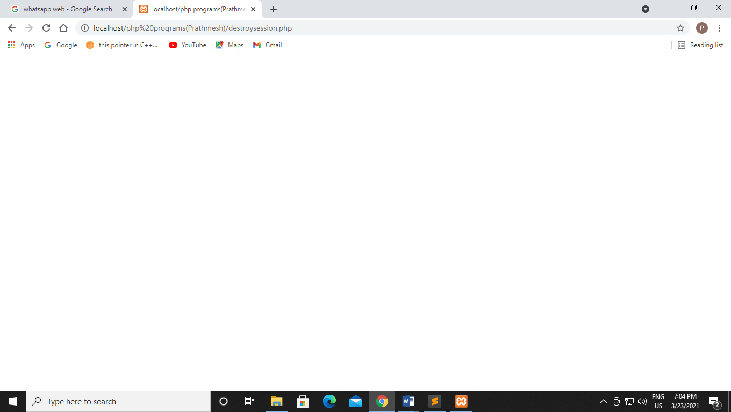

**After accessing the session:-**

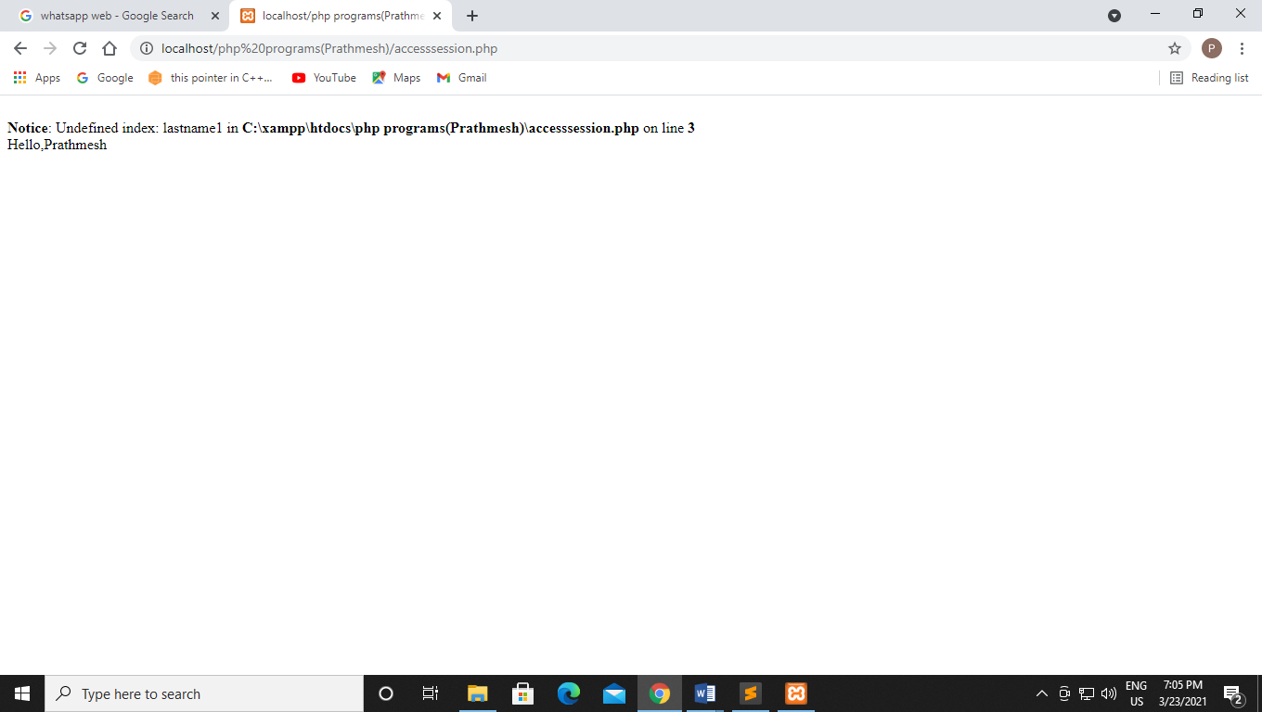

**Q80 Write a php program to destroy session completely.**

**Code:-**

<?php

session_start();

//destroying session

session_destroy();

?>

**Output:-**

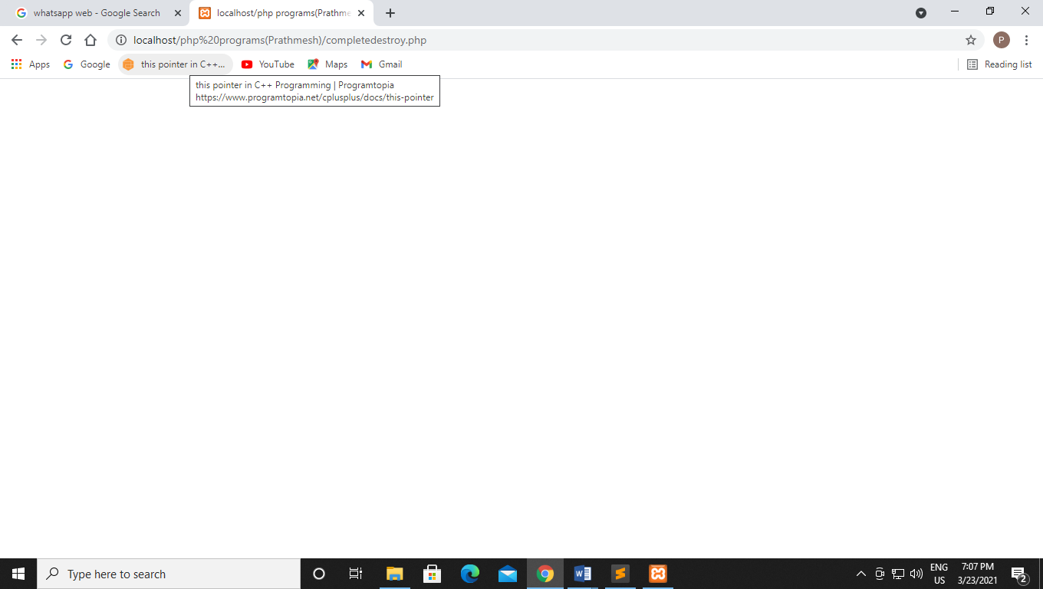

**After accessing the session:-**

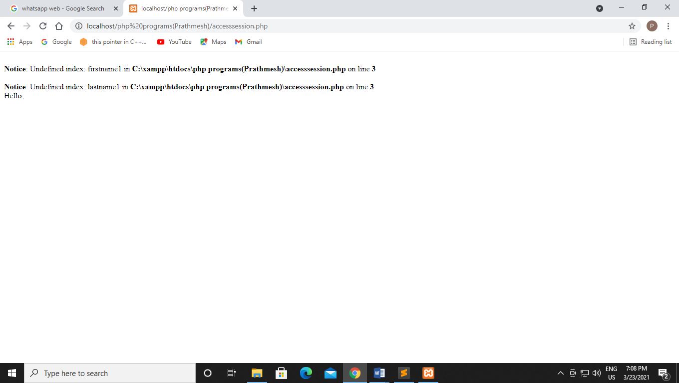

**Q81 Write a PHP program to increase counter value every time user visits page using session**

**Code:-**

<?php

session_start();

if (isset($_session['page_count'])) {

$_session['page_count'] +=1;

}

else

{

$_session['page_count'] =1;

}

echo "You are visitor number ".$_session['page_count'];

?>

**Output:-**

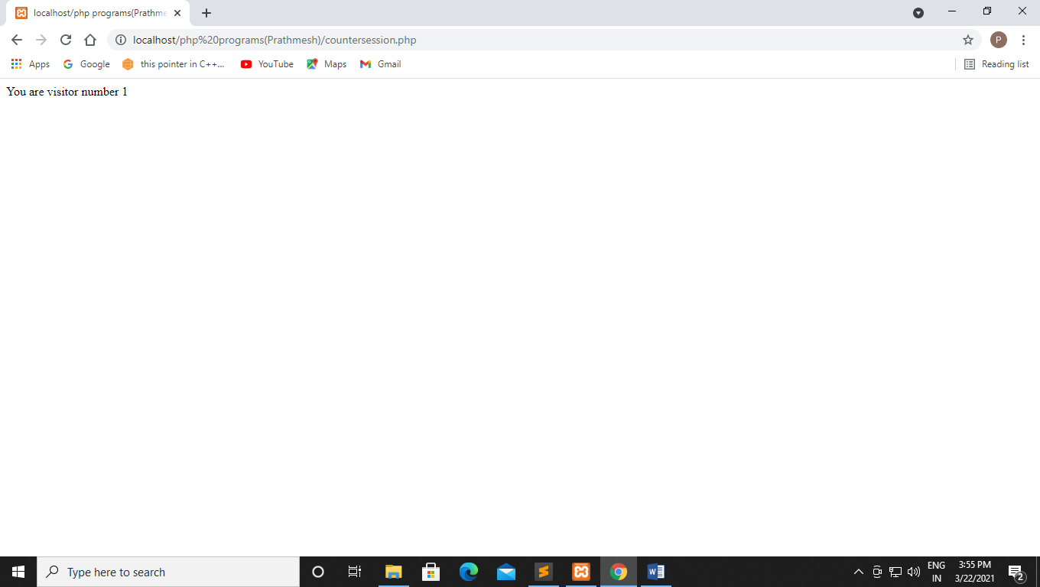

**Q82 Write a php code for destroying the counter session.**

**Code:-**

<?php

session_start();

if(isset($_SESSION['page_count']))

{

$_SESSION['page_count'] += 1;

}

else

{

$_SESSION['page_count'] = 1;

}

echo "you are visitor number" . $_SESSION['page_count'];

session_destroy();

?>

**Output:-**

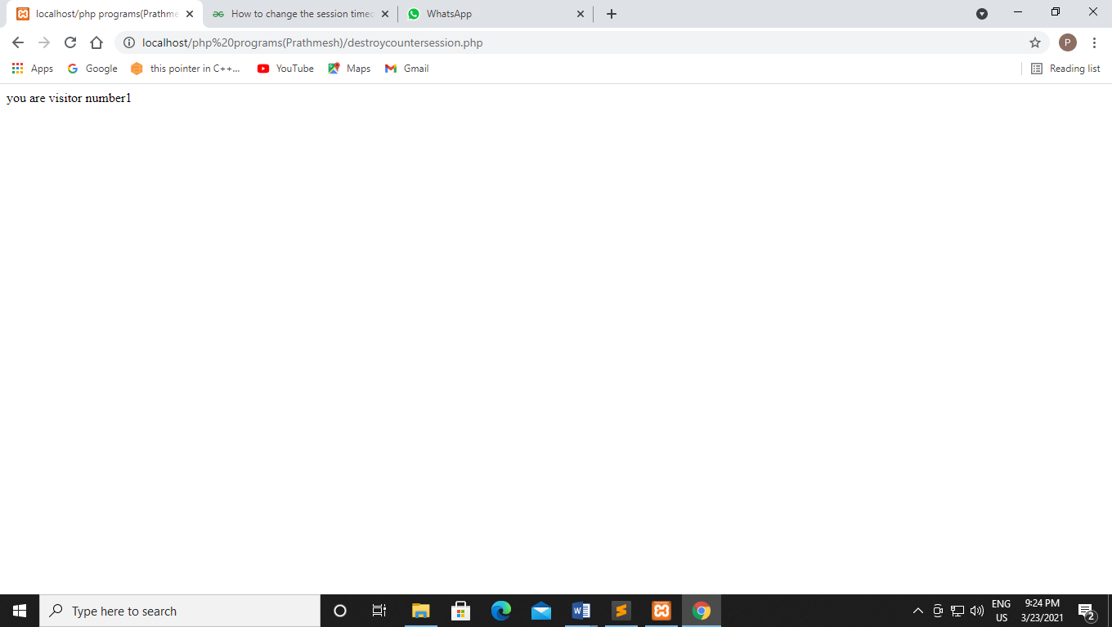

**Q83 Write a PHP code using session such that session will expire if user does not refresh page within 20 seconds. After 20 seconds if the page is not refreshed session will expire.**

**Code:-**

<?php

session_start();

$user="Prathmesh";

echo "this session will expired within 20 sec please refresh the page ";

$_SESSION["user"]=$user;

$_SESSION["user"]=time();

if (time() - $_SESSION["user"] > 20) {

echo "\n The page is refresh";

}

else {

session_destroy();

echo "this page is expired";

}

**Output:-**

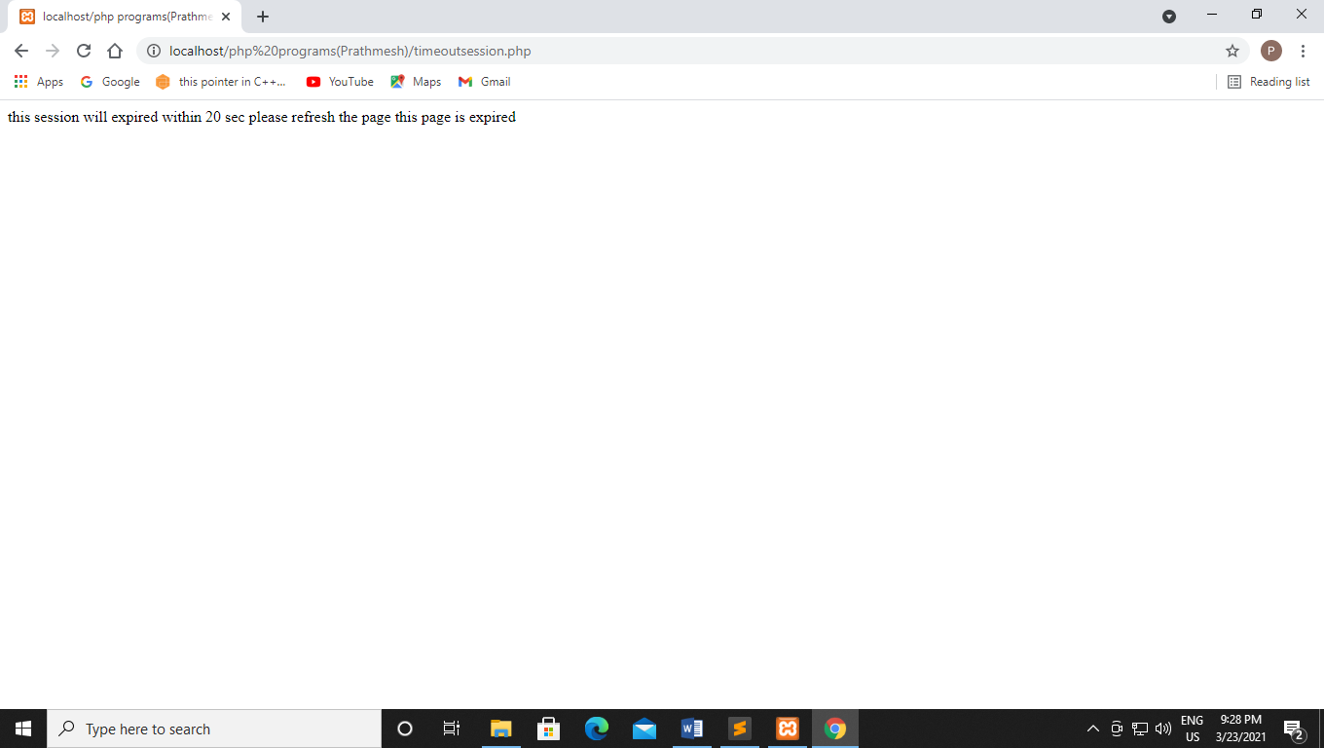

**Q84 Write a php to create a file which does not exist in drive using fopen()**

**Code:-**

<?php

$myfile=fopen("file.txt","w");

?>

**Output:-**

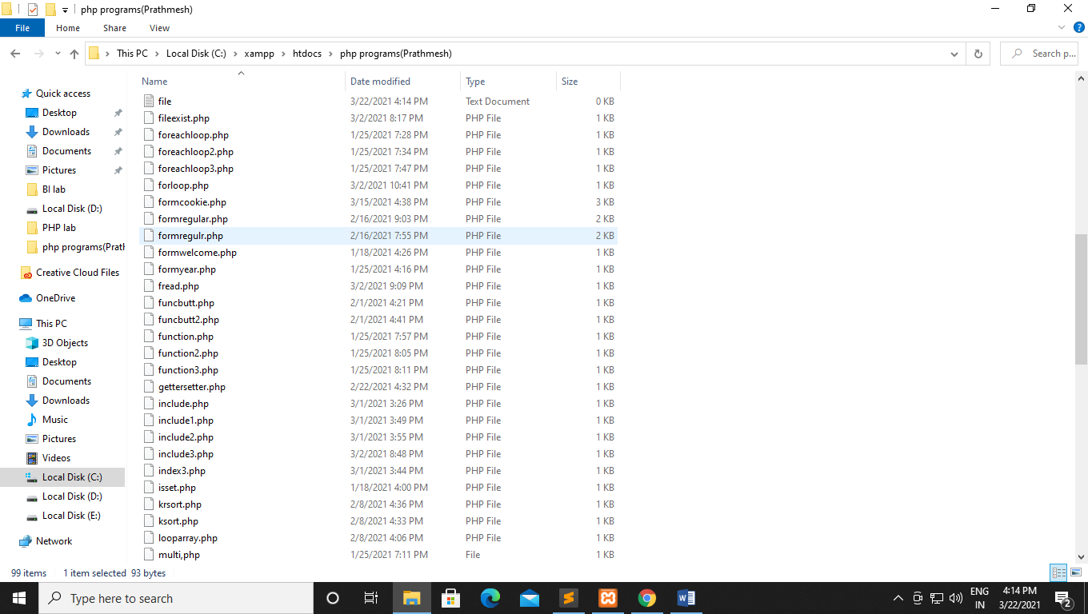

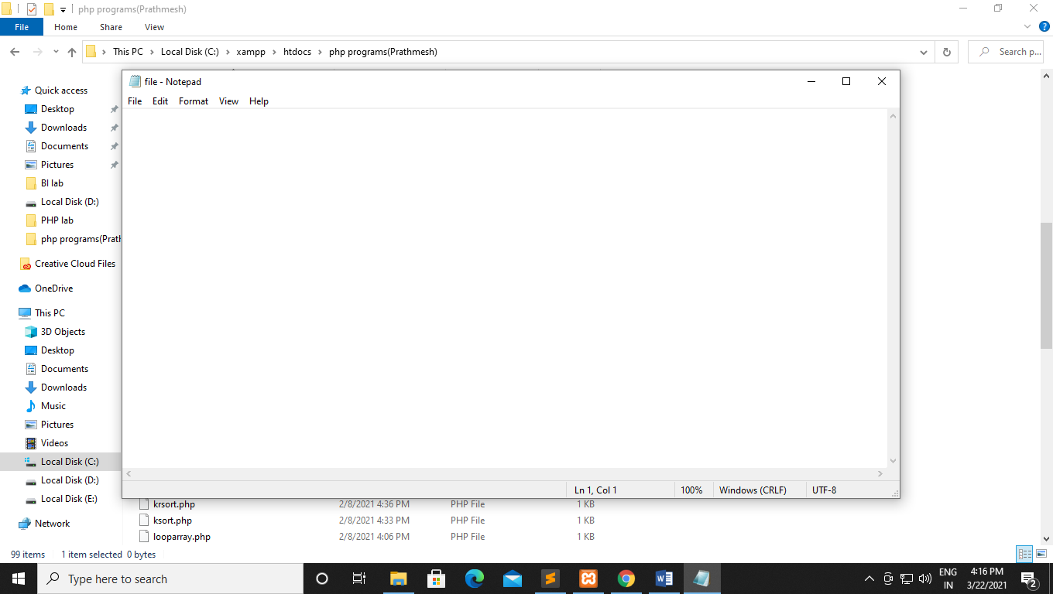

**Q85 Write a php program to create a file and write to the file.**

**Code:-**

<?php

$fp = fopen('data.txt','w');

fwrite($fp,'hello Prathmesh');

fwrite($fp, 'Welcome to the php write file');

fclose($fp);

echo "File has been written successfully";

?>

**Output:-**

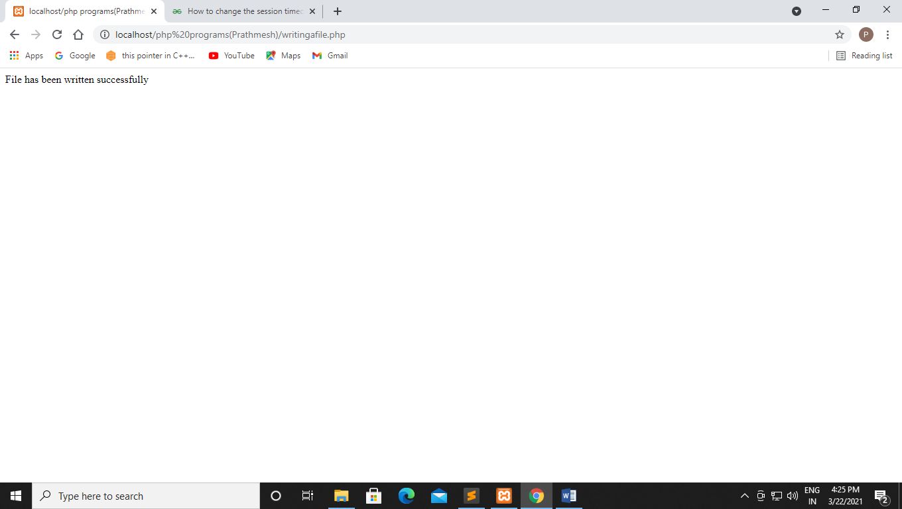

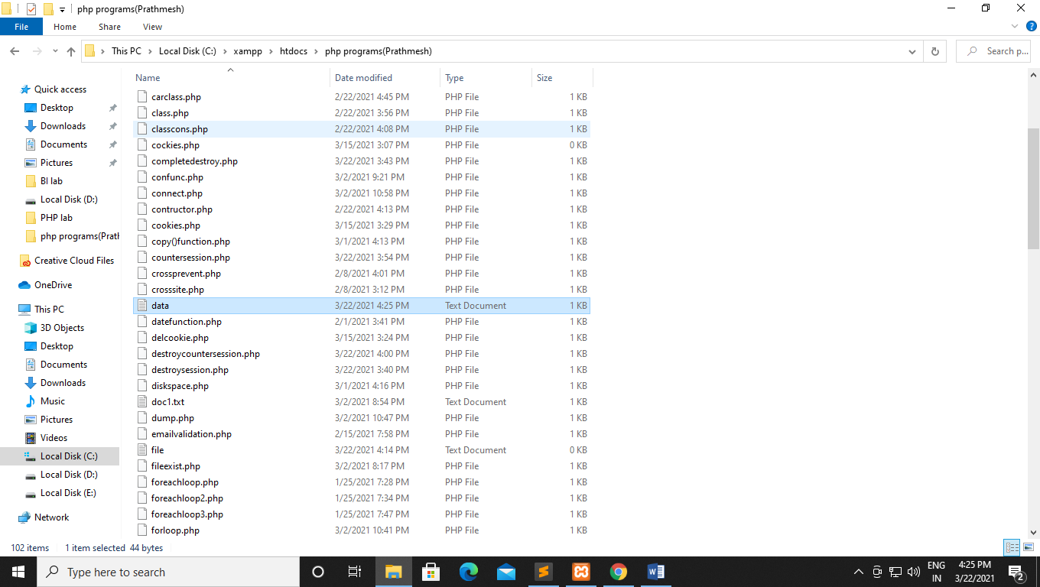

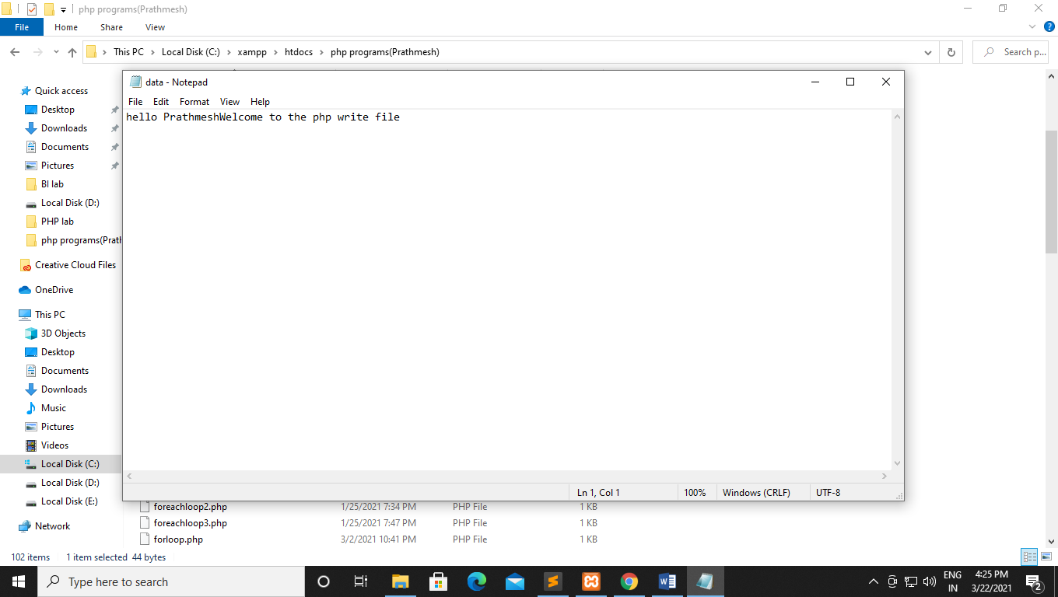

**Q86 Write a php program to create a file and overwrite it.**

**Code:-**

<?php

$fp = fopen('data.txt','w');

fwrite($fp,'hello');

fclose($fp);

echo "File has been overwritten successfully";

?>

**Output:-**

**Before Overwrite:-**



**After Overwrite:-**

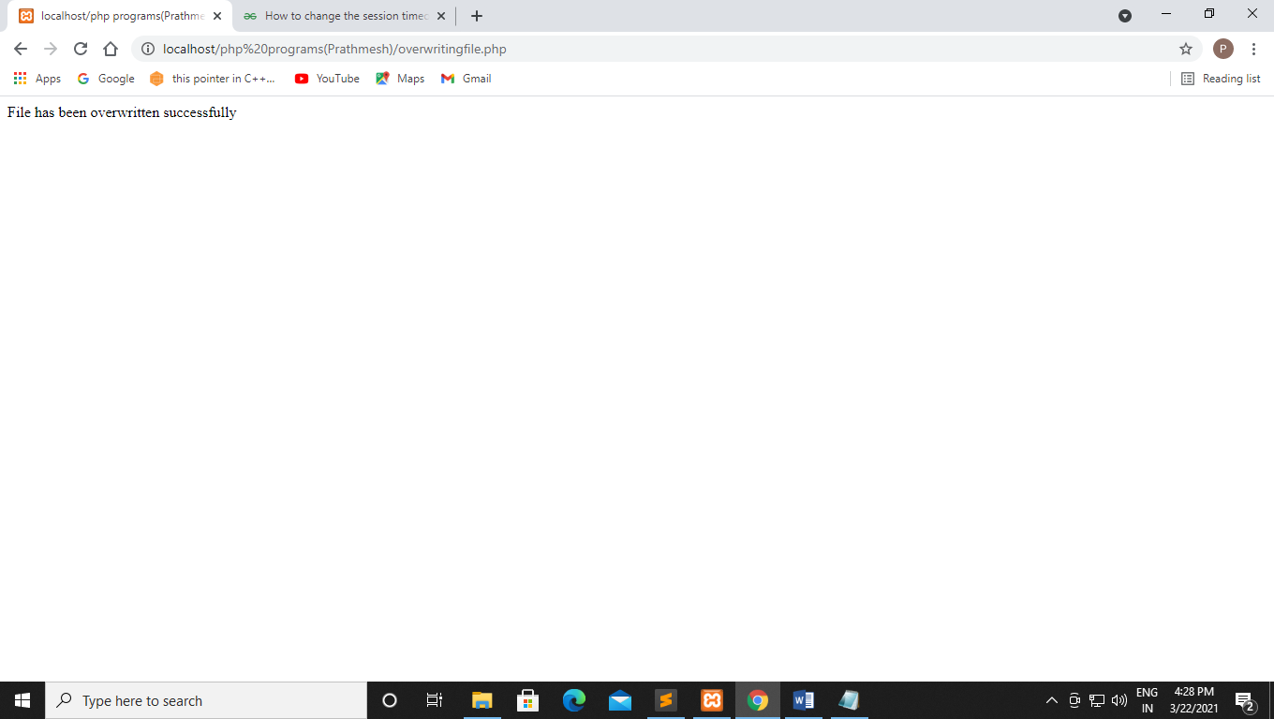

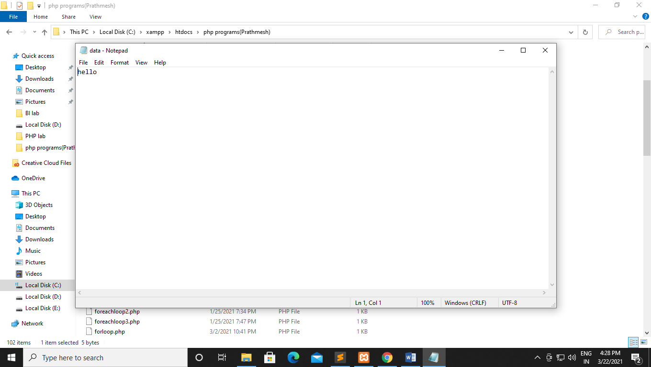

**Q87 Write a PHP program to append the file**

**Code:-**

<?php

$fp=fopen('data.txt','w');

fwrite($fp,'keep');

fwrite($fp,'smiling');

fclose($fp);

echo "File written successfully";

?>

**Output:-**

**Before append:-**



**After append:-**

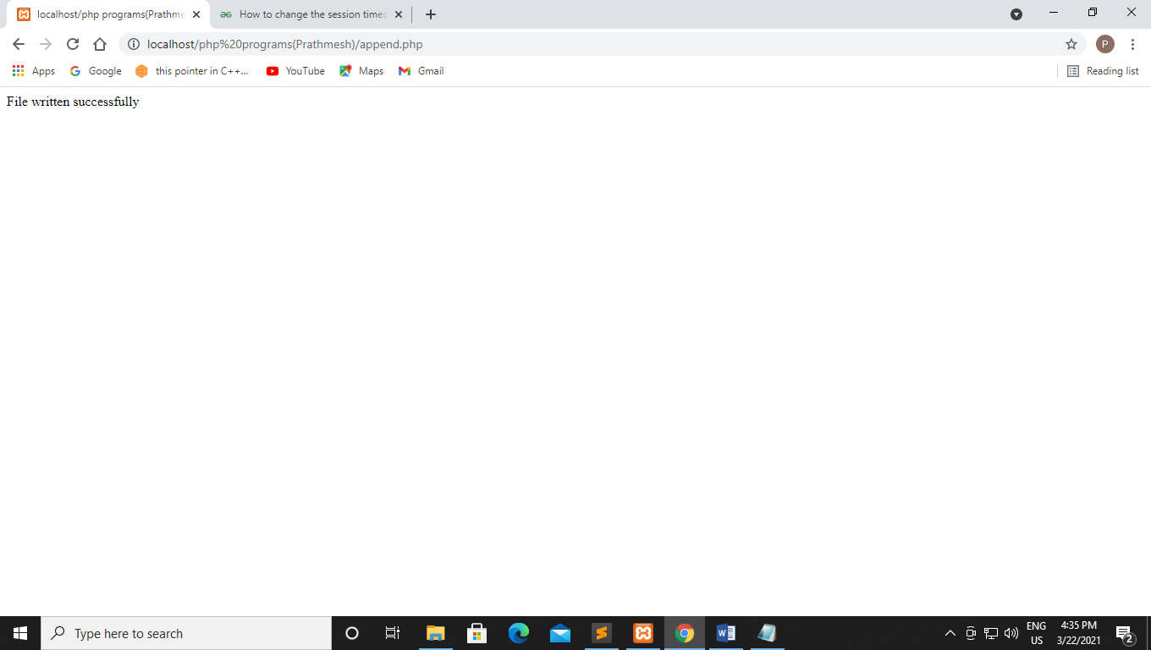

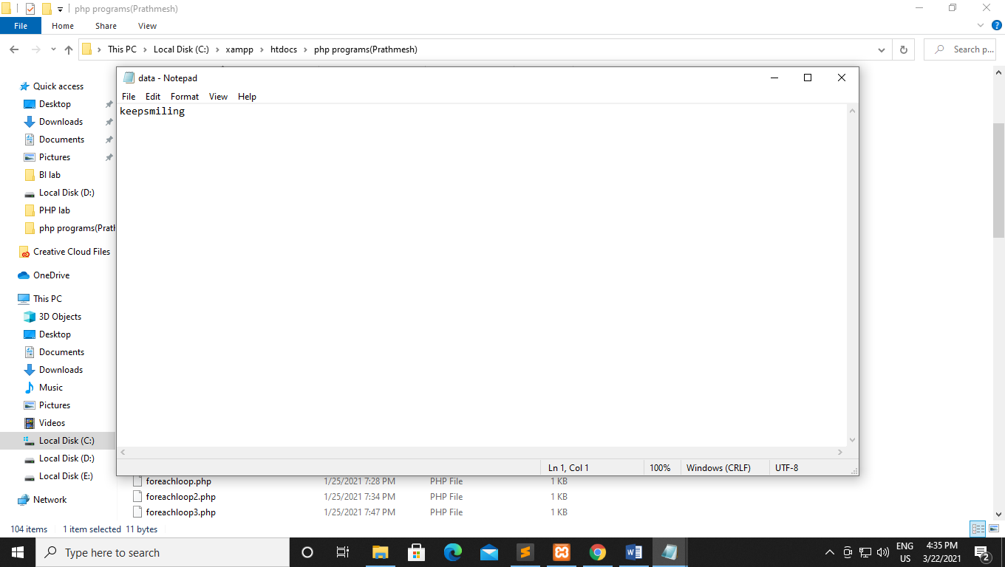

**Q88 Write a php program to read the content of the file**

**Code:-**

<!DOCTYPE html>

<html>

<head>

<title></title>

</head>

<body>

<?php

echo readfile("data.txt");

?>

</body>

</html>

**Output:-**

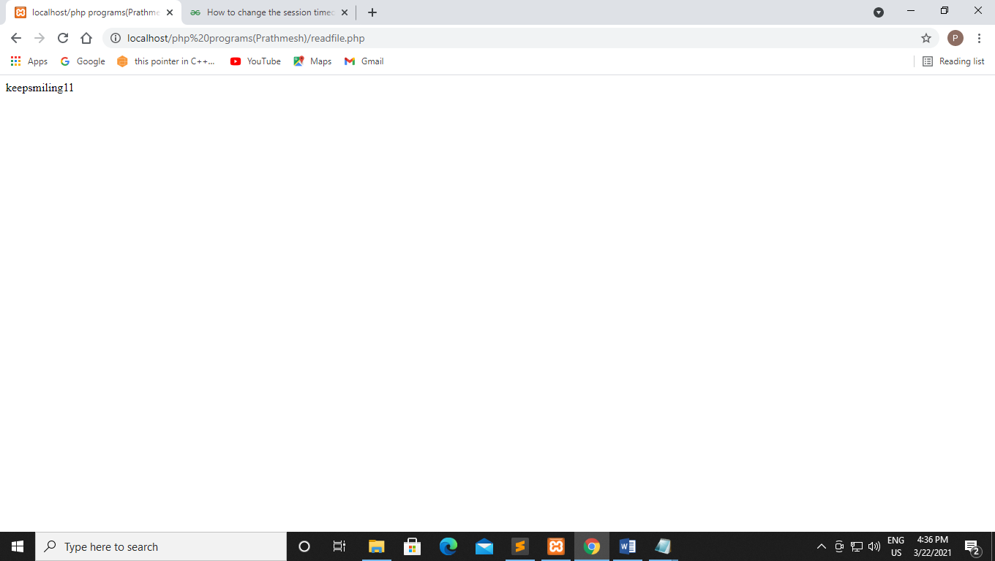

**Experiment no 11**

**Q89 Write a php program for read the content of text file using fread() and filesize()**

**Code:-**

<!DOCTYPE html>

<html>

<head>

<title></title>

</head>

<body>

<?php

$myfile=fopen("data.txt", "r") or die("Unable to open the file!!");

echo fread($myfile,filesize("data.txt"));

fclose($myfile);

?>

</body>

</html>

**Output:-**

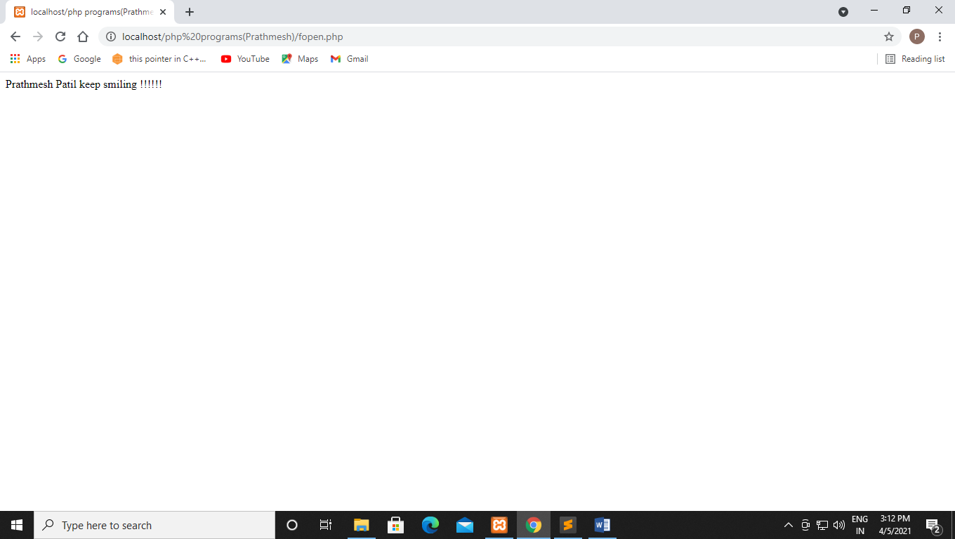

**Q90 Write a php program to read 12 bytes of the file**

**Code:-**

<!DOCTYPE html>

<html>

<head>

<title></title>

</head>

<body>

<?php

$myfile=fopen("data.txt", "r") or die("Unable to open the file!!");

echo fread($myfile,filesize("data.txt", 12));

fclose($myfile);

?>

</body>

</html>

**Output:-**

**Q91 Write a php program for fgets() function.**

**Code:-**

<?php

$myfile = fopen("data.txt", "r");

echo fgets($myfile);

fclose($myfile);

?>

**Output:-**

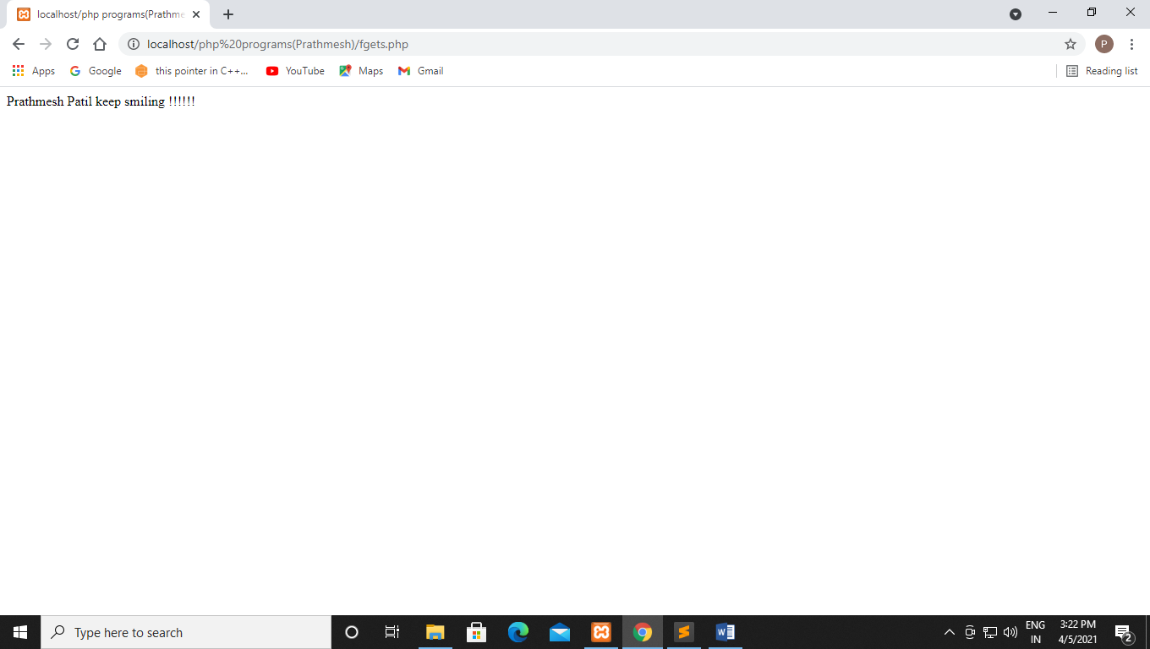

**Q92 Write a Php program for read a file character by character using fgetc()**

**Code:-**

<?php

$myfile = fopen("data.txt", "r");

while (!feof($myfile)) {

echo fgetc($myfile);

}

fclose($myfile);

?>

**Output:-**

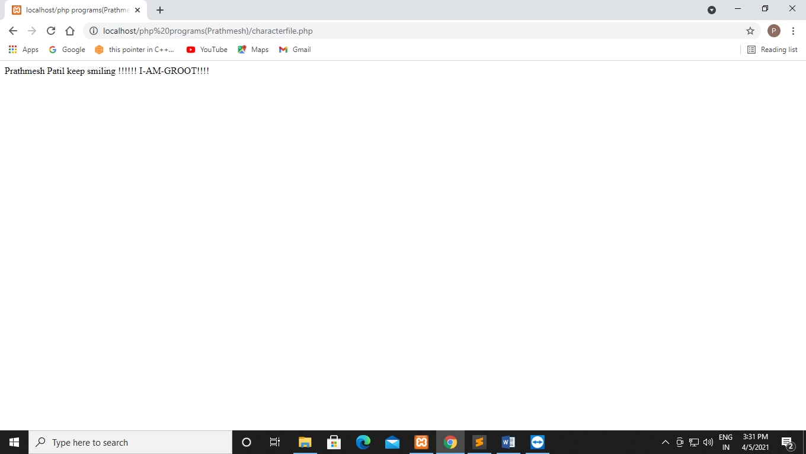

**Without While:-**

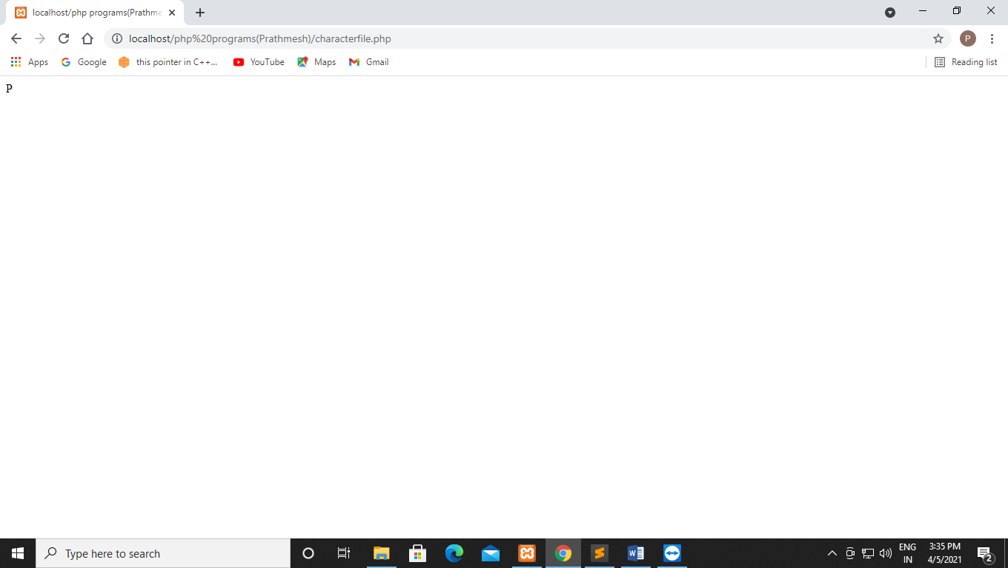

**Q93 Write a php program for deleting file.**

**Code:-**

<?php

if (!unlink("data.txt")) {

echo "Could not delete a file";

}

else

{

echo "File deleted successfully";

}

?>

**Output:-**

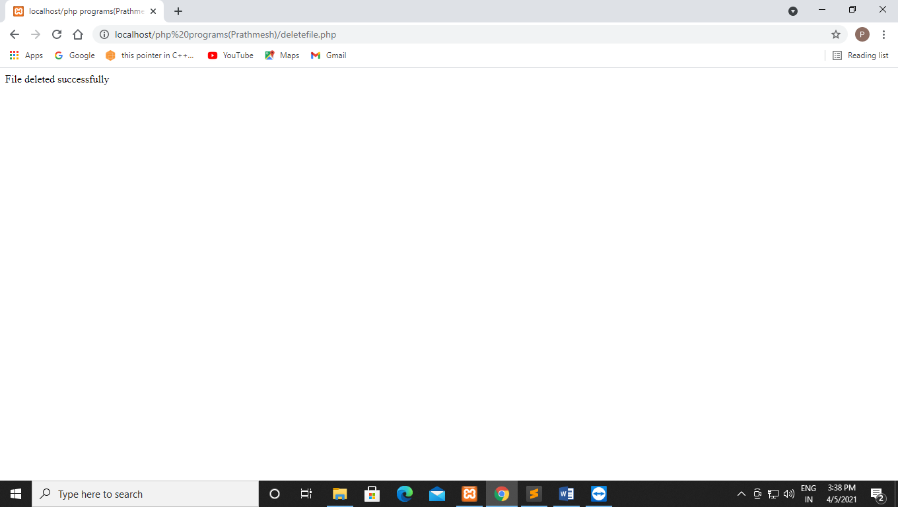

**Q94 Write a php program for creating hyperlinks and insert data to text file on clicking the hyperlink.Use include statement also.**

**Code:-**

**Index.php:-**

<!DOCTYPE html>

<html>

<head>

<title></title>

</head>

<body>

<ul>

<li><a href="./includeEx.php">Include Example</a></li>

<li><a href="./appendEx.php">Append Example</a></li>

</ul>

</body>

</html>

**includeEx.php:-**

<?php

include 'my_resource.php';

echo '

<a href="#">Home</a>

<a href="#">Gallery</a>

<a href="#">About us</a>

<a href="#">Contact us</a>

<br><br>';

echo "$x"

?>

**appendEx.php:-**

<?php

$fp = fopen('someText.txt','a');

fwrite($fp,"this is new text!");

fclose($fp);

echo "Appended successfully";

?>

**My_resouce.php:-**

<?php

$x="Text from other file";

?>

**Output:-**

**Index.php:-**

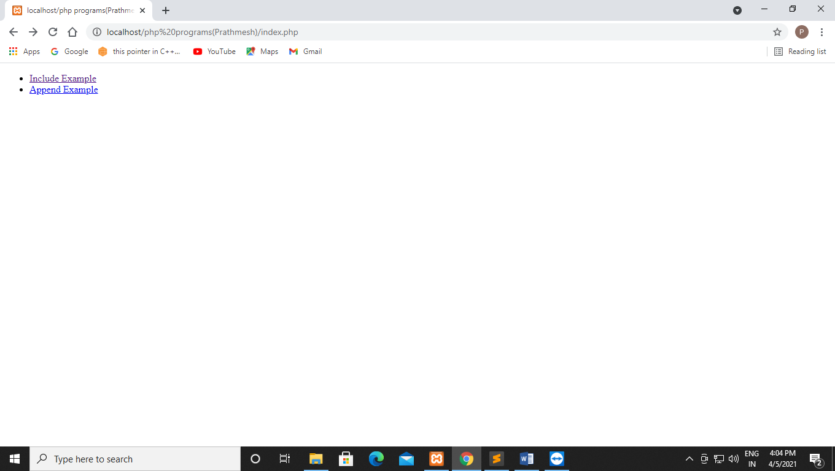

**includeEx.php:-**

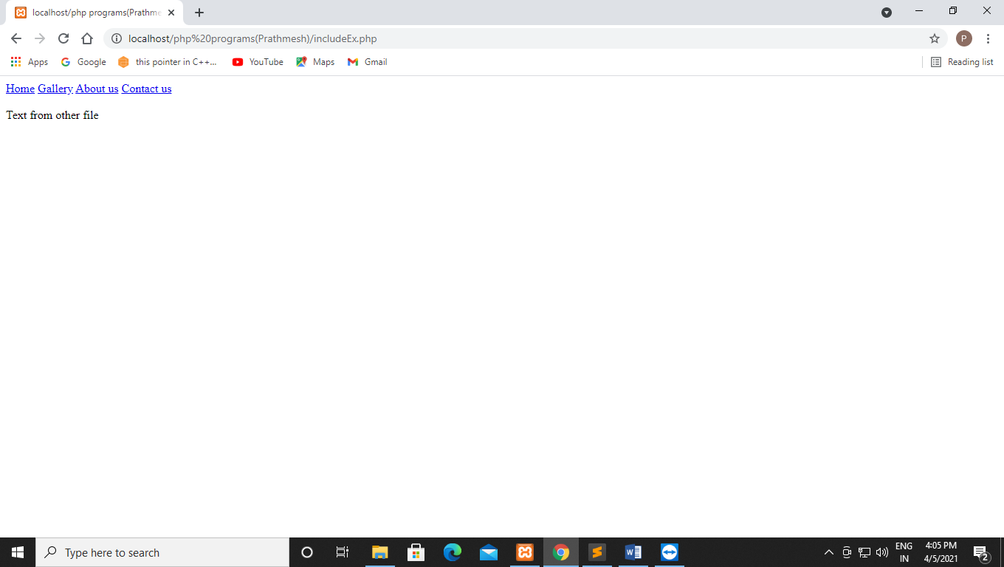

**appendEx.php:-**

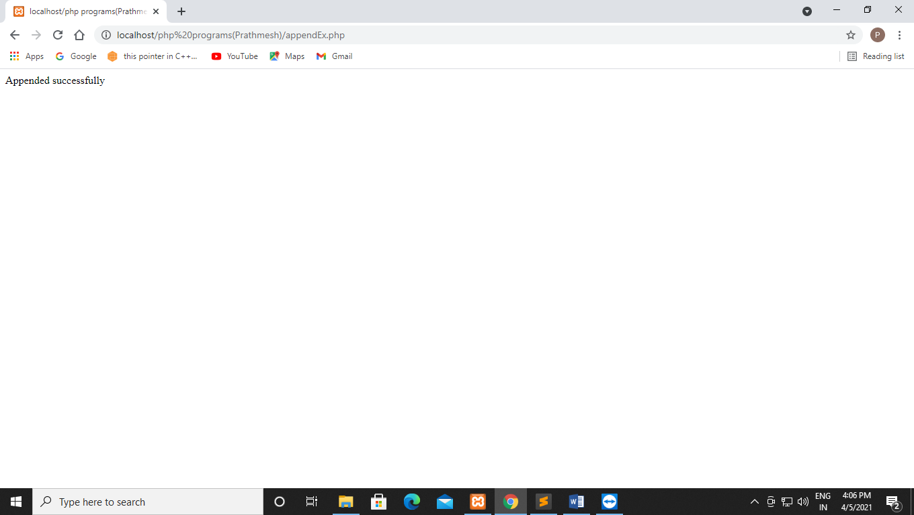

**Q95 Write a php program by using die() function handle the error if file does not exist**

**Code:-**

**By using die():-**

<?php

if (file_exists(",mytestfile.txt")) {

$file = fopen("mytestfile.txt", "r");

}

else{

die("Error: The file does not exist.");

}

?>

**Without die():-**

<?php

if (file_exists("kleembus.txt")) {

$file = fopen("kleembus.txt", "r");

}

else{

echo "Error: The file does not exist by without using die.";

}

?>

**Output:_**

**By using die():-**

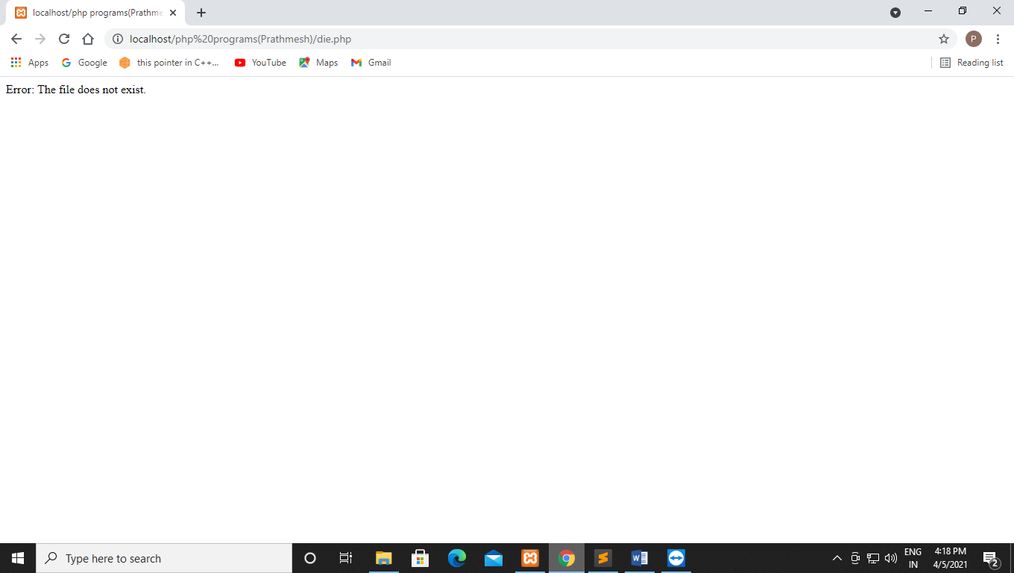

**Without die():-**

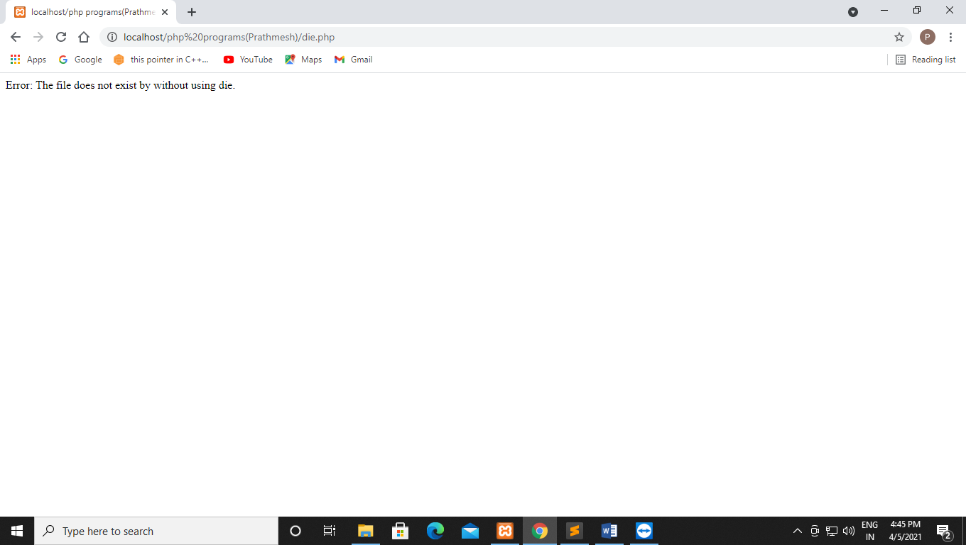

**Q96 Write a php programs for custom error handler**

**Code:-**

<?php

function php_error_handler($error_no, $error_msg){

echo "Ooops! Something went wrong......";

echo "Possible reason: " .$error_msg;

echo "We are working on it.";

}

set_error_handler("php_error_handler");

$result =7/0;

?>

**By using file which does not exist:-**

<?php

function php_error_handler($error_no, $error_msg){

echo "Ooops! Something went wrong......";

echo "Possible reason: " .$error_msg;

echo "We are working on it.";

}

set_error_handler("php_error_handler");

$myfile = fopen("abc.txt", "r");

?>

**Output:-**

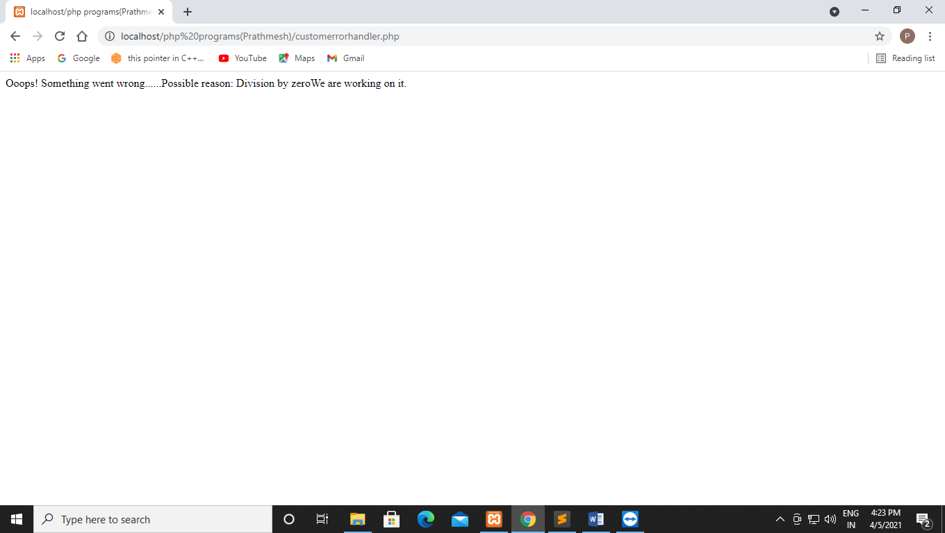

**By using file which does not exist:-**

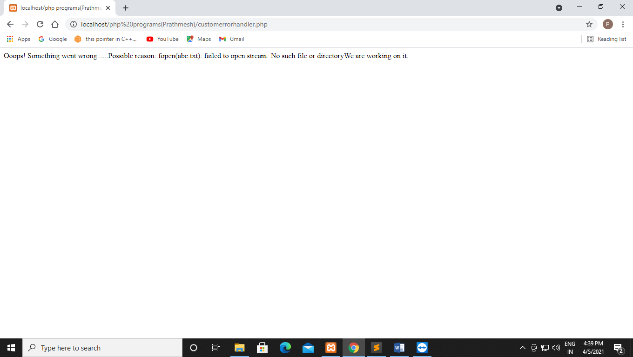

**12-4-2021**

**Experiment no 12**

**Q97 Using php and mysql create database**

**Code:-**

<?php

$link = mysqli_connect("localhost","root","");

if ($link === false) {

die("ERROR:_ Could not connect" .mysql_connect_error());

}

$sql = "CREATE DATABASE Demo";

if (mysqli_query($link,$sql)) {

echo "Database created successfully";

}

else{

echo "ERROR:-Could not able to execute $sql." .mysqli_error($link);

}

mysqli_close($link);

?>

**Output:-**

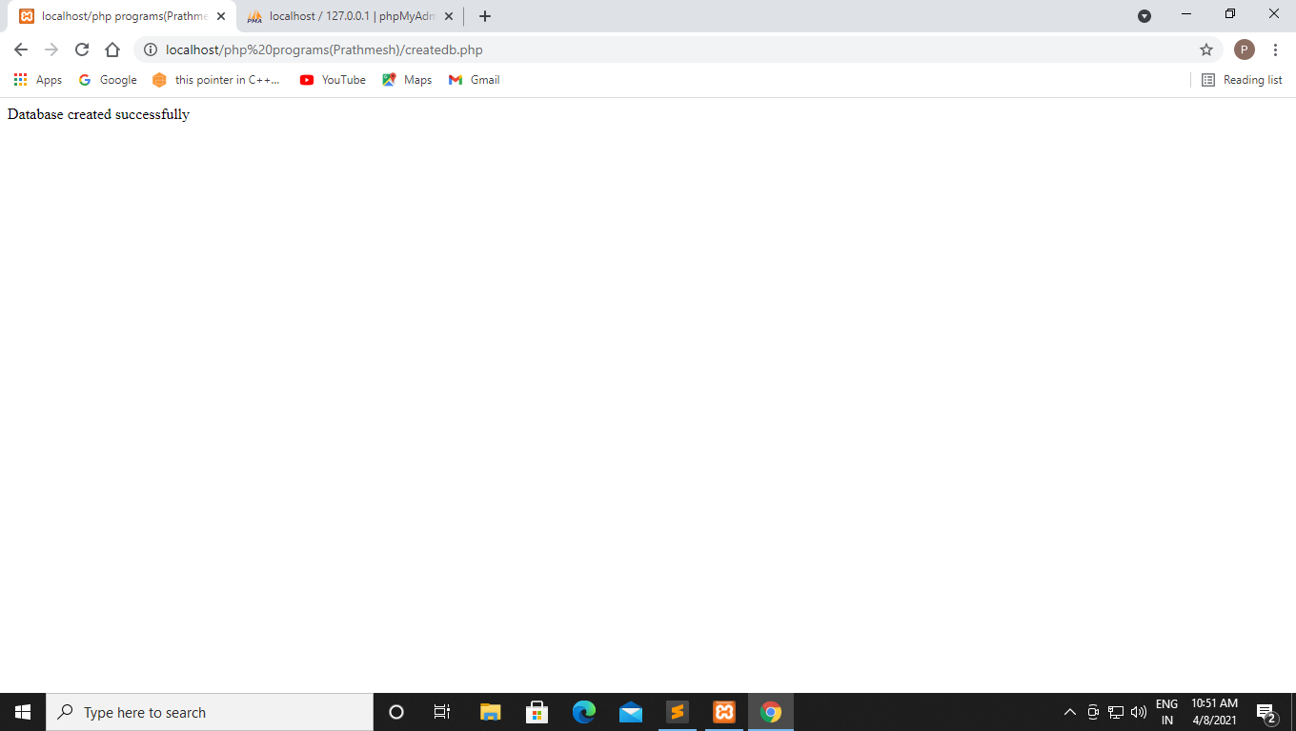

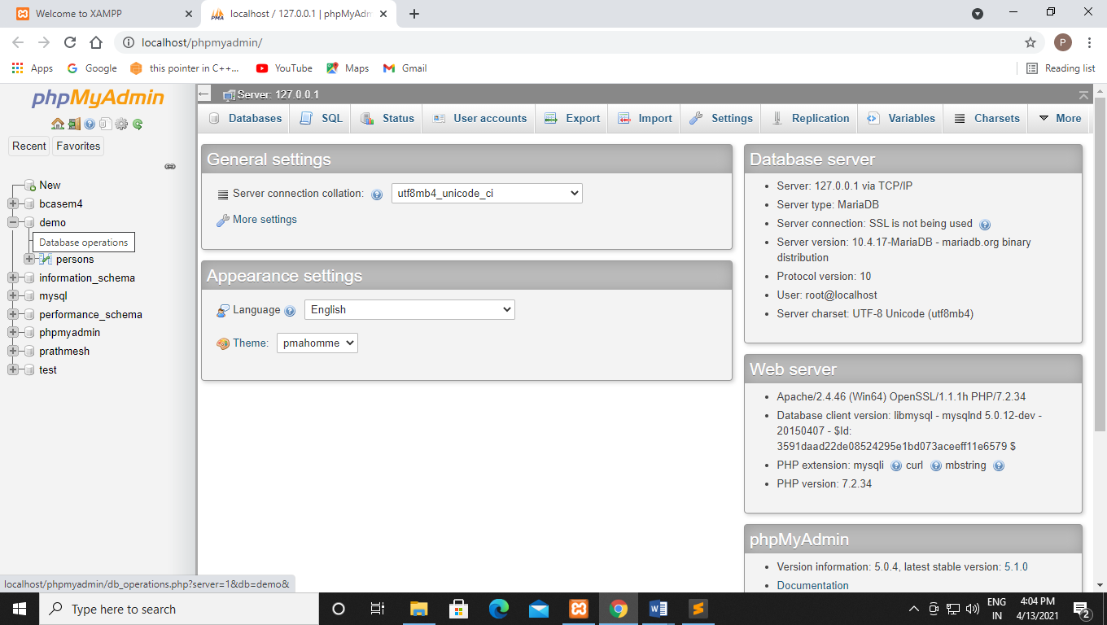

**Q98 Using php and mysql create table**

**Code:-**

<?php

$link = mysqli_connect("localhost","root","","demo");

if($link ===false){

die("ERROR: Could not connect." .mysqli_connect_error());

}

$sql = "CREATE TABLE persons(

id INT NOT NULL PRIMARY KEY AUTO_INCREMENT,

first_name VARCHAR(15) NOT NULL,

last_name VARCHAR(15) NOT NULL,

email VARCHAR(30) NOT NULL UNIQUE

)";

if (mysqli_query($link,$sql)) {

echo "Table created successfully.";

}else{

echo "ERROR: Could not able to execute $sql." .mysqli_error($link);

}

mysqli_close($link);

?>

**Output:-**

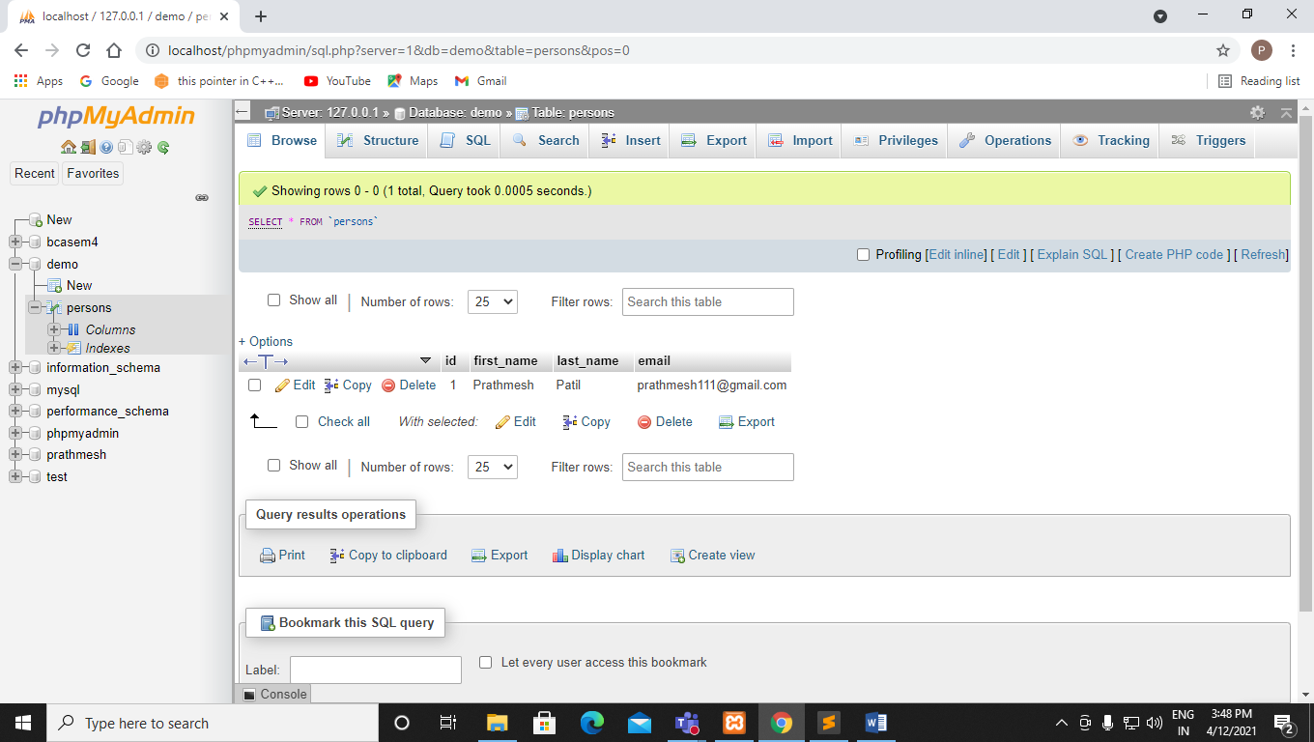

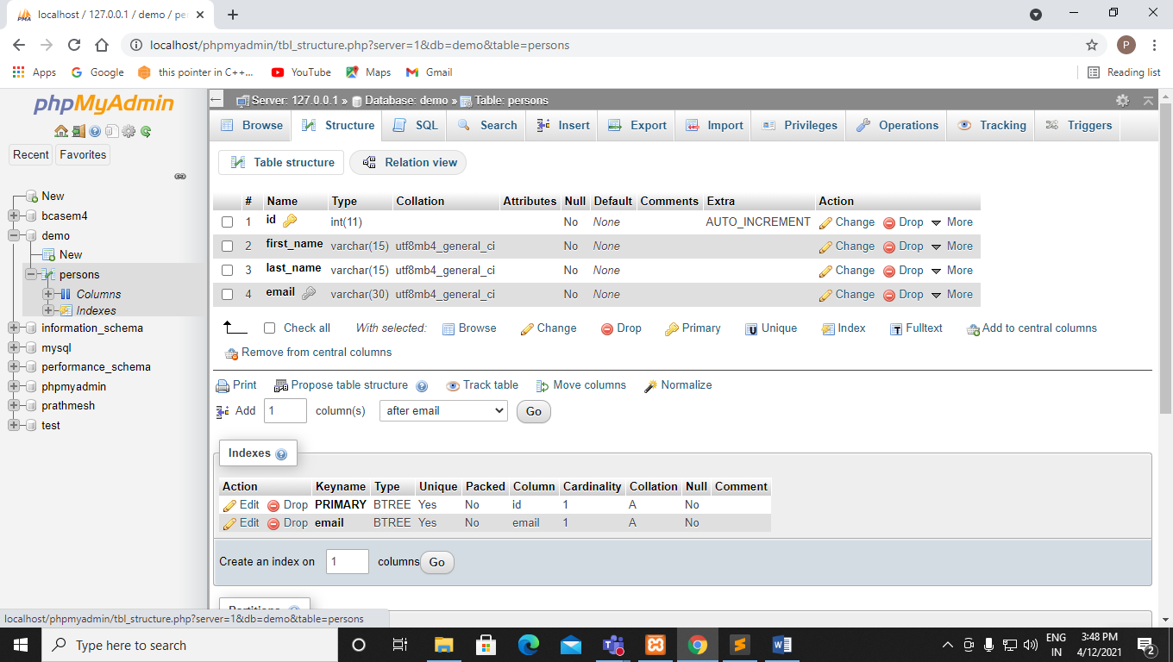

**Q99 Using php and mysql insert values to table**

**Code:-**

?php

$link = mysqli_connect("localhost","root","","demo");

if ($link ===false) {

die("ERROR: Could not connect." .mysqli_connect_error());

}

$sql = "INSERT INTO persons(first_name, last_name, email) VALUES ('Kaustubh','Patil','kaustubh@gmail.com')";

if(mysqli_query($link, $sql)){

echo "Records inserted successfully.";

}else{

echo "ERROR: Could not able to execute $sql." .mysqli_error($link);

}

mysqli_close($link);

?>

**Output:-**

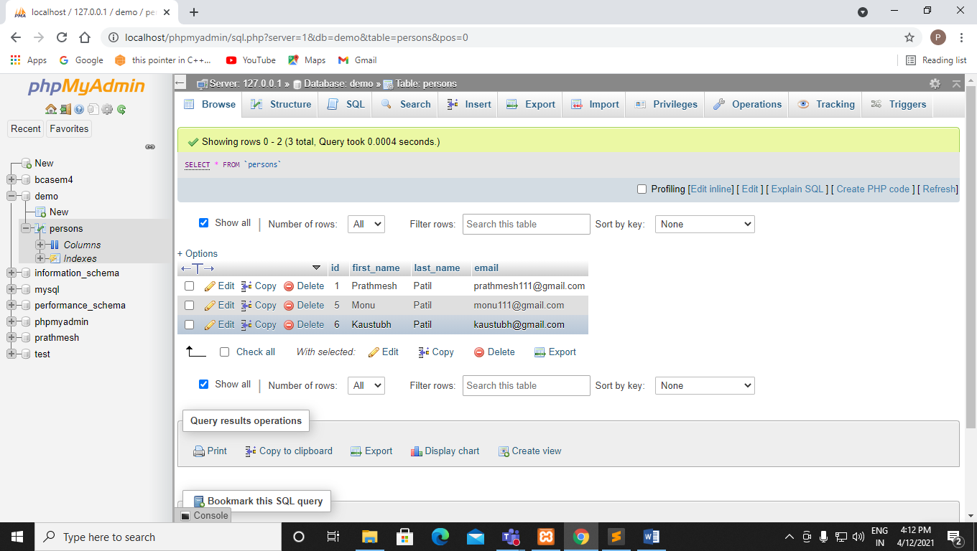

**Q100 Using php and mysql update values in the table.**

**Code:-**

<?php

$conn = new mysqli("localhost","root","","demo");

if ($conn -> connect_error){

die("Connection failed:" .$conn->connect_error);

}

$sql = "UPDATE persons SET last_name='Doc' WHERE id=5";

if ($conn->query($sql)=== TRUE) {

echo "record updated successfully";

}else{

echo "Error updating record" .$conn->error;

}

$conn->close();

?>

**Output:-**

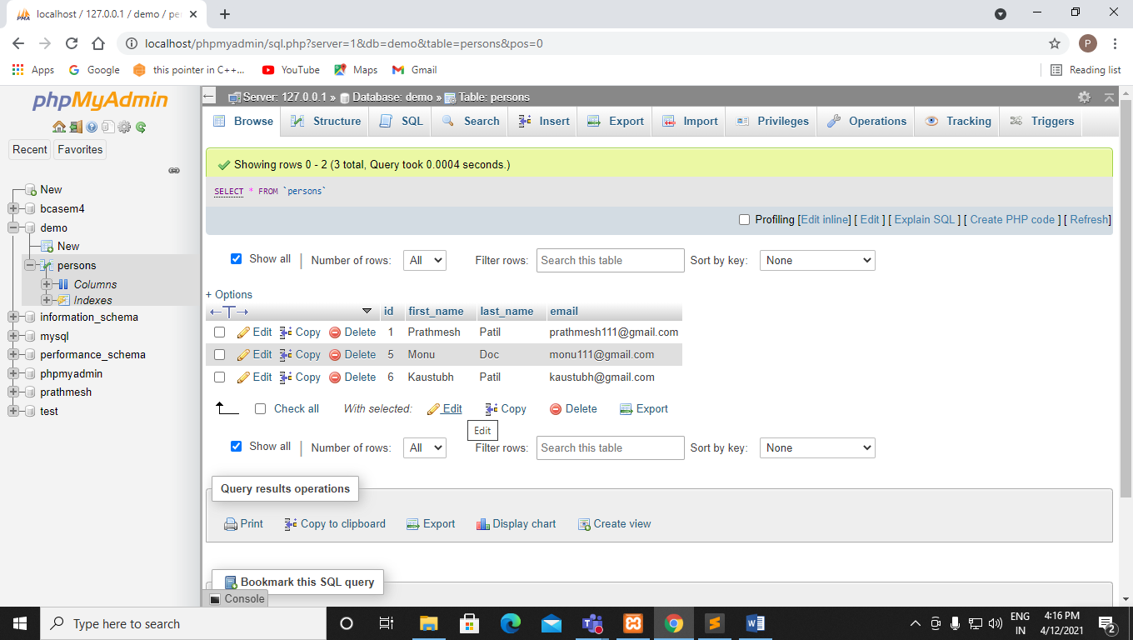

**Q101 Using php and mysql delete values.**

**Code:-**

<?php

$conn = new mysqli("localhost","root","","demo");

if ($conn -> connect_error){

die("Connection failed:" .$conn->connect_error);

}

$sql = "DELETE FROM persons WHERE id=7";

if ($conn->query($sql)=== TRUE) {

echo "record updated successfully";

}else{

echo "Error updating record" .$conn->error;

}

$conn->close();

?>

**Output:-**

**Before deleting record:-**

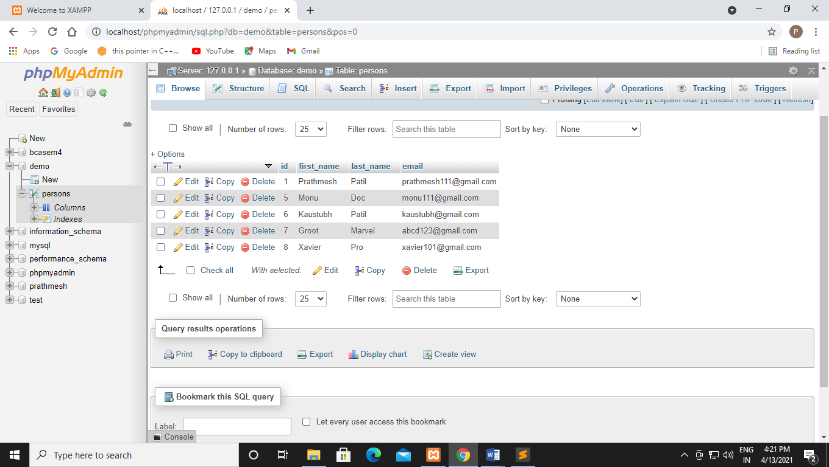

**After deleting record:-**

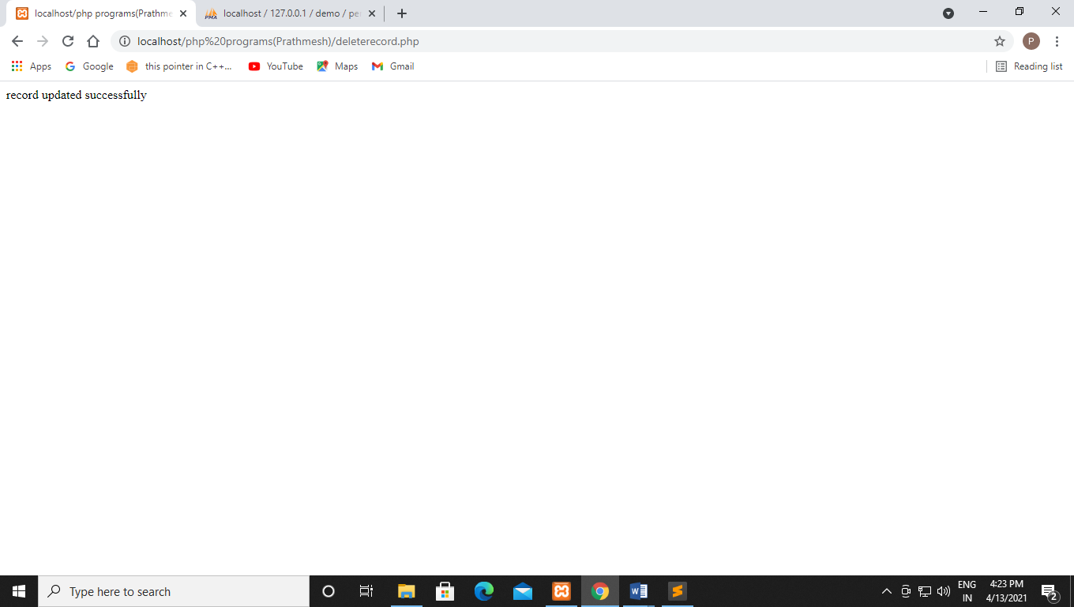

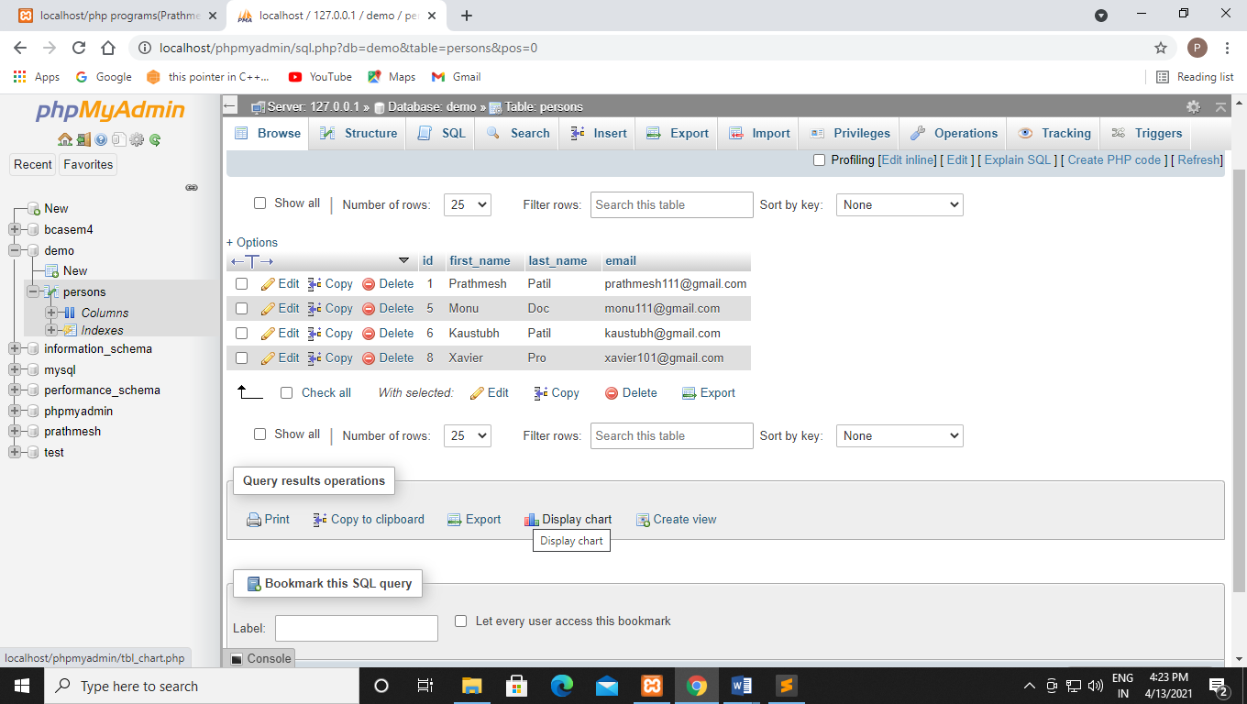

**Q102 Using php and mysql create student form and insert data into mysql.**

**Code:-**

**Databaseform:-**

<!DOCTYPE html>

<html>

<head>

<title></title>

</head>

<body>

<form action="insert.php" method="post">

<p>

<label for="firstName">First name:-</label>

<input type="text" name="first_name" id="firstName">

</p>

<p>

<label for="lastName">Last name:-</label>

<input type="text" name="last_name" id="lastName">

</p>

<p>

<label for="emailAddress">Email Address:-</label>

<input type="text" name="email" id="emailAddress">

</p>

<input type="submit" value="Submit">

</body>

</html>

**Output:-**

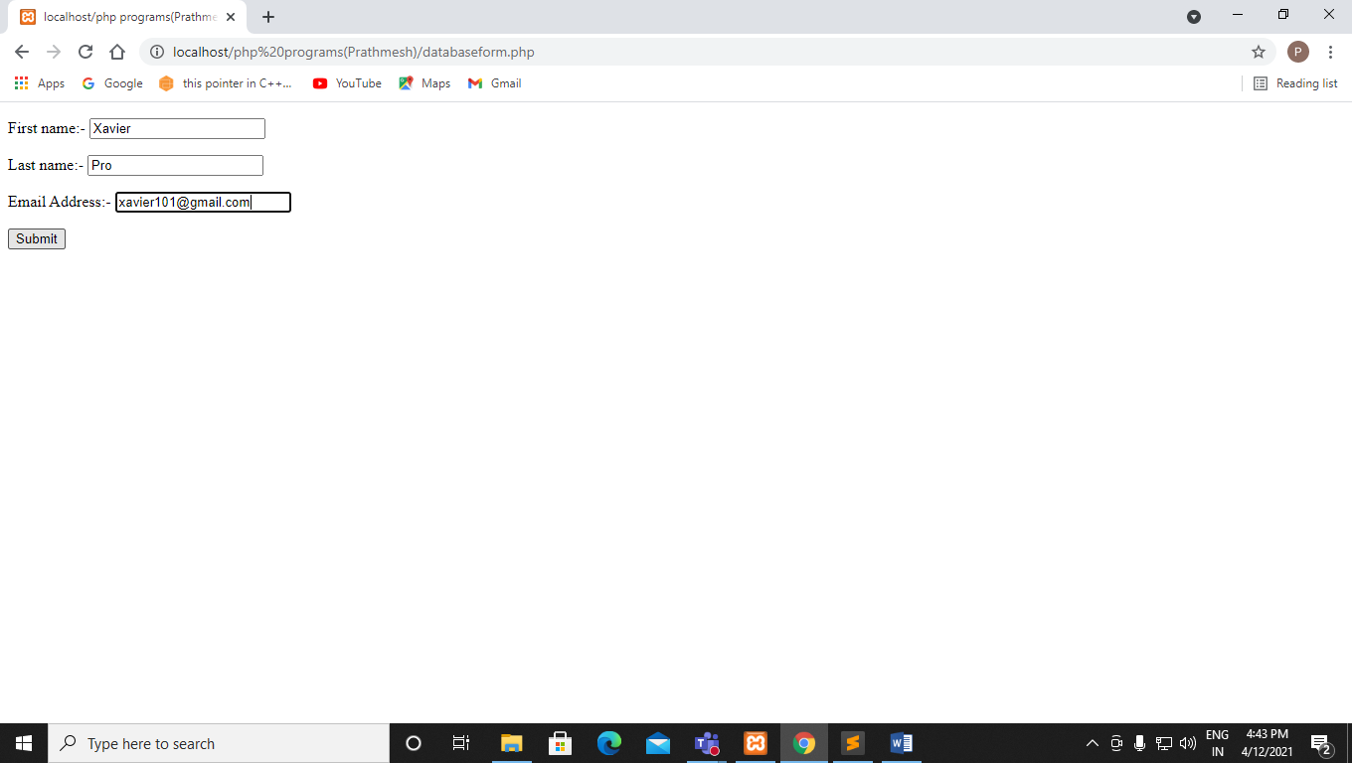

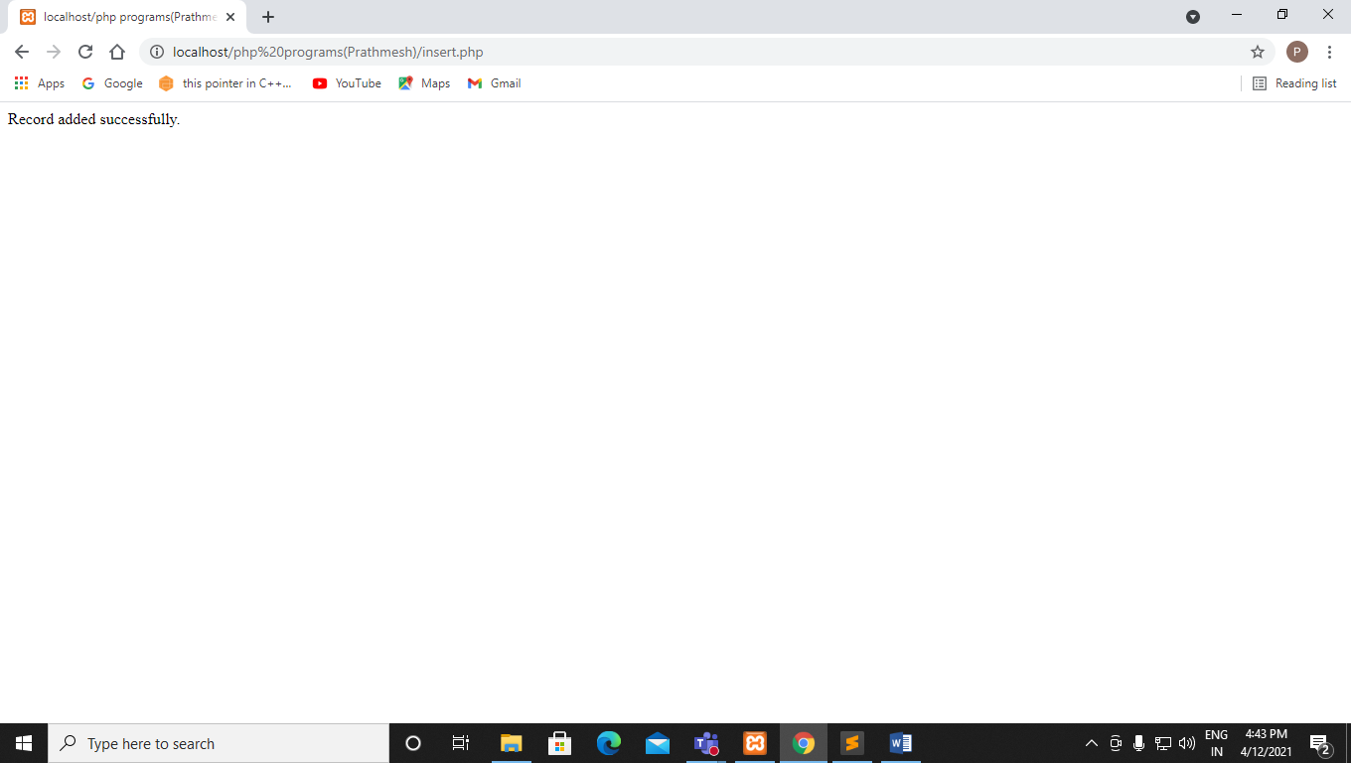

**Insert:-**

<?php

$link = mysqli_connect("localhost","root","","demo");

if ($link === false) {

die("ERROR:- Could not connect." .mysqli_connect_error());

}

$first_name = mysqli_real_escape_string($link, $_REQUEST['first_name']);

$last_name = mysqli_real_escape_string($link, $_REQUEST['last_name']);

$email = mysqli_real_escape_string($link, $_REQUEST['email']);

$sql ="INSERT INTO persons (first_name,last_name,email) VALUES ('$first_name', '$last_name', '$email')";

if (mysqli_query($link,$sql)) {

echo "Record added successfully.";

}else{

echo "ERROR: Could not able to execute $sql." .mysqli_error($link);

}

mysqli_close($link);

?>

**Output:-**

